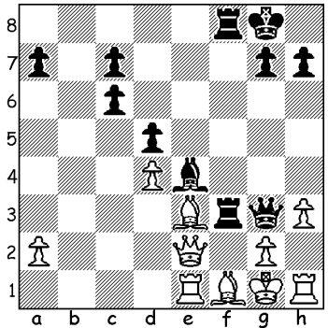

Diagram 519:
Yeon Lee Cho – Phiona Mutesi
(Women’s Olympiad 2012):
Black to play and win (3 moves):

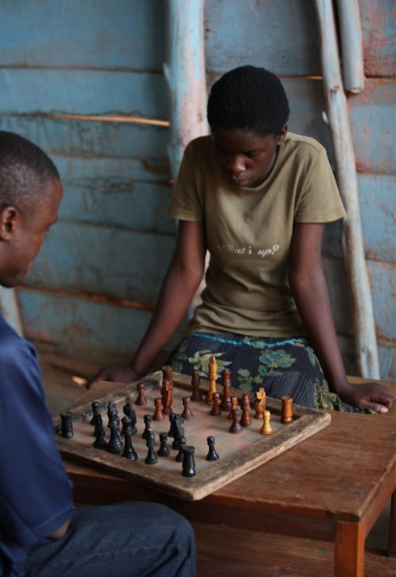

PHIONA MUTESI

I recently had passed to me by Norbert Muller an article on a teenage chess player, one whose play has not reached great heights but whose story is nevertheless one of such incredible achievement that Disney has bought the movie rights to a book written about her. Phiona Mutesi was born in Uganda in 1996 in extreme poverty. Her father died of AIDS leaving her mother to try to support her three children and a niece in three-by-three room. Phiona had to stop attending school at the age of nine because of the cost and the need to care for the other children. One day she followed her brother Brian to a church hall hoping there might be a
free meal. Instead she saw youngsters playing
chess, a game she had never seen but which
fascinated her. She was invited to enter by the
Phiona playing at her church hall organizer and learn the moves. She would walk
6km every day to play and her enthusiasm
won her coaching from the better players. Her mentor then took her to local boarding schools to mix with and play privileged children and her progress was such that she was chosen at 14 to play Board 2 for Uganda in the Women’s Olympiad in Russia. The snow and cold, the luxury of the hotel and the plentiful food were mind-boggling contrasts to her life in Africa. After her return she was given a scholarship by Sports Outreach to attend school, became the first female Ugandan junior champion, was runner-up in the Uganda Women’s championship and was chosen to play in the 2012 Olympiad in Turkey where she achieved a 50% score. She is rated 1668, the second highest female in Uganda and 16th overall. The position above shows her combinative ability and in the game below she shows tenacity defending a pawn down until an unexpected tactical idea allows her to equalize:

Nadine Kremer - Phiona Mutesi
2012 Women’s Olympiad: Ruy Lopez, Steinitz Defence
1.e4 e5 2.Nf3 Nc6 3.Bb5 d6
4.d4 Bd7 5.0-0 exd 6.Nxd4 Nxd4
7.Bxd7+ Qxd7 8.Qxd4 Ne7 9.Nc3 Nc6
10.Qd3 Be7 11.Nd5 0-0 12.Qg3 Nd4
13.Qd3 Ne6 14.Rd1 Rad8 15.Qg3 f5
16.Re1 Rf7 17.Nxe7+ Qxe7 18.exf Rxf5
19.Bh6 g6(a) 20.Qb3 Re8 21.Re3 Qh4
22.Rf1(b) Qxh6 23.Rxe6 Rxe6 24.Qxe6+ Kg7
25.Qc8 Rf7 26.Qxb7 a5 27.Qd5 Rf5
28.Qd4+ Kg8 29.Qc4+ Rf7 30.Re1 Qf8
31.Qd5 Kg7 32.Re2 Rf5 33.Qd4+ Kg8
34.Qc4+ Rf7 35.Qe6(c) Kg7 36.Qe8? Rxf2!
37.Qxf8+ Rxf8 and drawn after 50 moves.

a) Not 19…Kh8? or 19…Re8? 20.Rxe6!
b) 22.Rxe6? Qxf2+ 23.Kh1 Qf1+!
c) 35.Qd5 should win.

SOLUTION: 1…Rxe3! 2.Qxe3 Rxf1+ 3.Kxf1 Qxg2#

