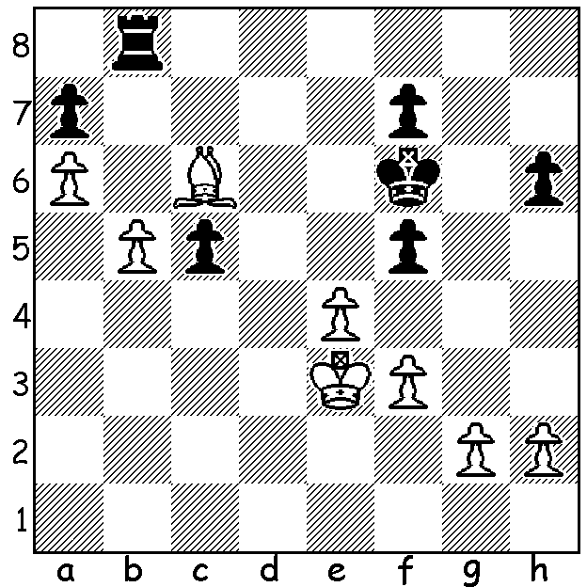

MAGNUS MAGIC
Diagram 520:
Magnus Carlsen – David Guijarro (2008) White to play and win (4 moves):

WA CHESS in 2013

2013 saw the death in November of WA’s long-time CAWA president and the state’s most successful player Hayden Barber, 15 times WA champion as well as a past NSW and ACT champion. Another state champion to pass on was Bill Ballantyne, champion in 1976 and 1982. In this year’s state championship Tristan Boyd, champion 2007-09, regained the title by half a point from 2011, 2012 champion Yita Choong. The Reserves championship resulted in a tie between Gordon Dunlop (6th time) and Natalie Maris. George Carolin-Unkovich was WA Junior champion, Yita Choong won the WA Allegro (rapid-play) championship while Ihsan Ferozkohi won the WA Lightning. Grand Prix winner for the fourth time was David Ellis, with George Carolin-Unkivich winning the Major section and Gary Donaldson winning the Minor for the sixth time. On the club scene, at Metro Yita Choong was club champion, David Ellis Open champion and Ihsan Ferozkohi winner of the Respini while at Perth Derek Elkington was club champion and Robert Maris and Steve Jones joint first in the Mary Thomson Cup. In inter-club competition Huntingdale came first in Division I (Harris Trophy), Metro won Division II and Perth Division III.
Here is the vital WA Championship game between WA’s top players in which White appears better for nearly all the game before a slip allows Black to bring off a brilliant sacrificial win:

YITA CHOONG - TRISTAN BOYD
2013 WA Championship, Rd 8
Sicilian Defence: Morra Gambit Declined
1.e4 c5 2.d4 cxd3. 3.c3 d3
4.Bxd3 d6 5.c4 Nf6 6.h3 g6
7.Nf3 Bg7 8.0-0 0-0 9.Nc3 Nbd7
10.Be3 b6 11.Rc1 Bb7 12.Bb1 Rc8
13.b3 Nc5 14.Nd2 a6(a) 15.Qe2 Bc6
16.f4 e6 17.Qf2 Qc7 18.b4 Ncd7
19.Rfd1 Ba8 20.Bd3 Ne8 21.Nb3 Qd8
22.c5 b5(b) 23.Bb1 d5 24.Bd4(c) Nef6
25.Nd2(d) Qc7 26.exd Bxd5 27.Nde4 Bxe4
28.Bxe4 e5 29.fxe Nxe5 30.Bf3(e) Rfe8
31.Kh1 Rcd8 32.Qg3 Bh6 33.Rc2?(f) Rxd4!!
34.Rxd4 Nxf3! 35.Rd6 Bf4! White resigns

a) White has established a Maroczy Bind set up, cramping Black who must patiently wait for opportunities for the liberating …b5 & …d5.
b) Black is prepared to allow White a protected passed pawn: 22…a5 was a possibility.
c) 24.exd seems attractive – 24…Bxc3 25.dxe (25.Rxc3 Bxd5 26.f5 Ng7) 25…fxe 26.Rxc3.
d) Here and next move e5 closes the position and keeps Black cramped.
e) 30.Nd5 Nxd5 31.Bxd5 maintains a slight advantage.
f) Black is now able to exploit this lessening of protection of the back rank and the weak black square complex around White’s king.
g) Black’s brilliant deflection exchange sacrifice followed by the queen offer produced a fitting way to clinch a state title against one’s closest rival.

The Perth Club kicks off 2014 with an open lightning tournament at N Woodvale Primary on January 8, 7.30 (no entry fee, no prizes). Contact Fred Maris on 93014806.

SOLUTION: 1.Bb7 (else 1…Rb6) and Black is helpless against 2.b6! axb 3.a7! winning the rook or queening.

