2014 AUSTRALIAN OPEN

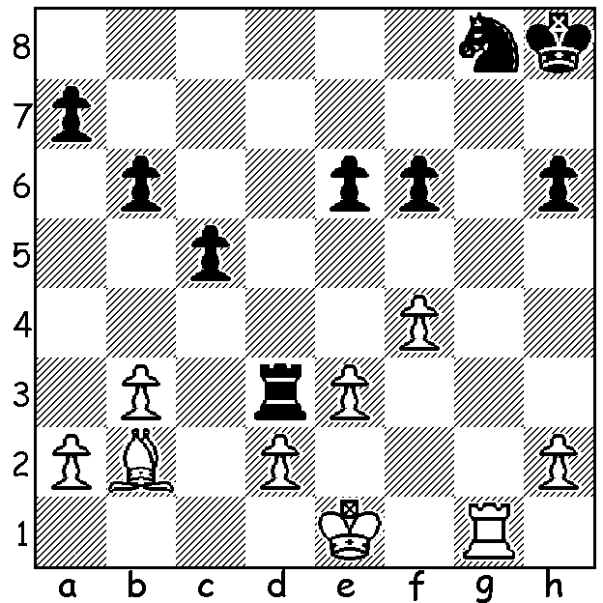
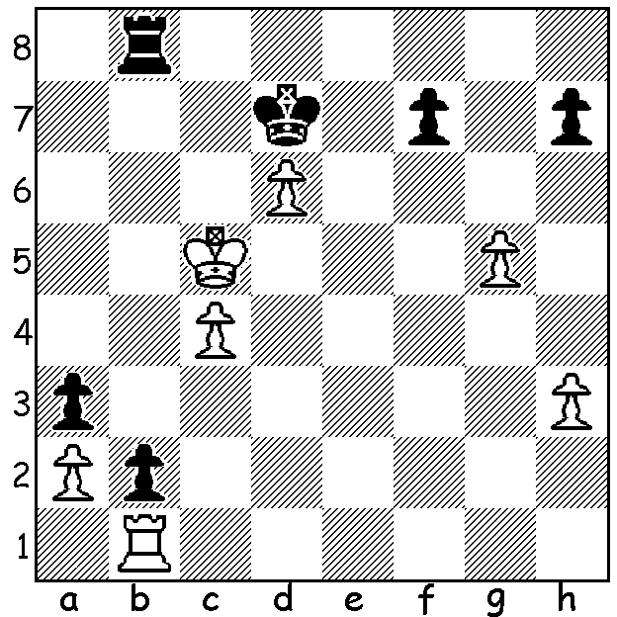
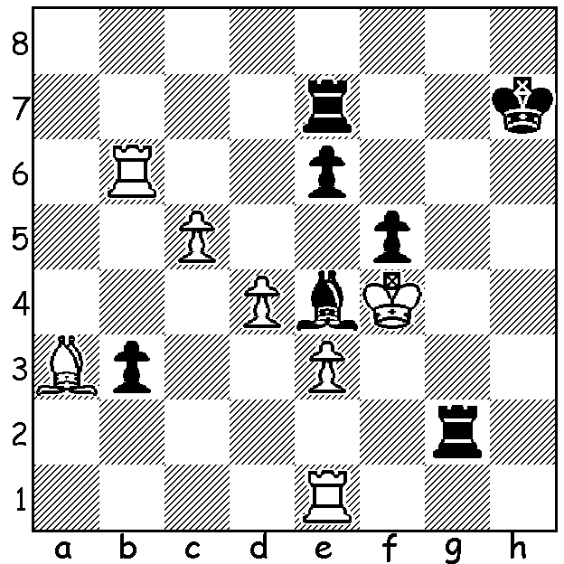

521 Goldenberg –Ly: 522 Papin – Lane: 523 Tang – Smirnov:
Black to play. White to play. Black to play.

A visit today to the Town Hall in Springvale, SE of Melbourne, would present a view of nearly 200 hushed participants in intense thought at the 11 round 2014 Australian Open Championships - 42 in the main event, 93 in the Reserves and 57 in the Challengers (Under 1600). With many of the leading Australian players from all over the country and a sprinkling of overseas players, competition has been fierce as participants strive for honours and the personal satisfaction of playing near error free chess. After 7 rounds Australian champion, teenager Bobby Cheng, and fellow Australian Moulthun Ly are locked in a three-way tie with Russian GM Vasily Papin on 5.5 with Igor Bjelbork and former child prodigy Tu Hoang Thong (Vietman) a half point behind. West Australians Yita Choong and Marc Vliestra have 3 and 1.5 respectively. In the Reserves former Australian champion Doug Hamilton leads with 6.5/7 while WA’s Richard Lilly and Dennis Holland have 4, Robert Hvistendahl and George Carolin-Unkovich 3.5 and Edward Ottschoffski 3.

Stephen Solomon - James Morris
2014 Australian Open, Rd 6
Modern Defence
1.e4 g6 2.d4 Bg7
3.Nc3 d6 4.Be3 a6
5.Qd2 Nd7 6.h4 h5
7.Nh3 b5 8.Ng5 Bb7
9.a4 b4 10.Bc4! e6(a)
11.Ne2 Ngf6 12.Bd3(b) c5
13.f3 0-0 14.0-0 cxd
15.Nxd4 d5 16.Qxb4 Rb8
17.Qd6 dxe 18.fxe Ng4?
19.Ndxe6! fxe6 20.Qxe6+ Kh8
21 Qxg6 Ndf6 22.Rxf6! Nxf6
23.Rf1(c) Qe8 24.Rxf6! Qxg6
25.Rxg6 Bc8 26.b3 and wins(d)

a) If 10..bxc3 11.Bxf7+ Kf8 12.Nxd8+ Ke8 13.Qxc3 winning.
b) White could try 11.Bxe6! – 11…fxe6 Nxe6 12.Qe7 Nxc7+.
c) 22.e5 also wins.
d) With so many extra pawns and continuing pressure against Black’s king, White wins comfortably - a splendid attack!

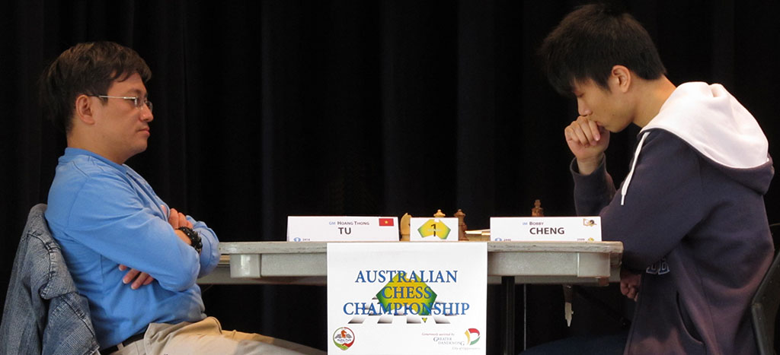

Australian champion Bobby Cheng (rt) v Vietnamese GM Tu Hoang Thong

SOLUTION:
All endings from the 2014 Australian Open:
a) 1…e5+! (obstruction sacrifice) 2.dxe Rg4#:
b) 1.Bd4 (another obstruction sacrifice - 1…cxd4 2.Ke2):
c) 1…Rb3!! (2.axb3 a2 wins) White played 2.Kd4 to stop 2..Rc3/3…Rc1 but now loses a number of pawns.

