2014 AUSTRALIAN OPEN

Two spectacular finishes by 1st place David Hamilton in the Reserves Championship:

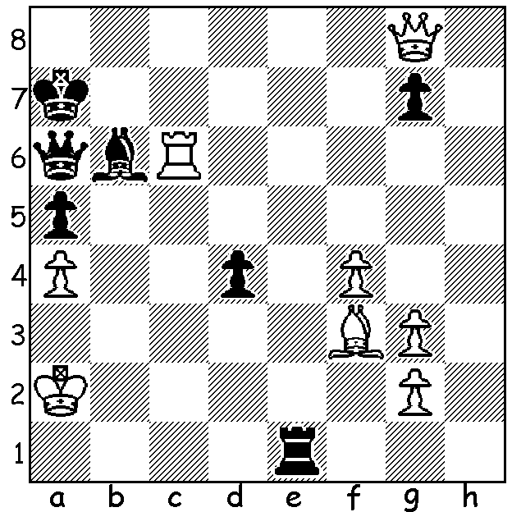
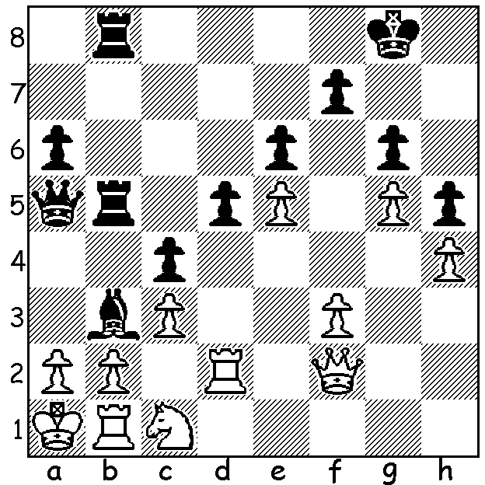

a) Colin Savige – Hamilton: b) Hamilton – Max Chew Lee:
Black to play. White to play.
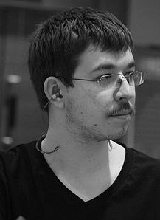
The Australian Open at Springvale Town Hall,
Victoria, finished last weekend with victory
going to 21 year old IM Max Illingworth with
8/11 (+7 =2 -2). Runners-up were Tu Hoang
Thong (Vietnam), Moulthun Ly and Karl Zelesco
on 7.5 followed by Vasily Papin (Russia), Igor
Goldenberg, Australian champion Bobby Cheng
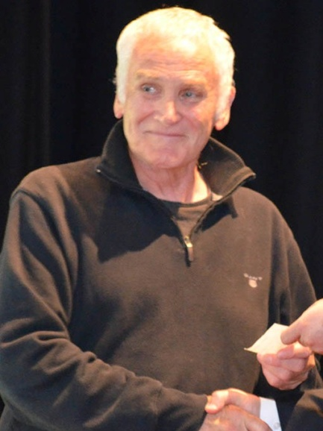
and Anton Smirnov with 7. Top rated player Papin failed to win a game from Rd 4 on. WA’s two players would be disappointed with their scores – Yita Choong with 5 and Marc Vliestra with 2.5. In the Reserves winner was former Australian champion Doug Hamilton (my very first opponent in the Australian Championships way back in 1973) with the fine score of 9.5/11. WA players scores: Edik Gilmetdinov 7, Dennis Holland 6.5, Richard Lilly and George Carolin-Unkovich 6, Robert Hvistendahl 5.5, Evan Yeung 4.5, Edward Ottshoffski 3.5. Edik gained the Reserves prize for Best Finish with 4.5 from his last 5 games. Open winner and Australian Olympiad player Illingworth started playing competitive chess at nine, has been NSW champion three times and was Australian Playerof the Year in both 2011 and 2012. Now here’s the game which won the Best Played
Game Prize:
Max Illingworth (top) & David Hamilton

Andrew Brown - Jason Tang
2014 Australian Open, Rd 4
Queens Gambit Declined
1.d4 d5 2.c4 e6
3.Nc3 Nf6 4.Nf3 Be7
5.Bf4 0-0 6.e3 Nh5
7.Be5 Nc6 8.Bd3 Nxe5
9.Nxe5 Nf6 10.c5(a) Nd7
11.f4 Nxe5 12.fxe5 Bg5(b)
13.h4! Bxh4+ 14.g3! Bxg3+
15.Kd2 h6 16.Qh5 f5
17.Ne2 Bxe5 18.dxe5 Qg5(d)
19.Qf3 Qe7 20.Rag1 Kh7
21.Nf4 Bd7(e) 22.Rg6 Be8
23.Rxe6 Qxc5 24.Rexh6+! gxh6
25.Rxh6+ Kxh6 26.Qh3+ Kg7
27.Ne6+ Kg8 28.Qg2+ Kf7
29.Nxc5 Bc6 30.Bxf5 resigns

a) A useful move blocking the centre and preventing a freeing …c5.
b) The cause of Black’s troubles enabling White to open lines of attack. 12…c6 (with …b6 to come) looks logical.
c) Already Black loses a piece.
d) The queen will only come under attack here. 18…Qe8 is better but Black’s prospects are bleak.
e) Black must try to develop as 21…Qxc5 is met by 22.Rxh6+!!

SOLUTIONS: a) 1…Bxa2!! 2.Nxa2 Qxa2+! 3.Kxa2 Ra5#
b) 1.Qa8+!! Kxa8 2.Rc8+ Ka7 3.Ra8#

:

