Local Boy 2014 Australian U 16 Champion

Talented WA youngster George Carolin-Unkovich won this year’s Australian Under 16 championship with the fine score of 8/9 (+7 =2). George, who is also a very talented musician, has improved markedly over the past year or so and joins a number of WA boys and girls who have achieved excellent results in national championships. This year’s championships, held in Sydney, attracted over 200 entrants in Open and Girls’ events divided into Under 18 to Under 8 groups. Winner of the Open was Anton Smirnov (NSW) with 7.5/9. Anton had also had an excellent result in the Australian Open in Springvale, coming =5th with 7/9. Other WA scores: Open – Adam Kelly 5.5/9 (=7th/22): Under 16 – Pokk Huan Koh 3.5: Under 14 - Ignatius Yap 5/9 (=13/ 43).

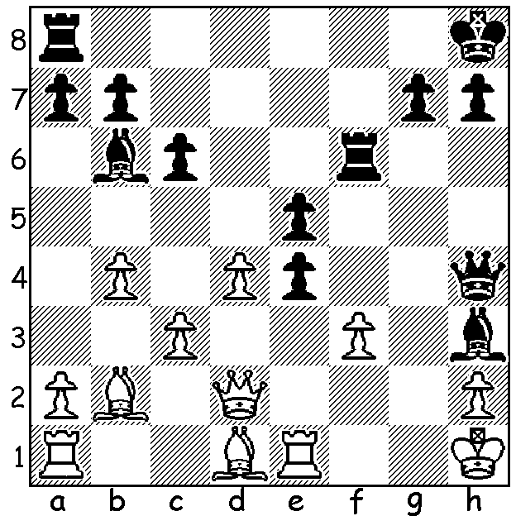

Diagram 526: Dennis Holland scored
6.5/11 in the Australian Reserves at
Springvale and among his victims was
highly rated Kevin Sheldrick.
How would Holland reply to
1.Rxe4, 1.fxe4 or dxe5?

Marc Vliestra would have been disappointed with his score at Springvale
but played his usual brand of enterprising chess throughout:

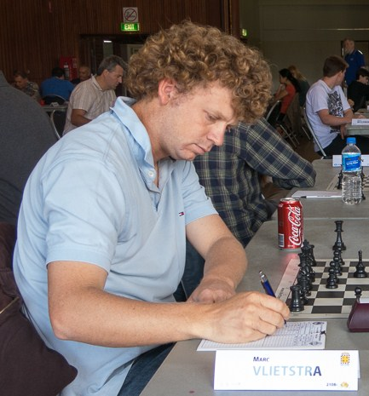
Marc Vliestra - Malcolm Pyke
2014 Australian Open, Rd 3
French Defence: Advance Variation
1.e4 e6 2.d4 d5
3.e5 c5 4.c4(a) cxd
5.Qxd4 Nc6 6.Qf4 Nge7
7.Nf3 dxc(b) 8.Bxc4 Ng6
9.Qe4 Ngxe5! 10.0-0(c) Nxc4
11.Qxc4 Be7 12.Nc3 0-0
13.Bf4 a6 14.a3 Qa5
15.b4 Qf5 16.Rfe1(d) Rd8
17.Na4 Nd4!(e) 18.Qc7 Nxf3
19.gxf3 Bd7(f) 20.Nb6 Rab8
21.Rad1(g) e5? 22.Rxd7(h) Rf8
23.Rxe7 exf4 24.Qxb8!(i) Qg5+
25.Kh1 Qxe7 26.Rxe7 Rxb8
27.Rc7 g5 28.Rc8+ resigns Marc Vliestra at Aus Ch 2014

a) You won’t find this in opening books but rather than 4.c3 which leads to a very closed position White strives for an open game.
b) Good is 7…Ng6 8.Qg3 d4 but Black sees a way to win a pawn.
c) If 10.Nxe5 Qxa5+ 11.Nc3 Qxe5.
d) White is unlikely to be unhappy with the pawn minus as he has a promising lead in development.
e) An excellent obstruction sacrifice – 17.Nxd4? Qxf4.
f) Effective is the ugly 19…Rd7.
g) Under increasing White pressure Black cracks when he has a logical way out of his difficulty with 21…Bg5! removing his unprotected piece from danger. White’s best then seems the unpromising 22.Bxg5 Qxg5+ 23.Qg3 Qxg3+ 24.fxg3 Bc6.
h) Wins easily as does 22.Nxd7 Rbc8 23.Qxe5 Qxe5 24.Rxe5.
i) An elegant simplification leading to an easily winning endgame as Black cannot reply 24…Rxb8 (25.Re8+ Rxe8 26.Rxe8#).
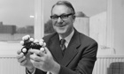
The death occurred very recently of renowned
Australian Sir John Cornforth aged 96. Sir John
was the only Australian Nobel Prize winner in
Chemistry (1975). Despite being handicapped by
total deafness from the age of 20 Sir John carved
out a remarkable career in UK. He was also an
accomplished chess player who scored 6/11 in the
1936 Australian Championship.

SOLUTION: If 1.Rxe4 Qxe4! (2.fxe4 Rf1#) ; if 1.fxe4 Qxe4+! (2.Rxe4 Rf1#): if 1.dxe exf! (threat 2…Bg2+).

:

