World champion Magnus Carlsen has been in the news this month after appearing on the Scandinavian TV chat show Skavian with billionaire and philanthropist Bill Gates, founder of Microsoft. He and Gates played a live game with Gates having 2 minutes and Carlsen 30 seconds with the game over in nine moves and 79 seconds with Carlsen using only 12 seconds of his time. Here’s the game:
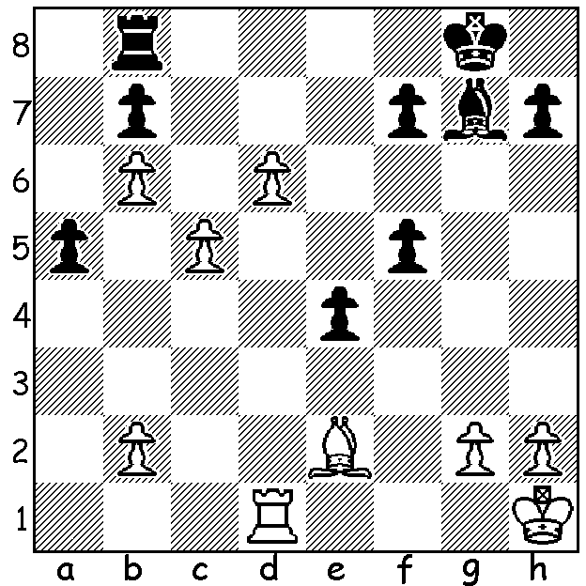
Bill Gates – Magnus Carlsen
Nimzovitsch Defence
1.e4 Nc6 2.Nf3 d5 3.Bd3 Nf6
4.exd Qxd5 5.Nc3 Qh5 6.0-0 Bg4
7.h3 Ne5 8.hxg4? Nfxg4 9.Nxe5 Qh2#.

And now Carlsen – Grischuk 2009:
White to play and win:

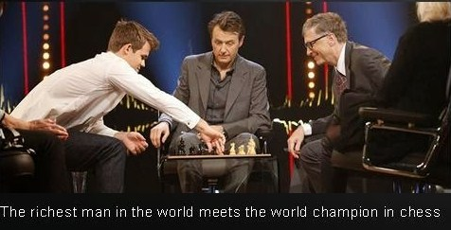

Here’s a game from George Carolin-Unkovich who has recently returned unbeaten from Sydney after winning the Australian Under 16 championship with the fine score of 8/9:

George Carolin-Unkovich - Tom Slater-Jones
French Classical : Steinitz Variation:
2014 Australian Under 16 Championship
1.e4 e6 2.d4 d5 3.Nc3 Nf6
4.e5 Nfd7 5.Nf3 c5 6.Bg5 Qb6
7.dxc5 Bxc5 8.Qd2(a) Nc6 9.0-0-0 Bb4(b)
10.a3 Bxc3 11.Qxc3 Qc5 12.Qe1 a6
13.Bd3 b5 14.c3 Rb8 15.Be3 Qe7
16.Bc2 a5 17.b4(c) axb 18.axb Qd8
19.Nd4 Nxd4 20.Bxd4 Nb6 21.Bxb6(d) Qxb6
22.Qd2 h6 23.f4 Ra8 24.Kb2 Ke7
25.Rhf1 Ra7 26.Qd4(e) Qxd4 27.Rxd4 f6
28.Rd2 Rf8 29.Bd3 Bd7 30.Ra1 Rxa1
31.Kxa1 Ra8+ 32.Kb2(f) g5 33.g3 Rg8
34.Re2 gxf4 35.gxf4 f5 36.Rf2 Kd8
37.Kc2 Kc7 38.Be2 Kb6 39.Bh5 Kc7
40.Kd3 Kb6 41.Ke2 Ra8 42.Ke3 Ra3
43.Kd3 Kc7 44.Rg2 Ra1 45.Rg7 Kd8
46.Kd4 Rh1 47.Rg2(g) Kc7 48.Ra2 Re1?(h)
49.Ra7+ Kd8 50.Kc5 Re4?(i) 51.Kd6 Rc4(j)
51.Rxd7+ & wins.

a) White hoped for 8…Bxf2+?! When he gives up both rooks with 9.Qxf2! Qxb2 10.Kd2 Qxa1 11.Bb5! Qxh1 12.Qc5!
b) 9…Ndxe5 seems possible but Black probably feared dangerous sacrificial attacks opening up lines to his uncastled king.
c) An unusual but effective way of blunting Black’s attack.
d) Thwarted in his attempts at a wild combinative game White banks on the superiority of his bishop over that of his opponent which is hemmed in by its own pawns:
e) If 26.f5 exf 27.Qxd5 and Black’s bishop is liberated.
f) Possible is 32.Ra2 but White judges his chances better with rooks on.
g) The immediate 47.Kc5 is good.
h) Black should hold up the White king advance with 48…Kb6.
i) Losing – 50…Ke7 kept Black in the game.
j) If 51…Bc8 52.Rh7 mates.
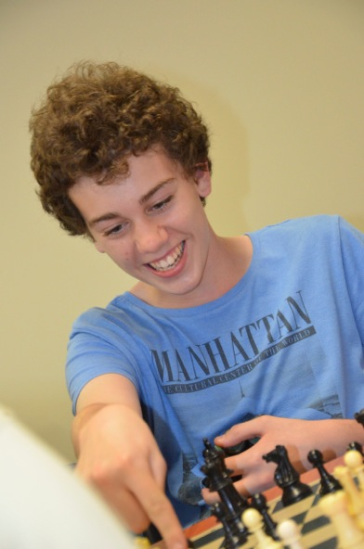
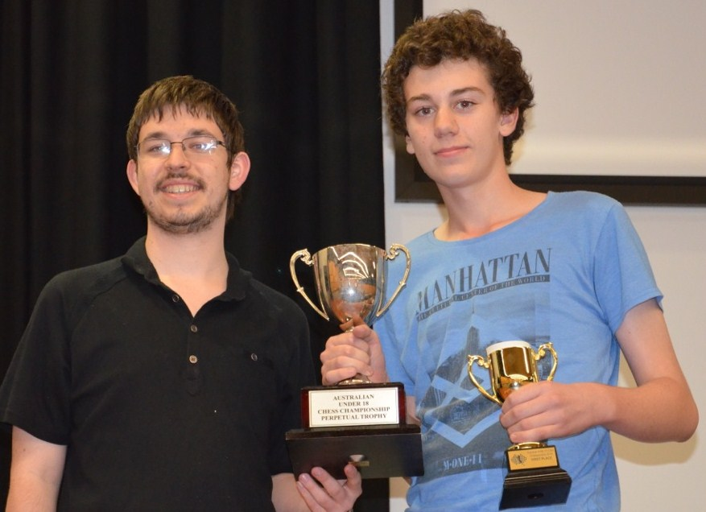

George Carolin-Unkovich receiving Under 16 trophy
from Australian Open champion Max Illingworth (above)
and happily analysing a win (right)

SOLUTION: 1.Ba6! If 1…bxa6 2.c6 and White queens: other moves allow 2.Bxb7!

