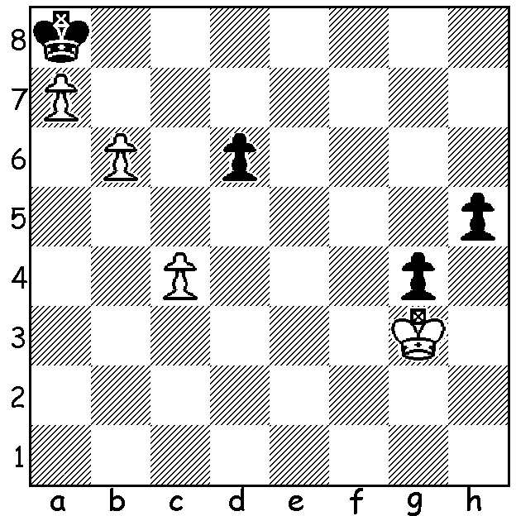

Diagram 528
Can White (to play) win
this level material pawn ending?

Returning to the 2014 Australian Open we see a game by ex-WA champion Yita Choong who scored 5/9. Some of his games, including the see-sawing game selected below, were extremely double-edged with the result in doubt until the end.

Yita Choong - David Castor
2014 Australian Open, Rd 4
Caro-Kann Advance
1.e4 c6 2.d4 d5
3.e5 Bf5 4.h4 h5
5.c4 e6 6.Nc3 Ne7
7.Bg5 dxc 8.Bxc4 Nd7
9.Nge2 f6 10.exf gxf
11.Be3 Nb6 12.Bb3 Nbd5
13.Ng3 Bg4(a) 14.Qd2 Nf5
15.Nxd5 cxd5 16.Bc2 Nxe3
17.Bg6+ Kd7 18.Qxe3 Qa5+
19.Kf1 Bd6 20.Ne2 e5
21.f3 Be6 22.Rc1 Rac8(b)
23.Kf2 Qb6 24.Rhd1 Rhg8(c)
25.Bh7 Rh8 26.Bg6 Rhg8(d)
27.Qh6 Rh8 28.Qg7+ Be7
29.Bh7 Rhf8 30.Kf1 Rf7
31.Qg6 Qd8(e) 32.Rxc8 Qxc8
33.Bg8 Rf8 34.Bxe6+ Kxe6
35.dxe Rg8 36.Nd4+ Kxe5(f)
37.f4+! Kxf4(g) 38.Qh6+ Kg4
39.Ne2?(h) Qf5+ 40.Kg1 Bc5+
41.Kh1 Qf2 42.Ng1 Kxh4
43.Nf3+ Kg3 44.Rg1 Rg4(i)
45.Qxf6 Qe2?(j) 46.Nh2! Bxg1
47.Nf1+ Qxf1 48.Qxf1 Bf2
49.Qd3+ Kf4??(k) 50.Qf3+ resigns


a) 13…Nxe3 14.fxe3 securing the safety of the
bishop on g4 was a good alternative.
b) 22…Qxa2 might have been risked.
c) Also 24…Rcg8.
d) 26…Qxb2 is not good – 27.Rb1 Qxa2 28.Ra1.
e) Black now gets into trouble: better was 31…Rxc1
32.Rxc1 Qxb2 although White retains excellent
attacking chances.
f) A forced move leaving Black’s king dangerously
exposed.
g) If 37…Kd6 38.Nf5+ wins.
h) White misses 39.Qe3 winning – 39…Bc5 (39…Bd6
40.Qf3+ Kxh4 41.Qxf6+) 41.Qf3+ Kxh4 42.Qf4+ Q/Rg4 43…Nf3#.
i) Threatens 45…Rh4+! 46.Nxh4 (overworked defender) 46…Qxg1#.
j) Now 45…Qe3 would leave Black on top.
k) Threatens 50…Rh4# but missing the coming fork. 49…Kh4 50.Qxd5 b6 leaves Black with a likely draw.

The first Grand Prix event of the year, the Perth Open, will be held on Sat 15 & Sun 16 Feb (10am – 5pm both days) at N Woodvale Primary, Trappers Dr.. Points can be gained for both the WA and Australian Grand Prix competitions. Entry $35 by Friday 14 Feb. See cawa.org.au and enquiries Norbert Muller 9409 9579.

SOLUTION: By allowing the Black pawns to advance and promote White is able to mate: 1.Kf4 Kb7 2.c5! (enabling White to advance his king more quickly) 2…dxc 3.Ke5 g3 (or 3…c4) 4.Kd6 g2
5.a8=Q+! Kxa8 6.Kc7 g1=Q 7.b7+ Ka7 8.b8=Q+ Ka6 9.Qb6#.

