One of the most spectacular moves ever was played by Viswanath Anand (Black) against Vladimir Kramnik (Amber Rapid-Play 2008):
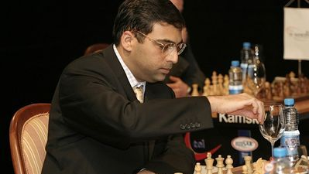
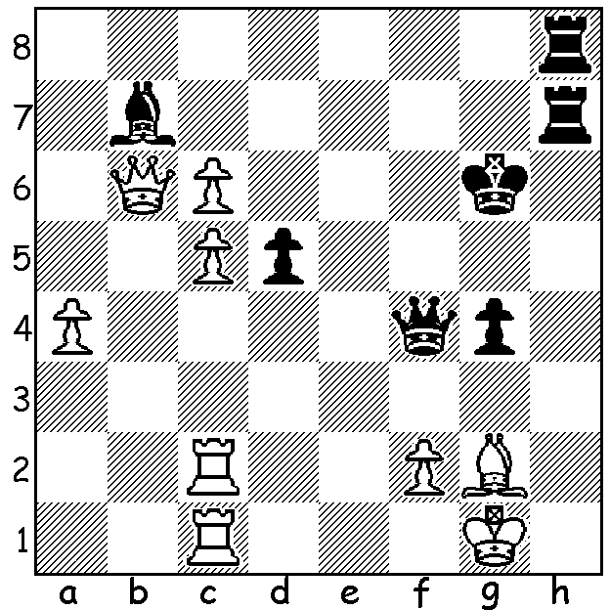

Last week The West reported that Sachin Tendulkar, the world’s leading scorer in both Test and International One-Day cricket, had been awarded India’s highest civilian award, the Bharat Ratna. The Bharat Ratna has only been open to sportpersons since 2011 and Tendulkar is the first sportsman to receive this award. I wondered if the last statement was correct and checked whether former world chess champion Viswanathan Anand, who was Indian Sports Star of the Year and Indian of the Year in 2012, had previously received the award. Although he had not, I discovered that there was considerable speculation in the Indian media on whether Anand would have been a more deserving recipient. Anand, born in 1959 and India’s first GM, was undisputed world champion from 2007-2013, having won the title in tournament play and then defended his title against ex-world champion Vladimir Kramnik in 2008, Veselin Topalov in 2010 and Boris Gelfand in 2012 before losing last year to Magnus Carlsen. Anand was rated world number one many times between 2007 and 2011 and has been hailed as the most versatile world champion ever, having won or successfully defended the title in tournament, match and knock-out formats as well as being World Rapid-Play champion in 2003. The game below is one of his world championship wins, the dramatic final game in his 6.5-5.5 win against his Bulgarian challenger Veselin Topalov in Sofia:

Veselin Topalov - Viswanathan Anand
World Championship 2010 Game 12
Queens Gambit Declined, Laskers Defence
1.d4 d5 2.c4 e6
3.Nf3 Nf6 4.Nc3 Be7
5.Bg5 h6 6.Bh4 O-O
7.e3 Ne4 8.Bxe7 Qxe7
9.Rc1 c6 10.Be2 Nxc3
11.Rxc3 dxc4 12.Bxc4 Nd7
13.O-O b6 14.Bd3 c5
15.Be4 Rb8 16.Qc2 Nf6(a)
17.dxc5 Nxe4 18.Qxe4 bxc5
19.Qc2 Bb7 20.Nd2 Rfd8
21.f3 Ba6 22.Rf2 Rd7
23.g3 Rbd8 24.Kg2 Bd3
25.Qc1 Ba6 26.Ra3 Bb7
27.Nb3 Rc7 28.Na5(b) Ba8
29.Nc4 e5 30.e4(c) f 5!
31.exf5 e4 32.fxe4 Qxe4+
33.Kh3 Rd4 34.Ne3 Qe8!(d)
35.g4 h5 36.Kh4 g5+
37.fxg6 Qxg6 38.Qf1 Rxg4+
39.Kh3 Re7! 40.Rf8+ Kg7
41.Nf5+(e) Kh7(f) 42.Rg3 Rxg3+
43.hxg3 Qg4+ 44.Kh2 Re2+
45.Kg1 Rg2+ 46.Qxg2 Bxg2 and wins(g)

a) A double edged move, allowing a weakening of his queenside pawns in return for a well placed bishop on b7.
b) 28.Rc2 c4 29.Rxc4 Bxf3+! 30.Kxf3 Qf6+ 31.Kg2 Rxc4 32.Qxc4 Qxb2+.
c) 30.Rd2 e4 31.f4 Rd3! 32.Ne5 f6!
d) The winning move.
e) 41.Rxa8 Rxe3+! 42.Rxe3 Rh4+! 43.Kxh4 Qg4#.
f) 41…Kxf8? 42.Nh4+ wins. Now if 42.Nxe7 Rh4+! mates.
g) Conclusion - 47.Kxg2 Qe2+ 48.Kh3 c4 49.a4 a5 50.Rf6 Kg8 51.Nh6+ Kg7 52.Rb6 Qe4 53.Kh2 Kh7 54.Rd6 Qe5 55.Nf7 (55.Rb6 h4)55...Qxb2+ 56.Kh3 Qg7 White resigns.

The first Grand Prix event of the year, the Perth Open, will be held tomorrow & Sunday (10am – 5pm both days) at N Woodvale Primary, Trappers Dr.. Points can be gained for both the WA and Australian Grand Prix competitions. Entry $35 TODAY! See cawa.org.au and enquiries Norbert Muller 9409 9579.

SOLUTION: 1…Qf3!!! 2.cxb7+ Kf5 White resigns (3.Bxf3 – 3…Rh1+ was threatened – 3…gxf3
4.b8=Q Rh1#.

