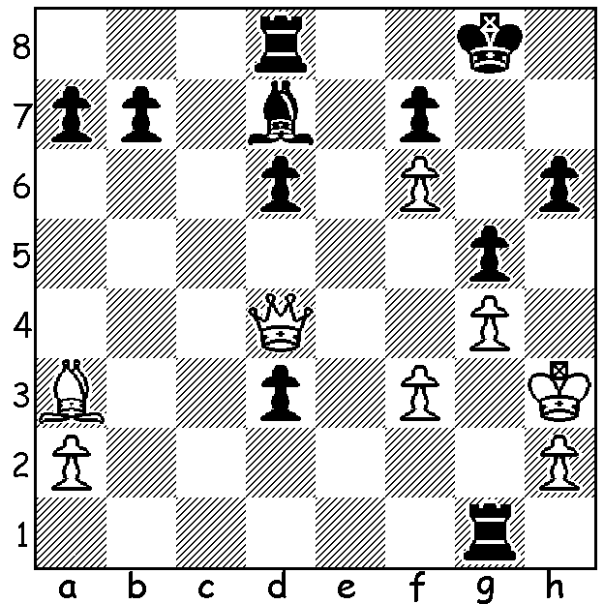

Pick out the two dangers
to White to find Black’s
winning line (3 moves):

This week we return to the Australian Junior Championships at which West Australian George Carolin- Unkovich won the Under 16 title. The performance of the championships was that of 12 year old Anton Smirnov from Sydney who scored 7.5/9 in the main event to become Australian Junior (Under 18) Champion. Anton learnt chess at the age of four from his father Vladimir, himself an IM. Anton won the Australian Under 8 Championship aged 5 and in 2009 was second in the World Under 8 Championship. Last year he scored 6/11, coming =31st/108, in the Indonesian Open, with a performance rating of 2459 and ahead of a number of GMs. He also performed well in this year’s Australian Championship coming =6th with 7/11. He now has a higher rating than world champion Magnus Carlsen, also a child prodigy, had at a similar age. Here is one of his games from the Australian Open:

Anton Smirnov - Christopher Wallis
2014 Australian Open
Caro-Kann Defence
1.e4 c6 2.d4 d5
3.Nc3 dxe 4.Nxe4 Bf5
5.Ng3 Bg6 6.h4 h6
7.Nf3 Nd7 8.h5 Bh7
9.Bd3 Bxd3 10.Qxd3 e6
11.Bd2 Ngf6 12.0-0-0 Be7
13.Ne4 Nxe4 14.Qxe4 Nf6
15.Qe2 Qd5 16.Kb1(a) Nxh5
17.Ne5 Nf6 18.f3(b) Rf8(c)
19.c4 Qd6 20.Bf4 Qb4
21.Rhe1 Qa5 22.a3 Qa6
23.g4 Rd8(d) 24.g5 hxg
25.Bxg5 Ng8 26.f4 Rd6
27.Qe4 Nf6 28.Qf3 Qa5
29.Ka2(e) Kd8 30.f5 Kc8
31.c5 Rd5 32.fxe fxe
33.Qh3 Kb8 34.Qxe6 Re8
35.Bxf6 gxf6 36.Nxc6!(f) bxc6
37.Qxc6 Qd8 38.Rd3 Rxc5
39.Rb3+ resigns

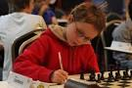
a) Rather than 16.c4 Qe4 17.Qxe4 Nxe4= White
offers a pawn.
b) Stops 18…Qe4.
c) If 19…0-0 White would use the half-open h file
to attack Black’s king but this leaves Black cramped
and he is unable to castle long.
d) 23…0-0-0 is met by 24.Nxf7! (24…Rxf7 25.Qxe6+).
e) Meets the threat of 29…Rxd4 30.Rxd4 Qxe1 (not
check) 31.Nxc6!
f) A winning sacrifice: White was not tempted by the
showy 36.Qxc6!? bxc6 37.Nxc6+ Kc7 38.Nxa5.

The Perth Open (WA & Australian Grand Prix event 15-16 Feb, 29 players) resulted in a tie for first place between WA’s top two players, WA champion Tristan Boyd and ex-champion Yita Choong, both with 5.5/6. In their game Yita won a pawn but with four pawn against three, all on the king’s wing, Tristan was able to hold the position in a rook and minor piece (later just rook) ending despite being short of time. Third was Australian Under 16 champion George Carolin-Unkovich (4.5) with another leading WA junior Adam Kelly (4), winning the Under 1800 prize. Yet another junior, Ignatius Yap (3.5), won the Under 1400 prize while WA women’s champion Aileen Fisher (4), also scored well, coming =4th.

SOLUTION: White’s king is precariously placed and Black’s d pawn is two squares from queening so 1…d2!! 2.Qxg1 Ba4 / 3…d1=Q or 2.Qxd2 Bb5 / 3…Bf1+.

