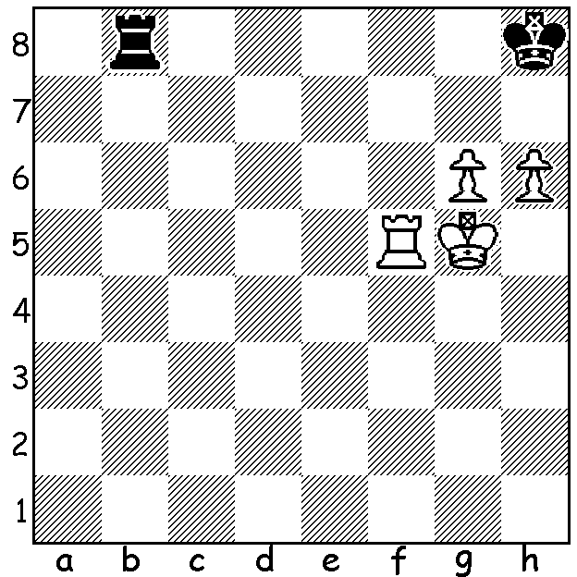
Rook + g pawn & h pawn v rook is a notoriously
slow and difficult ending to win with the inferior
side having blockade, rook checks and even
stalemate opportunities as defensive resources.
However Dmitry Gordievsky finds a neat and
quick way to finish off Alexander Grischuk in
the last round of the recent Moscow
Championship Super Final:

Everyone knows chess is immensely popular in Russia and tournaments there can be very large scale events. The recent Moscow Championships had a Super Final and a Women’s Super final, each with 10 players, an Open A with 194 players as well as a Women’s B, an Open Amateur, an Open Veterans and A & B Open Student tournaments. Top rated players in the Super Final were Alexander Grischuk, Ian Nepomniachtchi and Alexander Morozevich. Grischuk led by a point with one round to play but was caught by Evgeniy Najer after losing to Dmitry Gordievsky (see position above). However Grischuk triumphed 2-0 in the play-off with Najer. Here is one of his wins:

Alexander Grischuk - Ivan Popov
2014 Moscow Super Final
Sicilian Defence: Snyder Attack
1.e4 c5 2.Nf3 e6 3.b3 Nc6
4.Bb2 Nf6 5.e5 Nd5 6.Na3 a6
7.g3 Be7 8.Bg2 0-0 9.0-0 b5
10.c4 Nc7(a) 11.d4 cxd(b) 12.Nxd4 b4
13.Nxc6 dxc6 14.Nb1(c) Bb7 15.Nd2 a5
16.Ne4 Na6 17.Qh5 Kh8 18.Rad1 Qe8
19.Nf6! Bxf6(e) 20.exf6 g621. Qxa5 Qc8
22.Qb6 Nb8 23.Qxb4(f) Rxa2 24.Be5 Ba8
25.Qc5 Re8 26.Qe7!! Kg8 27.Bxb8 Qxb8
28.Rd7 resigns(g)

a) 10…bxc 11.Nxc4 f6 12.Qe2=. Black’s failure during the game to exchange off White’s e pawn has dire consequences.
b) If 11…d5 12.exd6 Qxd6 13.Ne5 Nxd4 14.Bxa8 Nxb8 15.Nf3.
c) The knight is heading for the perfect square e4. 14.Nc2 looks the obvious move but attempts to win the c pawn end in disaster: 14.Nc2 Bb7 15.Nd4 Qe8 16.Qf3 Kh8! 17.Nxc6? Rc8 / 18…Na8.
d) White retains an advantage after 15…Qd7 16.Ne4 Rfd8 17.Qg4.
e) 19…gxf6? 20.exf6 Bc5 21.Be4 wins.
f) 23.Rd2 is even better – 23…Nd7 24.Qxb4 Rxa2? 25.Rxd7!
g) Attempting to oust the queen with …Rb7 is too slow – 28…Ra6 29.Rfd1 Rb6 30.Rd8.

SOLUTION: 1.Rf8+!! Rxf8 2.g7+ Kg8 3.Kg6!! resigns.



