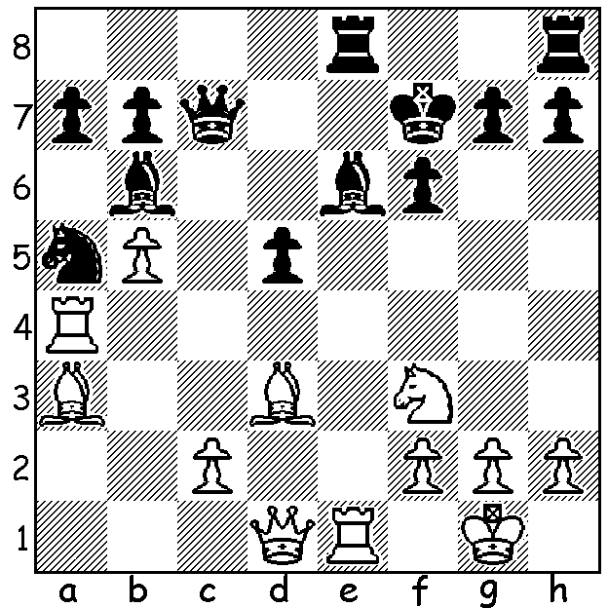

Carlsen – Nicolic 2005:
with all his pieces all well
placed for attack White wins
quickly (4 moves):

The latest world ratings give 23 year old Magnus Carlsen the highest rating ever attained at 2881. A child prodigy, the young Norwegian was a GM at 13, the world number 1 aged 19 and following his victory over Viswanathan Anand last year, the second youngest world champion after Gary Kasparov. Carlsen recently competed in an 6-player double round robin in Zurich together with world top players Levon Aronian (Armenia), Fabiano Caruana (Italy), Viswanathan Anand (India), Hikaru Nakamura (USA) and Boris Gelfand (Israel). The first half was played with classical time limits with the second half being rapid play. At the half way stage (with points doubled) Carlen led with 8/10 followed by Aronian 6 and Caruana 5. Here is one of Carlsen’s wins involving a fine positional exchange sacrifice:

Magnus Carlsen - Fabiano Caruana
Zurich 2014, Rd 3
Ruy Lopez, Berlin Defence
1.e4 e5 2.Nf3 Nc6 3.Bb5 Nf6
4.d3(a) Bc5 5.Bxc6 dxc6 6.h3 Nd7
7.Be3 Bd6 8.Nc3 c5 9.0-0 Nf8
10.Nd2 Ng6 11.Nc4 Be6 12.Ne2 Qd7
13.Nxd6+ cxd6 14.f4 exf 15.Nxf4 Nxf4
16.Rxf4 b6(b) 17.Qh5 d5 18.d4 c4
19.b3 Qc6 20.Raf1 0-0-0 21.bxc4 Qxc4
22.Rxf7! Bxf7 23.Rxf7 Rd7(c) 24.Rxd7 Kxd7
25.exd g6(d) 26.Qg4+ Kc7 27.Qe6 Kb7
28.Qe7+ Qc7 29.Qe4(e) Qd7 30.d6+ Ka6
31.Bf4 Rc8(f) 32.Kh2 Rc4(g) 33.Bg3(h) Rc8
34.Qd3+ Kb7 35.c4 Qc6 36.Qb3! Ka8(h)
37.a4 Re8 38.a5! Kb7 39.c5 Kc8
40.axb axb 41.d5! Qxc5 42.Qa4 Re3
43.Qa8+ Kd7 44.Qb7+ Ke8 45.d7+ Kd8
46.Bh4+ Re7 47.Qc8+! resigns


a) The success of the Berlin Defence against the more
aggressive lines (eg 4.0-0 Nxe4 5.d4 Nd6 6.Bxc6 dxc6
7.dxe Nf5 8.Qxd8+) has resulted in players increasingly
using this apparently innocuous move.
b) With White pieces able to take up aggressive posts on
the kingside, Black is reluctant to castle short.
c) If 23…g6 (as well as 24.Rxa7 White threatened 24.Qg4+
Kb8 25.Qxg7) 24.Qf3 Kb8 25.Qf6 winning.
d) If 25…Qxa2 26.Qg4+ Kd8 27.Qxg7 Re8 29.Bg5+ Kc8
30.d6 winning.
e) Here and on subsequent moves White avoids exchanging
queens (29.d6) and continues to play for the attack.
f) If 31…Re8 32.Qd3+ Kb7 33.c4 with continuing advantage.
g) There’s grave danger is removing the rook from the back rank.
h) 32.Qe7 would win – 32…Qc6 (exchanging queens is clearly lost) 34.d7 Rxc2 35.Qa3+ Kb5 (35…Kb7 36.d8=N+) 36.Qb3+ Ka6 37.Qxc2!.
h) 36…Qxc4? 37.d7 Qxb3 38.dxc8=Q+.

WA Allegro Championship will be held on Sunday 16 March at N. Woodvale Primary (see cawa.or.au for details ).

SOLUTION: 1.Ng5+! fxg5 2.Qf3+ Kg8 3.Rxe6! Rd8 (3…Rxe6 4.Qf8#) 4.Re7.

