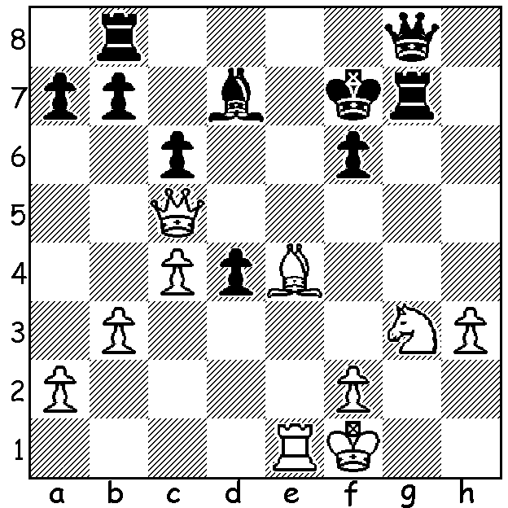

Carlsen – Gretarsson 2003:
White wins quickly:

Recapping from last week, the new world champion 23 year old Norwegian Magnus Carlsen led the 6-player Zurich tournament by 2 points at the half way stage leaving his opponents seemingly little chance of catching him in the Rapidplay games. However things did not go well for Carlsen in the Rapidplay, scoring only 2/5, although neither Fabiano Caruana (4/5) nor Levon Aronian (3/5) were able to catch him with both finishing overall on 9, a point behind Carlsen. Things could have been even worse for Carlsen in the Rapidplay when he came close to losing against the US champion Hikaru Nakamura in a most exciting and double-edged game:

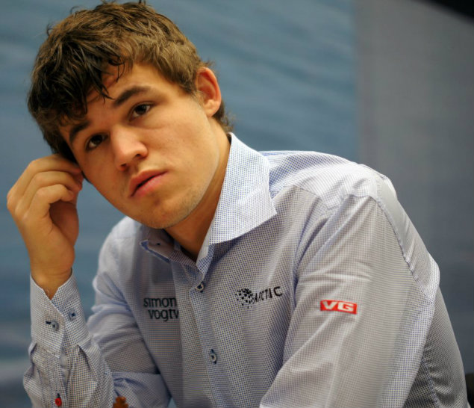
Hiakaru Nakamura - Magnus Carlsen
Zurich 2014, Rapidplay Rd 3
Nimzoindian, 4.f3
1.d4 Nf6 2.c4 e6
3.Nc3 Bb4 4.f3 d5
5.a3 Be7 6.e4 dxe
7.fxe e5 8.d5 Bc5
9.Bg5 0-0 10.Nf3 Bg4
11.h3 Bxf3 12.Qxf3 Nbd7
13.0-0-0 Bd4 14.Ne2 c5
15.g4(a) a5(b) 16.Kb1 Ra6
17.Ng3 g6(c) 18.h4 a4
19.Rh2 Qa5 20.Bd2 Qc7 Magnus Carlsen
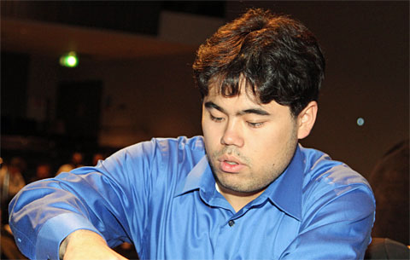
21.g5 Ne8 22.h5 Rb6
23.Bc1 Rb3 24.Qg4 Nb6
25.Be2 Nd6 26.Rdh1 Bxb2!
27.Bxb2 Nbxc4 28.Bxc4 Nxc4
29.hxg6 Qb6 30.g7(d) Rd8
31.Qh4 Rxb2+ 32.Ka1 Rxh2
33.Rxh2 Qg6 34.Nf5 Re8
35.Qg4 Qb6 36.Qh3 Qg6
37.d6(e) Nxd6! 38.Nxd6 Rd8
39.Nc4(f) Qxe4 40.Qh5 Rd3
41.Rh4 Qf5 42.Qe2 b5
43.Nd2 Qxg5 44.Qxd3 Qxh4(g)
Hikaru Nakamura

a) 15.dxc6 bxc6 16.Nxd4 exd4 17.Rxd4 Qb6 gives Black a very active position.
b) …a6 / …b5 or the gambit …b5 /…a6 seems the obvious way of developing play against the White king but Carlsen has a different plan in mind.
c) Weakening but preventing 18.Nf5 or 15.Nh5.
d) White could win with 30.gxf+ Rxf7 31.g6 Qxg6 32.Qxg6+.
e) Another missed win: 37.Qf1 b5 38.Rxh7!! Qxh7 39.Nh6+.
f) Better 39.Nc8 Kxg7 40.Ne7 Rd1+ 41.Ka2 Qe6+ 42.Qxe6 fxe6 43.gxh6. Now White’s queen and knight are unable to cope with the avalanche of pawns.
g) continued 45.Ne4 Kxg7 46.Qf3 Qf4 47.Qg2+ Kf8 48.Kb2 h5 49.Nd2 h4 50.Kc2 b4 51.axb cxb 52.Qa8+ Kg7 53.Qxa4 h3 54.Qb3 h2 55.Qd5 e4 56.Qh5 e3 57.Nf3 e2 58.Kb3 f6 59.Ne1 Qg3+ 60.Ka4 Qg1 61.Qxe2 Qa7+ White resigns

WA Allegro Championship (15 min) will be held on Sunday 16 March, 11am – 5pm, at N. Woodvale Primary (see cawa.org.au for details). Please try to submit entry before Sunday to Gordon Dunlop g-dunlop64@bigpond.com or 93686412 (late entry accepted up to 10.30 Sunday).

Did you watch ‘Bobby Fischer against the World’ on SBS1 last Sunday? The documentary showed the tragic life of chess reclusive genius Robert James Fischer (1943 – 2008) who wrested the world title from Russian domination when he defeated Boris Spassky in 1972 in Reykjavik.

SOLUTION: 1.Bg6+! (clearance sacrifice) if 1…Kxg6 Qh5!#: if 1…Rxg6 2.Qe7

