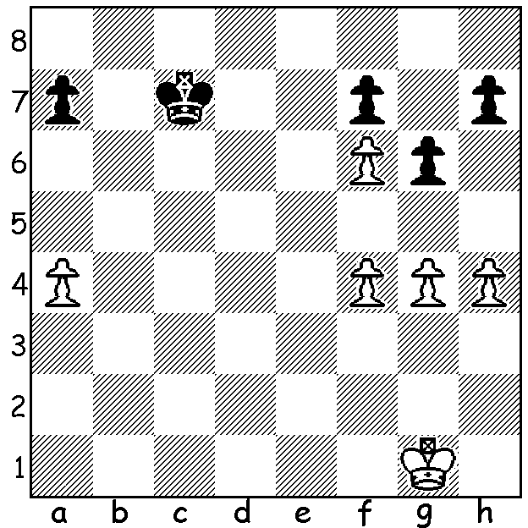

Smerdon – van Foreest (Café Batavia 2014):
Black to play:
although White has an extra pawn it is doubled
and Black’s king is much nearer the pawns.
What do you think the result will be after
1…Kb6, 1…Kd6 or 1…h5?

In October 2012 I reported on a relationship break-up in the life of Australian GM David Smerdon who had become disillusioned with the way things had been going. Smerdon’s words at the time were, ”It’s all over. I’m sorry. I’m breaking up with you once and for all.” However I have since discovered that he has made attempts at a reconciliation. Those with excellent memories will recall he was referring to his love affair with the Dutch Stonewall Defence (after 1.d4 Black sets up pawns on f5, e6, d5, c6) which had soured after a number of bad results. I don’t know when Smerdon and the Stonewall got back with each other again but they were seen together three times at the Café Batavia (Netherlands) tournament in February. Smerdon scored a solitary half point from those three games so things were clearly not working out for the two of them and I cannot see the reunion lasting. Despite those results Smerdon was leading the 10 player GM event by a half point after nine rounds. He lost quickly in the final round (a Dutch Stonewall) but, fortunately for him, his closest rival also lost, leaving him winner with 6/9. Here is his win from the event against a dangerous English opponent:

David Smerdon - Simon Williams
2014 Café Batavia, Rd 8
French Defence, Advance Variation
1.e4 e6 2.d4 d5
3.e5 c5 4.c3 Nc6
5.Nf3 Bd7 6.Bd3 Rc8(a)
7.dxc Bxc5 8.b4 Bb6
9.Na3 a6(b) 10.0-0 f6(c)
11.b5 Nxe5 12.Nxe5 fxe5
13.Qh5+ Kf8 14.Qxe5 Bc7
15.Qd4 axb 16.Nxb5 Bxb5
17.Bxb5 Nf6 18.Bd3 Kf7(d)
19.Rb1 e5 20.Qh4 b6
21.Bf5 Ra8 22.a4 Qd6(e)
23.Rd1 Qc6(f) 24.Rb5 Ra5(g)
25.Bg5 h6 26.Qh3 Rxa4
27.Bxf6 Kxf6(h) 28.Bd7(i) Qd6
29.Rbxd5! Qxd5 30.Qf5+ Ke7
31.Bxa4 resigns

a) 6…cxd 7.cxd Qb6 transposes into the Milner-Barry Gambit (8.0-0 Nxd4 9.Nxd4 Qxd4 10.Nc3).
b) 9…Bc7 seems an excellent possibility (10.Bf4 Nge7).
c) A little loosening - 10…Nge7 is an alternative.
d) If 18…e5 10.Qh4 e4 11.Be2 White will open up the position advantageously with f3. With the text Black will want the opportunity of retreating his king to g8 after moving the rook.
e) 22…e4 23.f3 Rxa4 24.fxe dxe 25.Bg5 puts Black under severe pressure.
f) Possible now seems 23…e4 (24.Bg5 g6 25.Bxf6 Qxf6 26.Qxf6+ Kxf6 27.Bd7=).
g) Risky is 24…Qxc3 25.Bb2.
h) If 27…Qxf6 28.Rbxd5 Rd8 29.Rxd8 Bxd8 30.Qd3 Be7 31.Qd5+ Kf8 32.Bh7 winning.
i) The queen cannot be taken – 28.Rbxd5?? Qxd5! 29.Bc2 Qc6 and wins.


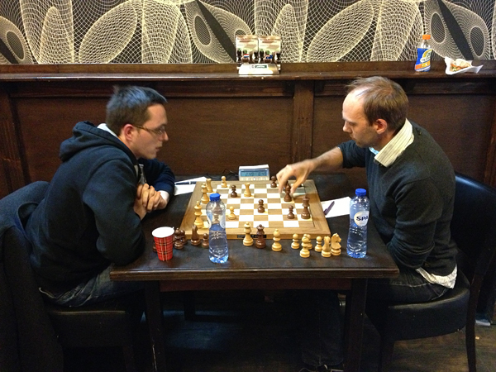

David Smerdon (rt) towards the end of his drawn game with the top ranked player Ernst Spike.

WA ALLEGRO (Rapidplay) CHAMPIONSHIP with 21 entries was played last Sunday at Woodvale. Winner was WA champion Tristan Boyd (8.5/9) who added another title to the Perth Open he won earlier in the year. Last year’s winner Ihsan Ferozkohi and Australian Under 16 champion George Carolin-Unkovich (6.5) were =2nd while 2004 champion Alex Janceski (6) won the Under 1900 top place and Stevan Mijailovic (5) the Under 1550.

SOLUTION: if 1…Kb6 2.f5 Ka5 (2….gxf 3.g5) 3.g5 Kxa4 4.h5 gxh 5.g6 wins: if 1…Kd6 a possible continuation is 2.Kf2 Ke6 3.g5 Kf5 (3…Kd5 4.Kf3 a5 5.Kg4 Ke6 6.f5+!) 4.Kf3 a5 5.Kg3 Ke4/6 6.Kg4 & wins: if 1…h5 (played) 2.f5! resigns (2…hxg 3.fxg or 2…gxf 3.gxh)

