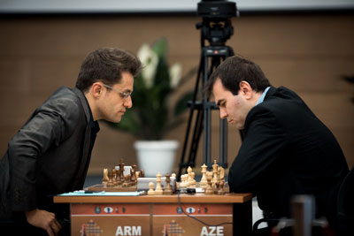
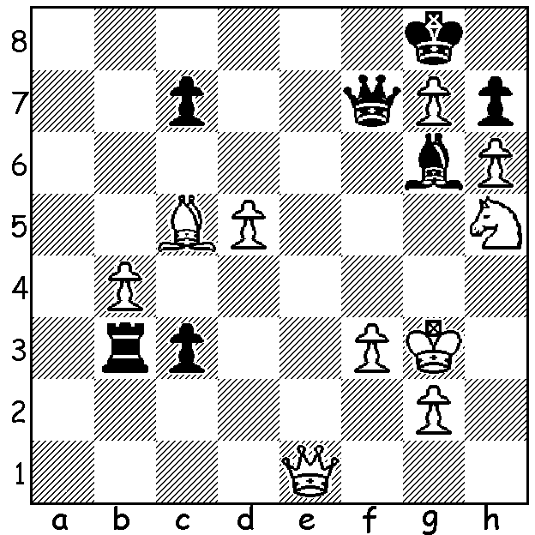

Diagram 535 Shakhriyar Mamedyarov – Levon Aronian (Candidates 2014):
a startling move by White leads to a won game (6 moves):

The struggle is on to find a challenger to new world champion, 23 year old Norwegian Magnus Carlsen, with eight of the world’s top players competing in a double round robin in Khanty-Mansiysk, Siberia, site of the 2010 Chess Olympiad. Pre-tournament favourite to win was world number 2 Levon Aronian (Armenia), the only player in the event rated above 2800. A match between Aronian and Carlsen would delight the worldwide chess community but standing in the way is ex-world champion Viswanathan Anand (India) who leads the tournament with 6/9, a point ahead of Aronian. Here is one of Aronian’s fine wins from the event:

Levon Aronian - Peter Svidler
2014 FIDE Candidates Rd 4
Grunfeld Defence
1.d4 Nf6 2.c4 g6 3.Nc3 d5
4.Nf3 Bg7 5.cxd Nxd5 6.e4 Nxc3
7.bxc3 c5 8.Rb1(a) 0-0 9.Be2 cxd
10.cxd Qa5+ 11.Bd2 Qxa2 12.0-0 b6
13.Qc1 Bb7 14.Bc4 Qa4 15.Bb5 Qa2
16.Re1 Rc8 17.Qd1 Qc2 18.Qe2 Nc6
19.Bd3 Qa2 20.Bc4 Qa4 21.Bb3 Qa3
22.Bxf7+!?(b) Kxf7 23.Qc4+ e6(c) 24.Ng5+ Ke8
25.Nxe6 Qe7 26.Nxg7+ Qxg7 27.Bc3 Nd8(d)
28.Qb3 Rc7 29.Ba1 Rac8 30.d5 Qd7
31.Qb2 Qe7(e) 32.Rbd1 Nf7 33.e5 Rc2
34.Qb5+ Qd7(f) 35.Qxd7+ Kxd7 36.e6+ Kd6
37.exf7 Rf8 38.Re6+ Kd7 39.Rf6 Re2
40.f4 Re7 41.Be5 Rexf7 42.Rd6+ Ke8(g)
43.Re1 Re7 44.Rc1 Rff7 45.Bf6 Rd7
46.Re6+ Kf8 47.d6 Kg8 48.h4 Rf8(h)
49.Bg5 Kf7 50.Rce1 Bc6 51.h5 a5
52.Re7+ Kg8 53.hxg hxg 54.R1e6 Rf7
55.Rxg6+ Kh7 56.Rh6+ Kg7 57.Ree6 resigns

a) A popular variation involving the sacrifice of the a pawn.
b) For the piece White will have two advancing passed central pawn and an exposed Black king to attack.
c) A necessary sacrifice of the e pawn to enable the queen to defend.
d) Svidler thought for 40 mins. Alternatives are 27…Ne7 and the simplifying 27…Nxd5
e) Svidler felt 31…Qf7 was better (32.Rbd1 Rc2 33.Qe5+ Kd7 34.Qg3 R8c4 35.e5! Bxd5 36.e6+ Nxe6 37.Rxd5+ Kc8).
f) Returning the piece: 34…Kf8 35.e6 Nd6 36.Qa4 with chances for both sides.
g) 42…Ke7 was necessary.
h) Not 48…Bd5 49.Re8+ Rf8 50.Re7 Rxe7 51.Bxe7 Re8 52.d7!

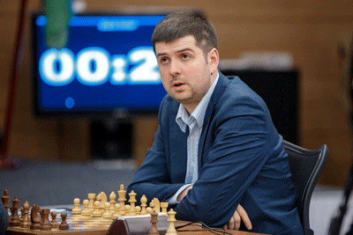
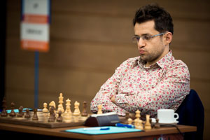

Levon Aronian Peter Svidler

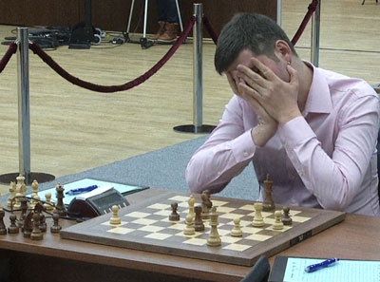
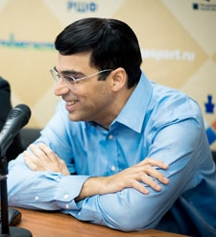

The two faces of Chess:
a happy Viswanathan Anand at a post-game interview
and a despairing Peter Svidler about to resign.

SOLUTION: 1.Qe8+!! (deflection sacrifice) 1…Qxe8 2.Nf6+ Kf7 3.Nxe8 Ra3 4.Nf6! Ra8 5.g8=Q+ Rxg8 6.Nxg8 Kxg8 7.Kf4 with a won ending.

