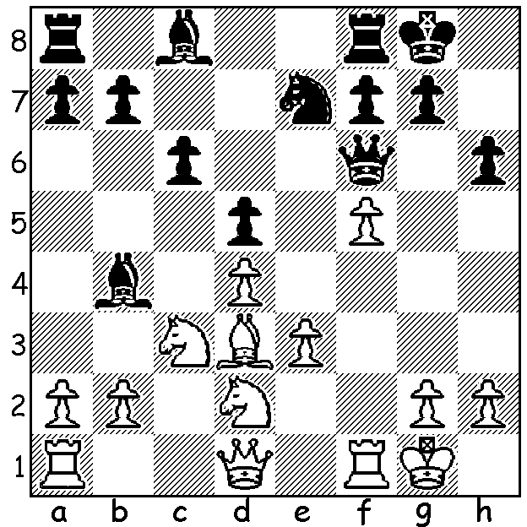
Last week we saw Mamedyarov’s winning
combination against Aronian in the Candidates.
This week the boot’s on the other foot:
Levon Aronian - Shakhriyar Mamedyarov
(Candidates 2014):
Black has just played 1…Ne7?
which White reveals as a blunder (5 moves):

The Candidates tournament in Khanty-Mansiysk, Siberia, finished earlier this week in a convincing victory for former world champion Viswanathan Anand who gains the right to a rematch with his conqueror Magnus Carlsen. Anand was unbeaten in scoring 8.5/14, a point ahead of fast finishing Sergey Karjakin (Russia) on 7.5. Other scores: Vladimir Kramnik (Russia), Shakhriyar Mamedyarov (Azerbaijan), Dmitry Andreikin (Russia) 7, Levon Aronian, Peter Svidler (Russia) 6.5, Veselin Topalov (Bulgaria) 6. After pushing Anand hard in Rd 13 in a 91 move game Karjakin defeated Aronian in the final round in another marathon lasting 94 moves.
Here is Anand’s Rd 1 game against the pre-tournament favourite. He returns a gambit pawn to gain 2B v B+N and then expertly proceeds to force queenside weaknesses to obtain a winning advantage:

Viswanathan Anand - Levon Aronian
2014 FIDE Candidates Rd 1
Ruy Lopez
1.e4 e5 2.Nf3 Nc6 3.Bb5 a6
4.Ba4 Nf6 5.0-0 Be7 6.Re1 b5
7.Bb3 0-0 8.h3 Bb7 9.d3 d5(a)
10.exd Nxd5 11.Nbd2 Qd7 12.Nxe5 Nxe5
13.Rxe5 Nf6 14.Re1 Rae8 15.Nf3 Bd6
16.Be3 Re7 17.d4 Rfe8 18.c3 h6(b) .
19.Ne5(c) Bxe5 20.dxe5 Rxe5 21.Qxd7 Nxd7
22.Red1 Nf6 23.c4!(d) c6 24.Rac1 R5e7
25.a4 bxc 26.Bxc4 Nd5 27.Bc5 Re4
28.f3 R4e5 29.Kf2 Bc8 30.Bf1 R5e6
31.Rd3 Nf4 32.Rb3 Rd8 33.Be3 Nd5
34.Bd2 Nf6 35.Ba5 Rde8 36.Rb6 Re5
37.Bc3 Nd5 38.Bxe5(e) Nxb6 39.Bd4 Nxa4(f)
40.Rxc6 Rd8 41.Rc4 Bd7 42.b3 Bb5
43.Rb4 Nb2 44.Bxb5 axb5 45.Ke3 Re8+
46.Kd2 Rd8 47.Kc3 resigns(g)

a) A Marshall Gambit type move giving up a pawn for open lines and attacking chances while White’s development is lagging behind. .
b) 18…Qf5 or 18…Nd5 19.Bd2 Rxe1+ 20.Nxe1 both seem preferable
c) Returning the extra pawn but gaining the advantage of 2B v B+N in an open position.
d) White will force serious weaknesses on Black’s queenside.
e) Even better was 38.Rxc6.
f) Maintaining material equality but will the knight escape? Black has a few combinative tricks ahead to try and save the cut off piece.
g) 47…Nd1+ 48.Kc2 wins the knight. A fine positional win by the recently deposed world champion against the favourite. With the other three games drawn Anand takes an early lead he was never to relinquish.

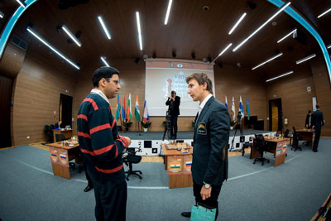
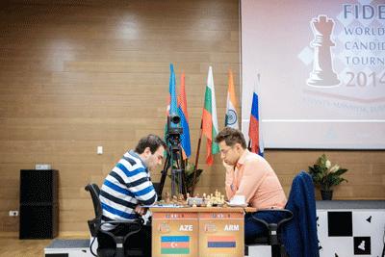

Aronian (rt) v Mamedyarov Anand & Karjakin discussing their Rd 13 game

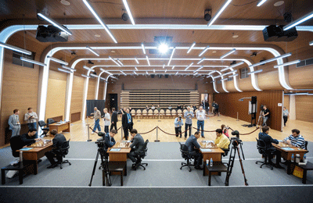

The playing arena Attentive spectators

WILLETTON OPEN (WA Grand Prix) will be held at N. Woodvale Primary on Easter Sunday and Monday, 20 – 21 April. Details cawa.org.au

SOLUTION: 2.N(d)e4!! dxe4 3.Nxe4 Qh4 4.g3 Qh3 5.Nf2 Qxf1+ 6.Kxf1.

