
Emil Joseph Diemer – Helmut Loder
(Correspondence 1950):
A surprise move by White leads
to immediate resignation:

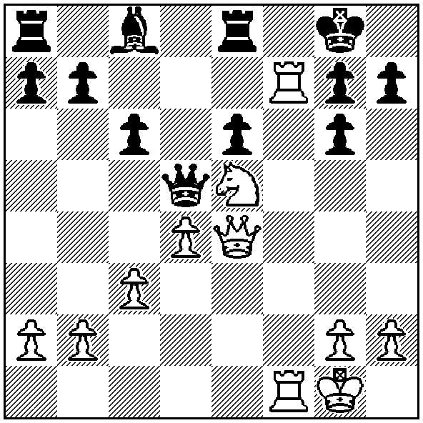
Diemer

It’s over six months since the third in an alphabet series of players who have given their name to openings. This week begins a look at the Blackmar-Diemer Gambit (1.d4 d5 2.e4). Named firstly after Armand Edward Blackmar (1826-88) its (limited) later popularity was due to the diligent efforts of Emil Joseph Diemer (1908-1990). The aim of the gambit is the utilisation of minor pieces and queen assisted by the rook on the half-open f file to attack Black’s king which normally castles kingside.
Blackmar was an accomplished violinist and pianist who, with his brother Henry, founded the Blackmar Brothers Music Publishing House which operated out of New Orleans. Their issue of six editions of the ‘The Bonnie Blue Flag’, a song which became such a popular rallying cry for the South, led to Blackmar being arrested and fined on the orders of Union general Benjamin Butler.
Blackmar published analysis of his innovative opening gambit which he used with some success. Here are three short games of his all beginning with 1.d4 d5 2.e4 dxe 3.f3 exf:

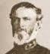
Blackmar - Farra (France 1881)
4.Nxf3 e6 5.Bd3 Nf6
6.c3 Be7 7.0-0 Nc6
8.Nbd2 h6 9.Ne4 0-0
10.Nfg5! hxg5 11.Nxg5 Bd7
12.Rxf6! Bxf6 13.Qh5 Re8
14.Bh7+ Kh8 15.Nxf7#

Armand Edward Blackmar

Blackmar – A. Lapeyre (France 1882)
4.Nxf3 e5 5.d5 e4 6.Ne5 Bd6
7.Bb5+ c6 8.dxc Qa5+ 9.Nc3 Ke7
10.Qd5! Be6 11.Qxe6+! fxe6 12.cxb Bxe5
13.bxa8=Q Bxc3 14.bxc3 Qxc3+ 15.Ke2 Qxc2+
16.Bd2 Nd7 17.Rhc1 Qb2 18.Bxd7 Kxd7
19.Qc8+ Ke7 20.Rc7+ Kf6 21.Qf8+ Ke5
22.Rc5+ Kd4 23.Qd6#

Blackmar - L. S. Atkinson
Correspondence 1884
4.Nxf3 Bf5 5.c3 e6 6.Bc4 Be7
7.0-0 Nf6 8.Nbd2 c6 9.Ne5 Bg6
10.Ndf3 Nbd7 11.Qe2 Bh5 12.Qe1 Bxf3
13.Nxf7! resigns

GUFELD CUP (WA Grand Prix) will be held on Easter Sunday and Easter Monday, April 20, 21, 10am – 5.30pm. Information on cawa.org.au and enquiries 0439798607.

KALGOORLIE CHESS CLUB: anyone interested whatever standard or wanting to learn please contact David Walker (past WA Reserves Champion) dwalk@operamail.com or 0438427062.

CAFÉ DI MONDO in the centre of Midland Farmers Market provides the opportunity to play chess on Sundays 10 – 12.

SOLUTION: 1,Nxg6!! if 1…Qxe4 2.Ne7+ Kh8 3.Rf8+ Rcf8 4.Rxf8# (or 2.Rf8+! Rxf8 3.Ne7+ Kh8 4.Rxf8#): if 1…hxg6 2.Qxg6 and mates.

