
Diemer – Roller (1952):
White’s next move leads to immediate resignation:
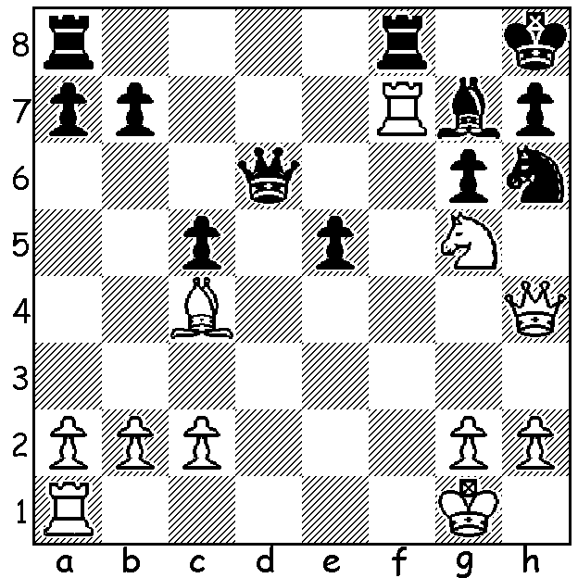

Last week we began a look at the Blackmar-Diemer Gambit (1.d4 d5 2.e4) with its aim of directing the minor pieces and queen, assisted by the rook on the half-open f file, against Black’s king which normally castles kingside. Named firstly after Armand Edward Blackmar (1826-88) it was refined and its theory developed through the diligent efforts of Emil Joseph Diemer (1908-1990). While after 2…dxe Blackmar played 3.f3 Diemer played 3.Nc3 before 4.f3 (after 3…Nf6 or 3…Bf5). He played the gambit at virtually every opportunity and was convinced of its strength. “Play the Blackmar-Diemer Gambit and mate will come by itself,” he wrote. In 1953 as an evangelist for the Blackmar-Diemer he began publishing a magazine devoted wholly to the gambit. Publication ceased in 1956 when Diemer’s creditors became too impatient and withdrew support. In the main line after 4…exf Diemer played both 5.Nxf3 and 5.Qxf3 offering a second pawn. This week games (and puzzle) with 5.Nxf3:

1.d4 d5 2.e4 dxe 3.Nc3 Nf6 4.f3 exf 5.Nxf3

Diemer – Meir Rauch 1953
5…e6 6.Bg5 Be7
7.Bd3 Nbd7 8.Qe2 0-0
9.0-0 c6 10.Qf2 Qc7
11.Qh4 h6 12.Bxh6! gxh6
13.Qxh6 Re8 14.Ng5 Bf8
15.Bh7+ Kh8 16.Nxf7#
(an identical mating pattern to Blackmar – Farra from last week)

Diemer – Fleishmann 1954
5…e6 6.Bg5 c5
7.Bxf6 gxf6 8.d5 e5
9.Bc4 Nd7 10.d6 Nb6
11.Bxf7+! Kxf7 12.Nxe5+! fxe5
13.0-0+ Kg8 14.Ne4 Bg7
15.Qh5 Be6 16.Rf3 Nd5
17.Rg3 Nf4 18.Rxg7+! Kxg7
19.Qxe5+ Kg8 20.Qxf4 Qf8
21.Nf6+ Kg7 22.Qg5+ Kf7
23.Rf1 resigns

Diemer - Bacl 1950
5…g6 6.Bc4 Bg7
7.0-0 0-0 8.Bg5 c5
9.d5 Nbd7 10.d6 e6
11.Qe1 h6 12.Qh4 hxg5
13.Nxg5 Nh5 14.g4 Ndf6
15.Rxf6! Qxf6 16.Nce4 Qd4+
17.Kh1 Qxc4 18.gxh5 f5
19.hxg6 Rd8 20.Nf6+! Bxf6
21.Qh7+ resigns

Diemer – J. Kotek 1956 (correspondence)
5…g6 6.Bc4 Bg7
7.0-0 0-0 8.Bg5 Bd7
11.Qe1 h6 12.Qh4! Kh7
13.Rae1 Nc6 14.d5 Na5
15.Bd3 b6 16.d6! cxd
17.Rxe7! Qxe7 18.Nd5 Qe5
19.Nxf6+ Bxf6 20.Bxf6 Qe3+
21.Kh1 Kg8 22.Ng5! resigns
(22…h5 23.Qxh5! gxh5 24.Bh7#)

Diemer – Wolfgang Ludwig 1973 (correspondence)
5…Bf5 6.Ne5 e6
7.g4 Bg6 8.Qf3 c6
9.g5 Nh5 10.Be3 Nd7
11.0-0-0 Nxe5 12.dxe5 Qc7
13.Bg2 Qxe5? 14.Qxc6+!! bxc6
15.Bxc6+ Ke7 16.Rd7+ Ke8
17.Rd5+ Ke7 18.Bc5+ Qd6
19.Rxd6 & wins quickly
(if 19…Rc8 20.Rhd1)

SOLUTION: 1.Qxh6! (deflection) resigns (1…Bxh6 – 1…Qd4+ doesn’t help - 2.Rxh7#).

