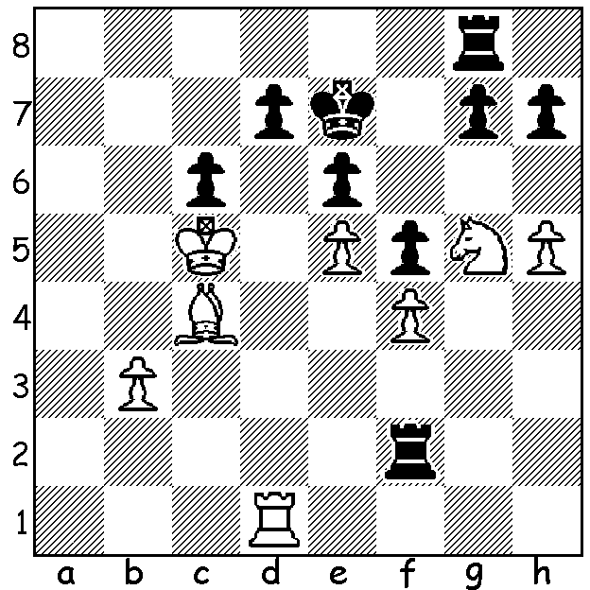

I fell foul of a nice combination
from Gary Donaldson at the recent
Gufeld Cup: White to play and win:

The second of this year’s WA Grand Prix events, the Gufeld Cup, was played over Easter at the Perth Club in Woodvale. Winner with a picket fence 6/6 was Ihsan Ferozkohi with Gordon Dunlop (5) second and husband and wife Andrew and Kathryn Hardegen together with Ned Tomic equal 3rd with 4. Junior Ignatius Yap (4) won the first rating prize closely followed by Gary Donaldson and Gavin Adam (3.5). Best unrated players were Aayush Bhardwaj and Parekh Sahil (both 3). Interestingly among the 20 players there were 3 family groupings, husband and wife, father and son and brothers. Adam Kelly, now 17, is one of a number of WA’s talented junior players and he had wins against both Andrew and Kathryn.

Adam Kelly - Kathryn Hardegen
2014 Gufeld Cup
Kings Indian Saemisch

1.d4 d6 2.e4 Nf6
3.f3 c5 4.d5 g6
5.c4 Bg7 6.Nc3 a6
7.Bg5 Nbd7 8.Qd2 h6
9.Be3 Ne5 10.h3 g5
11.h4 g4(a) 12.f4 Ned7
13.Nge2 b5 14.Ng3 b4
15.Nd1 Nb6 16.Bd3(b) Qc7
17.0-0 a5 18.Nf2 a4
19.Rae1 Ba6 20.b3 Nfd7
21.Nd1 Bf6 22.e5 dxe
23.fxe Nxe5 24.Bf4 0-0-0(c)
25.Qe2(d) Nf3+! 26.Rxf3!(e) gxf3
27.Bf5+ Nd7 28.Qxf3 Qb6
29.Ne4 Bd4+ 30.Ne3 e5(f)
31.dxe6 Ne5(g) 32.e7+ Rd7
33.Bxe5 Bxe5 34.Nd5 Bd4+
35.Kh1 Qc6 36. Bxd7+ Kxd7
37.Qxf7 resigns

a) Black could preface this with 11…Nh5 (12.Bf2 g4).
b) White’s natural break e5 would be premature: 16.e5 dxe 17.fxe Nfxd5! cxd5 18.Bxe5.
c) Black misses 24…Nxd5! when a possible exciting and very complicated continuation might be 25.Nh5 Nxf4 26.Nxf6+ exf6 27.Qxf4 0-0-0 28.Qxf6 Nxd3 29.Qxa6+ Qb7 30.Qxb7+ Kxb7 31.Re7+ Kc8 32.Rfxf7 Rhe8 33.Rc7+ Kb8 34.Rb7+ Ka8 Draw.
d) Not 25.Qe3 Nxd5! 26.Bxe5 Nxe3
e) A fine exchange sacrifice giving White a strong attack: the alternative 26.Qxf3 leaves Black better after 26…gxf3 27.Bxc7 Kxc7.
f) Better the pinning 30…Bb7
g) Losing quickly – 31…fxe 32.Nd6+ Kb8 33.Nb5+ e5 34.Nxd4 cxd4 35.Nd5 with attack.

The DOEBERL CUP, played over Easter in Canberra, is one of Australia’s most prestigious tournaments and this year attracted over 300 players in four sections with eight Western Australians making the cross country trip to compete. Hopefully a detailed report next week.

SOLUTION: 1.Rxd7+! Kxd7 2.Bxe6+ Ke7 3.Bxg8 & wins.

