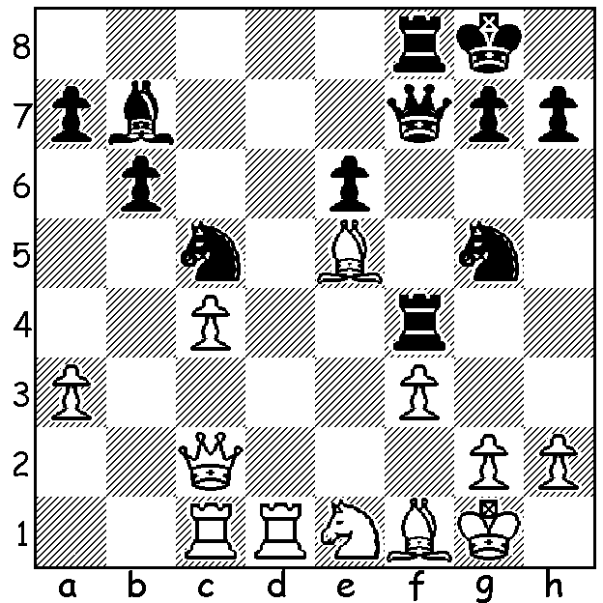
Diagram 540
In a tournament such as the Australian Championship
the pairing of two West Australians might either result
in a friendly short draw or be played to the death with
the intensity of an Eagles-Dockers Derby.
The last round Doeberl Cup game between Yita Choong and Leon Taylor ended with Leon (Black) unleashing a
fierce sacrificial attack which Yita was unable to withstand:

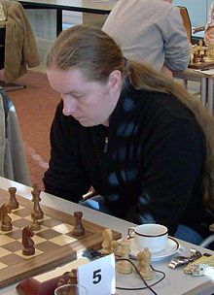
The DOEBERL CUP, played over Easter in Canberra,
one of Australia’s most prestigious tournaments, in this
its 52nd year attracted over 300 players in four sections
with eight Western Australians making the cross country
trip to compete. The top tournament, the Premier, was won
by Romanian GM Liviu Dieter Nispeanu (now resident in
Germany) on tie-break from fellow Romanian GM Levante
Vajda after both finished on 7.5. Top Australians in =5th
place were Stephen Solomon, Moulthon Ly & Andrew
Brown (6.5). WA scores: WA champion Tristan Boyd &
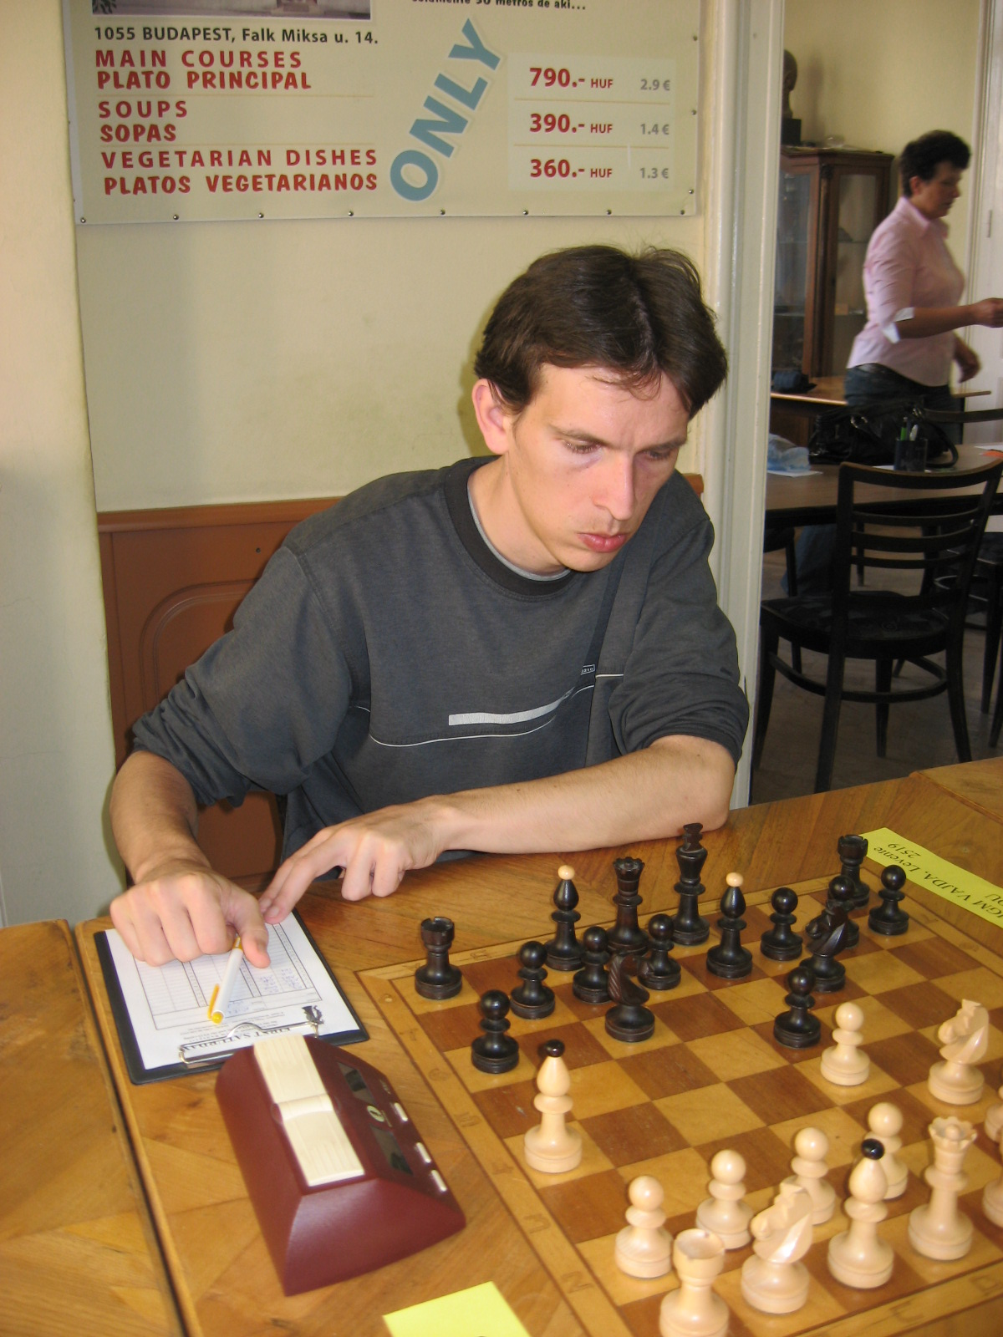
Leon Taylor 5, Yita Choong 4, Marc Vliestra, & Australian Under 16 champion George Carolin-Unkovich 3.5, Dennis Holland 3, Edik Gilmetdinov 2.5. Evan Yeung scored 2.5/7 in the Major.

A highlight of the week was the visit of former world champion Gary Kasparov who spent considerable time in book signing and photo shoots. Kasparov was seeking support for his candidacy for FIDE president.

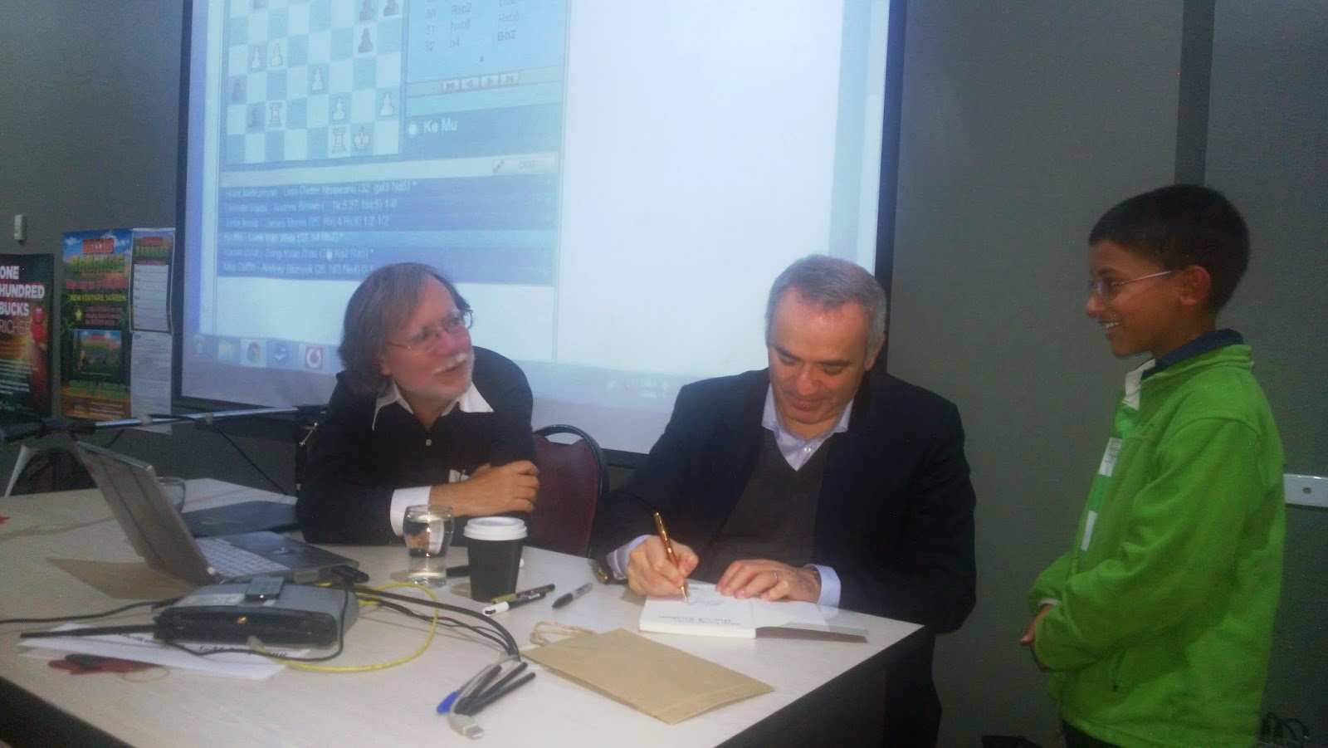

Top scorers at Doeberl,
Nispeanu (top)& Vadja
Gary Kasparov (rt) book signing for a
young fan watched by Ian Rogers

Here is one of Leon Taylor’s wins from the event in which he essays a slighter dubious gambit but with sharp play presents his opponent with problems he is unable to solve:

Leon Taylor - Svetozar Stojic
2014 Doeberl Cup, Canberra
Sicilian Defence, Wing Gambit
1.e4 c5 2.a3 Nc6
3.b4 cxb 4.axb Nxb4
5.c3 Nc6 6.d4 d5
7.exd Qxd5 8.Na3 e5
9.Nb5 Bd6 10.Qf3 Qxf3(a)
11.Nxd6+ Kd7 12.Nxf3 Kxd6
13.Ba3+ Ke6?(b) 14.d5+! Kxd5
15.Ng5 e4(c) 16.Nxf7 Bg4
17.Rb1 Nh6 18.Nxh8 b6(d)
19.Rb5+ Ke6 20.Bc4+ Kf6
21.h3 Bd7(e) 22.g4 g5(f)
23.h4! Nxg4 24.hxg+ Kg7
25.Nf7 Na5 26.Rxa5 bxa5
27.Bc5 Rc8 28.Bd4+ Kg6
29.Nd6 Rc6 30.Bf7+ Kxg4
31.Nxe4+ Kf4 32.Bd5 Rg6(g)
33.Rxh7 Be6 34.Ba8 Bf5
35.Rf7 Re6 36.Bxa7! Rxe4
37.Bxe4 Kxe4 38.f3+! resigns

a) Virtually a losing move. 10…e4 keeps Black in the game – 11.Bc4! exf3 12.Bxd5 Bb8 (12…fxg 13.Nxd6+ Kd7 14.Bxg2 Kxd6 15.Ba3+) 13.Nxf3.
b) Trying to save his extra pawn but exposing his king.
c) 15…Nh6?? 16.Rd1#. Now play hinges on White’s attempts to save his knight.
d) Clearly 18…Rxh8 19.Rxb7 is hopeless.
e) 21.Be6 22.Be5 Bxe5 23.Rxe5 winning.
f) Preventing 23.g5#.
g) 32…Rh6? 33.Be3+! Nxe3 34.fxe3+.

WA LIGHTNING CHAMPIONSHIP: Sunday 18 May (start 1pm) at N Woodvale Primary. Details cawa.org.au and enquiries Gordon Dunlop dunlop64@bigpond.com or 93686412.

SOLUTION: 1…Nxf3+! 2.gxf3 Rxf3 3.Ng2? Rf2 4.Qc3 Rxg2+! Resigns. White could have improved with 2.Nxf3 (2…Qxf3 3.Bg2 Qe3+ 4.Kh1 Rf2 5.Rd8+ Kf7 6.Qxf2 Qxf2 7.Bxb7 Nxb7 8.Rd7+ Ke8 9.Rxg7 Qf3+ 10.Rg2 Nc5 when Black will need to work hard for a win).

