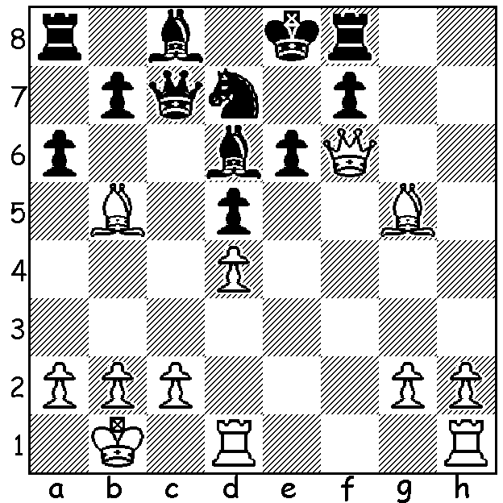

Diemer –Toth (1948):
White quickly breaks through:

Blackmar-Diemer Gambit (Part III)

The previous article on the Blackmar-Diemer Gambit four weeks ago centred on Emil Joseph Diemer’s development of the gambit and his successes with 5.Nf3. This week a look at his games with the offer of a second pawn with 5.Qxf3. But first a little more about the man himself. As a player he never gained great success with his best results being 1st Hastings Reserves 1936 and 1937, 1st Swiss Championship 1952. Consequently he struggled financially throughout his life. A fanatic, Diemer devoted his life to whatever was his current interest. He joined the National Socialist party and was given the role of chess correspondent, travelling around Europe to report on important international tournaments. Prior to the publication of his magazine on the gambit (1955-6) he was expelled from the German Chess Federation. He later moved to the Netherlands, giving up serious chess to follow even more passionately the study of Nostradamus. He mailed over 10,000 letters on Nostradamus and claimed he had cracked the seer’s secret code. In 1965 he was committed to a psychiatric clinic and while there he was not permitted to play chess on the grounds it was too stressful. As he aged, with his gaunt features and flowing white beard, his appearance more and more matched the eccentric personality he had been throughout his life.

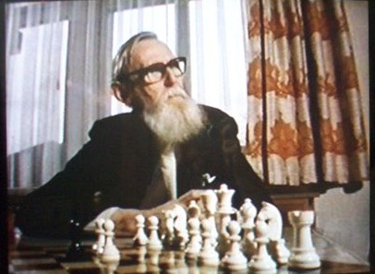
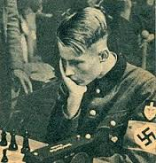

1.d4 d5 2.e4 dxe 3.Nc3 Nf6 4.f3 exf 5.Qxf3

Diemer – Schickner 1950
5…Qxd4 6.Be3 Qb4
7.0-0-0 c6 8.Rd4 Qa5
9.Be2 e5 10.Ra4 Qc7
11.Nh3 Be7 12.Rf1 h6
13.g4 Be6 14.g5 hxg
15.Nxg5 Nbd7 16.Nxe6 fxe6
17.Qg2 0-0-0 18.Rxa7 Nb8
19.Na4 Nfd7 20.Ra8 Qd6
21.Rd1 Qb4 22.Bb6 Nxb6
23.Qxc6+!! bxc6 24.Ba6+ Kc7
25.Ra7#

Diemer – Waller 1948
5…Qxd4 6.Be3 Qd8
7.Rd1 Nbd7 8.Bc4 e6
9.Nh3 h6 10.0-0 c6
11.a3 Qc7 12.Ne4 Ne5
13.Nxf6 gxf6 14.Qxf6 Ng4
15.Rd8+! resigns

Diemer – Klaus Locher 1949
5…c6 6.Bd3 Qxd4
7.Nge2 Qg4 8.Qf2 e5
9.h3 Qb4 10.a3 Qb6
11.Be3 Qc7 12.Bxa7 Be6
13.Bb6 Qc8 14.0-0 Nbd7
15.Be3 Bd6 16.Ng3 0-0
17.Nf5 Bxf5 18.Bxf5 Qc7
19.Rad1 Rad8 20.Qh4 g6
21.Bh6 Rfe8 22.Bxd7 Nxd7
23.Ne4 Be7 24.Rxd7! Rxd7
25.Nf6+ Kh8 26.Bg7+! resigns

SOLUTION: 1.Rhd1! is decisive, eg 1…axb5 2.Rxe6+! fxe6 3.Qxe6+ Be7 4.Qxe7# or 1…e5 2.dxe Bb4 3.e6! axb5 4.exf#.

