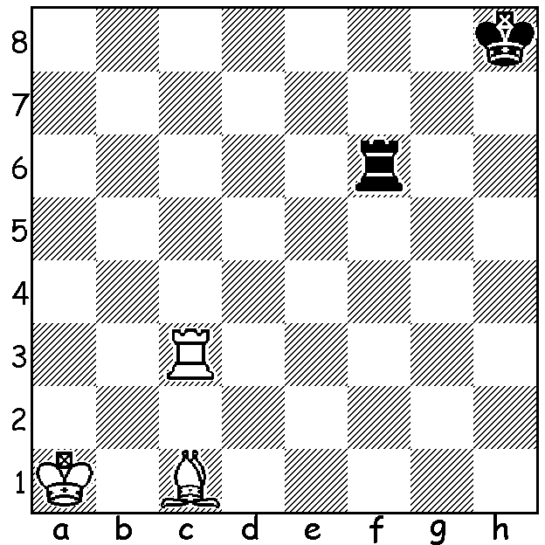
Diagram 543:
An elegant problem by
R.Bianchetti 1928:
White to play and win
(2 variations on Black’s first move):

The second major tournament of the Metropolitan Club in Nedlands, the Metro Open, has recently started. The club begins its season early in the year with its club championships, divided into four or five rating sections of about ten players. Winner of the premier event this year and club champion for the fifth year running is Yita Choong with 8.5/9 with Ihsan Ferozkohi runner-up on 7. Other division winners and runners-up: B – Adam Kelly 7.5/9 and Robin Shaw 6 (unbeaten): C – Dougal McLean 8/8 and Brian Gale 5.5: D – Stewart Hunt 8/10 and Ben Hunt 7.5. Here are a couple of games from the championship, in both the winner sacrifices pawns on the queenside for an attack resulting in an attack against the king, the first with a gambit, the second in forceful middlegame play:

George Carolin-Uncovich - Richard Lilly
2014 Metro Championship, Rd1
French Defence, Wing Gambit
1.e4 e6 2.Nf3 d5
3.e5 c5 4.b4 cxb
5.a3 Nc6 6.axb Bxb4
7.c3 Be7 8.d4 f6
9.Bd3 fxe 10.dxe Nh6
11.Bxh6 gxh6 12.0-0 Qc7
13.Re1 Bd7 14.Na3 0-0-0
(Despite the broken kingside Black would be better castling there as White is able to use the half –open files on the queenside to attack the king.)
15.Nb5 Qb8 16.c4 Be8
17.Qb3 Bg6 18.Nfd4 a6
19.cxd Nxd4 20.Nxd4 Bxd3
21.Rac1+ Kd7 22.Qxd3 Bg5
23.Rc2 exd5 24.Qf5+ Ke8
25.Qe6+ Be7 26.Nf5 Rd7
27.Nd6+ resigns

Winner is the current Australian Under 16 champion while his opponent was WA champion in 1973 & 1974 and winner of the Metro Championship 8 times from 1962 to 1995.

Michael Kueh - Gordon Dunlop
2014 Metro Championship, Rd 6
Queens Gambit, Exchange Variation
1.d4 d5 2.c4 e6
3.Nc3 Nf6 4.cxd exd
5.Bg5 Be7 6.Qc2 0-0
7.e3 Nbd7 8.Bd3 h6
9.Bf4(a) c6 10.Nf3 Re8
11.0-0-0 b5 12.g4 b4
13.Na4 Nb6 14.h3 Nxa4
15.Qxa4 c5 16.dxc Bd7
17.Qxb4 Rc8 18.Kb1 Rxc5
19.Qd2 Qb6 20.Nd4 Ba4
21.Rc1 Rec8 22.Rxc5 Rxc5
23.Rc1 Ne4 24.Bxe4 dxe4
25.Nf5 Rxc1+ 26.Qxc1 Bf6(b)
27.Nd6 Qb4 28.Nf5(c) Bb5
29.Bd6 Bd3+ White resigns(d)

a) 9.h4!
b) Black’s bishops together with the queen become a formidable attacking combination.
c) If now 28.Qc8+ Kh7 29.Qf5+? g6! 30.Qxf6 Qe1#.
d) 30.Ka1 Bxb2+! 31.Qxb2 Qe1+.

SOLUTION: 1.Bb2 (threatening to win by 2.Rc6 or Rf3): Black must move the rook and keep it close to king on f8 or h6 (1…Kh7 Rc7+ or 1…Kg8 2.Rg3+). If 1…Rf8 2.Rc7+ Kg8 3.Rg7+ Kh8 4.Ka2! (Black is in zugzwang having to move his rook away from his king eg 4…Ra8+ Ra7+, 4…Rf2 Rg2+ while if 4…Rg8 5.Rf7+. Note 4.Kb1 allows stalemate opportunities - 4…Rf1+ 5.Kh2 Ra1+! 6.Kg3 Ra3+! 7.Kc4 Rc3+! Draw.) If 1…Rh6 2.Rg3+ Kh7 3.Rg7+ Kh8 4.Kb1! with similar ideas to Variation I.

