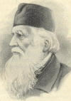
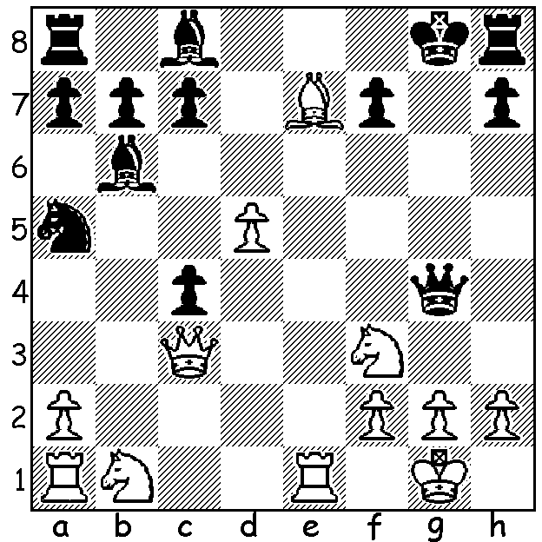

William Davies Evans – George MacDonnell:
White mates in 3 moves:

The letter E in our alphabet series on players who have openings or defences named after them provides us with Captain William Davies Evans, a Welshman who lived from 1790 to 1872. Very much an amateur, Evans did not learn the game until he was 28 and his work as a sea captain, principally for the Royal Mail Packet Service and the P & O Company, prevented his regular participation in the game. While he has left a legacy to chess in the form of the Evans Gambit, his greater achievement, far more important to the world at large, was his system of green, red and white lights for maritime safety at night which was adopted by the British Admiralty in 1848 and subsequently by many other nations. He was awarded £1500 by the British Government for his invention and presented with a gold chronometer by the Tsar of Russia.
The Evans Gambit, an offshoot of the Giuoco Piano, at the cost of one or two pawns, seeks to gain control of the centre and a lead in development. After 1.e4 e5 2.Nf3 Nc6 3.Bc4 Bc5 4.b4 Bxb4 5.c3 Ba5/c5/e7 6.d4 a lively game ensues.

William Davies Evans - Alexander McDonnell
London, circa 1825
1.e4 e5 2.Nf3 Nc6
3.Bc4 Bc5 4.0-0(a) d6
5.b4 Bxb4 6.c3 Ba5
7.d4 Bg4 8.Qb3 Qd7(b)
9.Ng5! Nd8 10.dxe dxe
11.Ba3 Nh6 12.f3 Bb6+
13.Kh1 Bh4(c) 14.Rd1 Qc8
15.Rxd8+?(d) Qxd8 16.Nxf7! Qh4?(e)
17.Qb5+ c6 18.Qxe5+ Kd7
19.Qe6+ Kc7 20.Bd6#

- Evans played the gambit on both the 4th (the accepted ‘book’ move) and the 5th move.
- 8…Bxf3 is better (9.gxf3 exd 10.Qxb7 Ne5 Santasiere-Marshall 1926).
- 13…Be6 is necessary.
- Unnecessarily speculative – 15.Qb5+ Nc6 16.Bd5 wins.
- Losing as does 16…Nxf7 17.Bb5+ c6 18.Qe6+ or 16…Bxf7 17.Bxf7+ Nxf7 18.Qe6+. 16…Qf6! seems to give Black the better chances (17.Nxh8? 0-0-0 gives Black a very strong game as White has great difficulty completing his development while 17.Qa4+ c6 18.Nd6+ Kd7 19.Nxb7 Bxf3! 20.Nd2 Bxg2+ 21.Kxg2 Ng4 22.Bc5 or Nc5+ leaves the result uncertain).

The gambit appeared to be virtually extinct until resurrected by Kasparov in a vital game against Anand in the 1995 Tal Memorial:

Gary Kasparov - Viswanathan Anand
1995 Tal Memorial, Riga
1.e4 e5 2.Nf3 Nc6
3.Bc4 Bc5 4.b4 Bxb4
5.c3 Be7 6.d4 Na5
7.Be2 exd 8.Qxd4! Nf6
9.e5 Nc6 10.Qh4 Nd5
11.Qg3 g6 12.0-0 Nb6
13.c4! d6 14.Rd1 Nd7
15.Bh6 Ncxe5 16.Nxe5 Nxe5
17.Nc3!(a) f6 18.c5 Nf7?(b)
19.cxd cxd(c) 20.Qe3 Nxh6
21.Qxh6 Bf8 22.Qe3+ Kf7
23.Nd5 Be6 24.Nf4 Qe7
25.Re1 resigns(d)

- Better than 17.Bg7 Bf6!
- Losing – 18…Bd7 gives Black good prospects.
- If 19…Bxd6 20.Bb5+ c6 21.Re1+.
- If 25…Bh6 26.Bc4: if 25…Bd7 26.Qb3+ Kg7 27.Bb5 Qd8 28.Bxd7 Qxd7 29.Ne6+: if 25…Re8 26.Nxe6 Qxe6 27.Bc4 Qxc4 28.Qxe8+ Kg7 29.Rac1.

SOLUTION: 1.Qxh8+!! Kxh8 2.Bf6+ Qg7 (or 2…Kg8) 3.Re8#.

