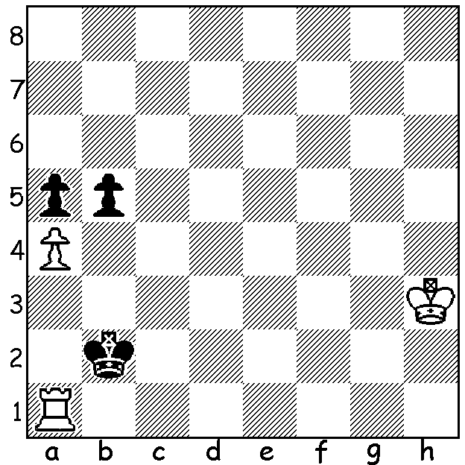

Diagram 545: M Grinfeld 1903:
White to play and win (5 moves):

The 2014 Chess Olympiad will be played in Tromso, Norway, from August 1 -15, a fitting venue after Norway’s Magnus Carlsen’s ascendancy to world champion. The Australian team will be David Smerdon, Moulthon Ly, Max Illingworth, Junta Ikeda and Anton Smirnov while the Women’s team is Arianne Caoili, Irina Berzena, Giang Nguyen, Emma Guo and Bikjan Dekic. Over the next few weeks I shall be writing about each of the Australian team, starting with David Smerdon who was born in 1984 in Brisbane. He became an IM at the age of 14, was Australian Junior champion in 1999 and became a GM in 2009. He won the 2009 Queenstown Classic and last year won the 6th Batavia Tournament in Amsterdam. He is a full-time chess player at present domiciled in Europe. His play is noted for his extremely adventurous style, ever ready to sacrifice for promising attacks. Here is a recent game from the British 4 Nations Chess League against one of the top English GMs:

John Emms – David Smerdon
4 Nations Chess League (UK) 2012-13
Scandinavian Defence
1.e4 d5 2.exd Nf6
3.Nf3 Bg4 4.Bb5+ Nbd7
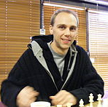
5.h3 Bh5 6.c4 e6(a)
7.dxe fxe 8.d4 c6
9.Ba4 Nb6 10.Bb3 Bb4+
11.Nc3 0-0 12.Be3 a5
13.a3 Bxc3+ 14.bxc3 a4
15.Ba2 Qe7 16.g4 Bg6
17.Ne5 Be4 18.f3 Nfd7!?(b)
19.fxe4 Nxe5 20.dxe5 Qh4+
21.Ke2 Qg3 22.Rf1(c) Qg2+
23.Rf2(d) Rxf2+ 24.Bxf2 Rf8(e)
25.Qd4(f) Qf3+ 26.Ke1 Qh1+
27.Bg1 c5(g) 28.Qe3 Rf3
29.Qxc5 Nd7 30.Qd4 Nxe5!(h)
31.c5 Rf8 32.Bxe6+ Kh8
33.Qe3 Qg2 34.Bf5 Nf3+
35.Kd1 Rd8+ 36.Kc1 Rd2
37.Qxf3 Rc2+ 38.Kb1 Rb2+
White resigns

a) This seems to be a novelty. Black’s gambit hopes to gain some play on the f file.
b) The dual symbol !? is given as ‘speculative attempt to complicate’ in MCO – a fitting description here.
c) A perpetual check is very possible after 22.Bxb6: 22…Qg2+ 23.Kd3 Rad8+ 24.Bxd8 Rxd8+ 25.Ke3 Qg3+! 26.Qf3 Rd3+! 27.Kxd3 Qxf3+ 28.Kd4 Qf2+.
d) Better 23.Kd3 – 23…Nd7 24.Qe2 Nxe5+ 25.Kd2 Nf3+ 26.Rxf3 Qxf3 27.Qxf3 Rxf3 28.Rh1 with winning prospects.
e) Black is not interested in the draw – 24…Qxe4+ 25.Be3 Qg2+ 26.Bf2 Qe4+ 27.Kf1 Qh1+ 28.Ke2 Qe4+.
f) 25.Qg1 keeps White very much alive – 25…Qxe4+ 26.Kd2 Nxc4+ 27.Bxc4 Qxc4 with about equal chances.
g) A tempo gaining pawn sacrifice.
h) White is now lost.

The South West Open starts tomorrow (11am) at Bridgetown Civic Centre and concludes Sunday. Today is the last day for entries; contact Gordon Dunlop g-dunlop64@bigpond.com or 9368 6412. Sadly organizer, CAWA Secretary Norbert Muller, is unable to attend and officiate after suffering serious injuries after a roof fall. I’m sure the whole WA chess community would want to wish him a speedy recovery.

SOLUTION: Clearly with his king so far away White cannot move his attacked rook allowing 1…bxa and 1.axb Kxa1 2.b6 a4 3.b7 a3 4.b8=Q a2 gives the book draw of Q v rook’s pawn on 7th. White’s win is the deflection 1.Ra3!!: if 1…Kxa3 2.axb a4. 3.b6 Kb2 (or Ka2) 4.b7 a3 5.b8=Q(+) while if 1…b4 2.Rg3 b3 3.Rg5 Ka3 4.Rxa5 (4….b2 Rb4) 4…Kb4 5.Ra8 b2 6.Rb8+ or 6.a5! b1=Q 7.Rb8+.

