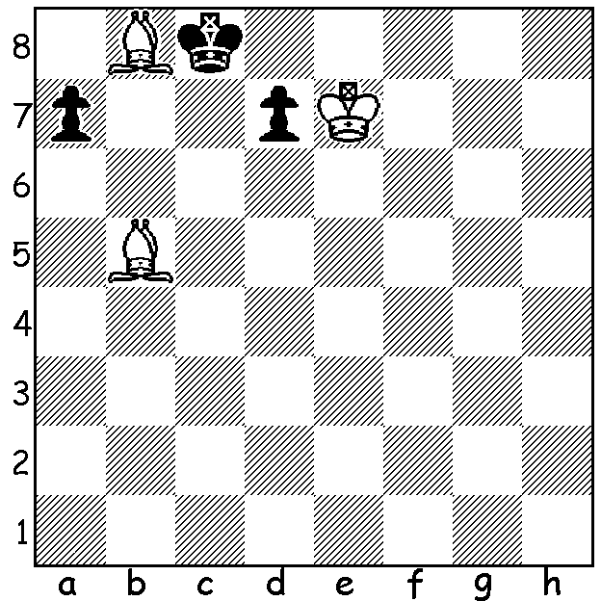
Continuing our look at the Australian Olympiad team with
Board 3 Max Illingworth who this year won the Australian
Championship. Born in November 1992 in Sydney, Max really
came to the fore in 2012 when he won the Queenstown Chess
Classic, NSW championship, scored 7/10 in the Olympiad,
became an International Master and was Australian Player of
the Year. Other achievements include being runner-up in the
Australian Open 2013 and NSW champion 2011-13.

Max Illingworth - Blair Mandla A D’Orville 1842:
2011 Australian Open White to play and mate in 4:
Nimzoindian: Rubinstein Variation
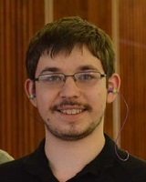
1.e4 d5 2.exd Nf6
3.c4 c6 4.d4(a) cxd
5.Nc3 e6 6.Nf3 Bb4
7.Bd3 dxc 8.Bxc4 Nc6
9.0-0 0-0 10.a3 Be7(b)
11.Qd3 b6 12.Bg5 Bb7
13.Rad1 Rc8 14.Ba2 Nd5
15.Bb1 g6 16.h4(c) Nb8(d)
17.Bh6(e) Nxc3+ 18.bxc3 Ba6
19.Qe3 Bxf1 20.Bxf8 Bxf8
21.Kxf1 Qc7 22.Rd3 Bxa3
23.h5 Bd6 24.Ba2 Bf4
25.Qe4 Nd7 26.hxg hxg
27.g3 Bc1(f) 28.Rd1 Bh6
29.Bxe6(g) fxe6 30.Qxg6+ Bg7
31.Qxe6+ Kf8 32.d5(h) Nf6?(i)
33.Ne5 Bh8 34.d6 resigns Max Illingworth

a) 4.dxc is not recommended as Black gains a positional advantage after 4….Nxc6.
b) The game began as a Scandinavian Defence, transposed into the Botvinnik-Panov Attack in the Caro-Kann before a further transposition to the Nimzoindian.
c) This seems a novelty.
d) 16…Nxc3 17.bxc3 Na5 is a good alternative.
e) 17.Ne2 is logical, removing the knight from danger with the possibility of assisting in a kingside attack.
f) A useful move deflecting the rook from the 3rd rank.
g) An enterprising sacrifice, but will it win?
h) 32.Qf5+ Nf6 33.Ne5 is better.
i) Loses – 32…Re8 33.Qg6 Ne5 34.Qf5+ Qf7 and Black has the winning chances.

OLYMPIAD APPEAL: With five men and five women, together with a non-playing captain for each team, the cost of Australia’s participation in the Tromso Olympiad, Norway, starting on August, team 1, will exceed $40,000. The chess community throughout Australia has been asked to contribute generously as no government assistance is available, putting a considerable financial strain on all the players. Readers who would like to assist should check out acfappeal.aunz.org to make a donation.

This year’s South West Australian Open (23 entries), again played in Bridgetown, was won by Marc Vliestra with 6/6 with Gavin Adam (4.5) runner-up. Gyuala Plaganyi and Gary Donaldson (both 4/6) were joint WA Country champions while top rating prizes went to Gary Donaldson and Tom Webb (under 1750) and rapidly improving junior Sri Dharmapuri (under 1300), all with 4/6. The players, who hailed from Perth, Bridgetown, Albany and other SW towns as well as two visiting players from Liverpool, UK, were all appreciative of local hospitality which included fresh scones, jam and cream, cake and biscuits, tea and coffee throughout the event. Players too should be thanked for their generosity in raising over $200 towards the Australian Chess Olympiad Appeal, with a number returning their prizes.

SOLUTION: 1.Ba6+! Kxb8 2.Kd6 (zugzwang) Ka8 3.Kc7 d6/5 4.Bb7#.

