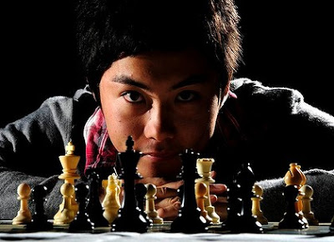
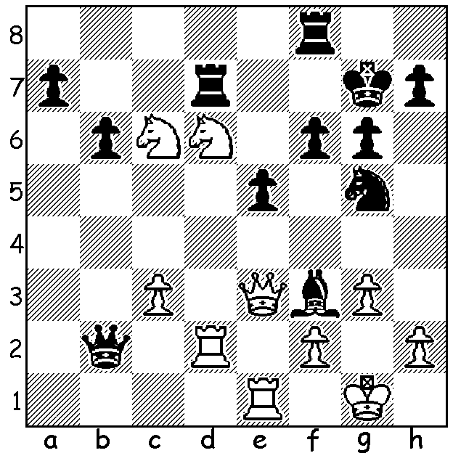

Yin Wenlin – Junta Ikeda:
with White threatening Rxb2 & Nf5+,
Black has to act decisively: Junta Ikeda in 2012

We continue our look at the 2014 Australian Olympiad team this week with Board 4 Junta Ikeda. Junta was born in 1991 and is one of a group of young players rising to the top in Australian chess. He was Australian Junior Champion in 2008 and became an IM (International Master) in 2010. He has gained valuable experience overseas and in 2013 won the Japanese Championship with the fine score of 9.5/11. His game below against another Australian rising star shows a real maturity in pursuing long term goals and is a refreshing change from the more tactical games which tend to dominate this column week by week:

Junta Ikeda - Andrew Brown
2014 ANU Masters (Canberra)
Sicilian: Rossolimo Attack
1.e4 c5 2.Nf3 Nc6
3.Bb5 g6 4.0-0 Bg7
5.c3 Nf6 6.d4 a6(a)
7.Ba4 b5(b) 8.Bc2 cxd
9.cxd d5 10.e5 Ne4
11.Be3 0-0 12.Nbd2 Nxd2
13.Qxd2 Bg4 14.Ne1 Qa5
15.Qxa5 Nxa5 16.f3 Be6
17.b3 f6 18.f4 fxe
19.fxe Rxf1+ 20.Kxf1 Rc8
21.Ke2 Bg4+ 22.Kd2 e6
23.h3 Bf5 24.Bxf5 gxf5
25.Nd3 Bf8 26.Rg1(c) Rc7
27.g4 fxg 28.hxg Nc6
29.Nf4 Nd8 30.Nh5 Bb4+
31.Kd3 Rc3+ 32.Ke2 Rc2+
33.Kf3 Be7 34.g5(d) Nf7(e)
35.g6(f) hxg 36.Rxg6+ Kf8
37.Ng7 Nd8 38.Nxe6+ Nxe6
39.Rxe6 Rxa2 40.Rb6 Ra3
41.Kg4 Rxb3 42.Bh6+ Kf7
43.Rxa6 b4 44.Kf5 Rf3+
45.Bf4 b3 46.Rb6 Kg7(g)
47.Rb7 Kf8 48.Rb8+ Kg7
49.Rb7 Kf8 50.Ke6 Rxf4
51.Rb8+ Kg7 52.Kxe7 Rxd4
53.Rxb3 Re4 54.Rg3+ Kh6
55.e6 Kh5 56.Kd6 Kh4
57.Rd3 Kg5 58.e7 resigns

a) 6…Nxe4 7.d5 Nd6 8.Ba4 is considered =.
b) Again 7…Nxe4 8.d5 Na5 9.Re1=.
c) With a central space advantage White attempts to open up the kingside advantageously while Black will seek counterplay along the open c file.
d) Rather than 34.Rg2 Rxg2 35.Kxg2 White is prepared to jettison his queenside pawns as he needs to keep his rook to break through effectively.
e) It was better to leave the knight protecting the e pawn. However the natural 34…Rxa2 leaves the rook temporarily out of play.
f) Choosing to open up the g file in preference to the natural 35.Nf6+.
g) The counterattacking 46…Ba3 to push the b pawn would make White work harder for the win – 47.e6+ Ke8 48.Ke5 threatening 49.Rb8+ Ke7 50.Bg5+ or 47…Kg8 48.Kg4 Rd3 49.Bd5 b2 50.Rb8+ Kh7 51.Rxb2! or 47…Kf8 48.Kg4 Rd3 49.Kh5 b2 50.Bh6+ Kg8 51.Kg6 Rg3+ 52.Bg5 Bd6! 53.Rxb2 Bf4 54.e7! or 47…Ke7 48.Kg4 Rd3 49.Bg5+ Kf8 50.Kf5 b2 51.Rb8+ Kg7 52.Bf6+ Kh7 53.Rh8#.

SOLUTION: 1…Qxd2! 2.Qxd2 Bxc6 and Black now has the threats (…Nf3+ & …Rfd8). The game soon finished with 3.Re3 Rfd8 4.Ne8+ Kf8 5.Qe1 Nf3+ 6.Rxf3 Bxf3 & White resigns.

