
DIAGRAM 579
Anton Smirnov – Igor Bjelobrk
(Australian Open 2014):
White wins material (4 moves):
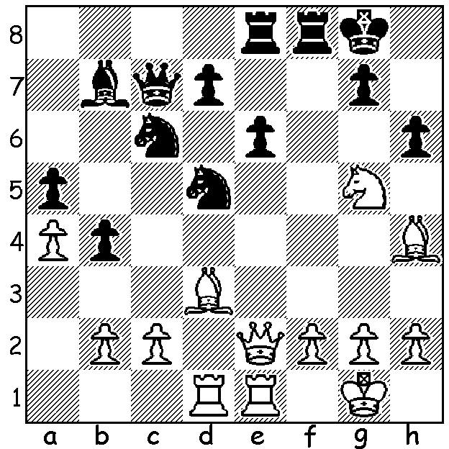

This year’s Australian Olympiad Open team for Tromso, Norway,in August must surely be Australia’s youngest team ever and may well be the youngest team in the event with ages ranging from 29 to 13 and with an average age of about 22. So much for the idea that chess is an old man’s game! Our youngest player, Anton Smirnov, who is only 13, was taught to play when four by his father Vladimir Smirnov, himself a Russian IM. Anton was Australian Under 8 champion when 5 and in 2009 was =2nd in the World Under 8 Championship. This year he won the Australian Junior Championship and was =5th in the Australian Open Championship. Here are two games of his, the first played when he was only 9:

Paul Glassan - Anton Smirnov
Australian Open, Jan. 2011
Ruy Lopez, Schliemanns Defence
1.e4 e5 2.Nf3 Nc6
3.Bb5 f5(a) 4.Nc3 fxe
5.Nxe4 d5 6.Nxe5 dxe4
7.Qh5+ g6 8.Nxg6 hxg6
9.Qxh8 Be6 10.0-0 Qd7
11.Qh4 Be7 12.Qxe4 0-0-0
13.Bxc6 bxc6 14.Qa4 Bc5
15.Qa6+(b) Kb8 16.c3 Nf6
17.d4 Bd6 18.f4(c) g5!?
19.c4(d) Bc5! 20.dxc5? Qd4+
21.Kh1 Ne4(e) 22.Qa3 Nf2+
23.Kg1 Nh3+ 24.Kh1 Qg1+!
White resigns

- The Schliemann is an ultra-aggressive defence in which Black .will be prepared to sacrifice.
- Safer for White is completing his development with 15.d3 Ne7 16.Be3.
- Better 18.Bg5.
- White is reluctant to open the b8-h2 diagonal for Black’s bishop with 19.fxg.
- Obviously 21…Bxc4 wins but Black sees the possibility of a spectacular finish.

Anton Smirnov – Tirta Chandra Purnama
2013 Indonesian Open
Sicilian Defence, Kan Variation
1.e4 c5 2.Nf3 e6
3.d4 cxd 4.Nxd4 a6
5.Bd3 Qc7 6.0-0 Nf6
7.Qe2 d6 8.c4 Be7
9.Nc3 0-0 10.Kh1 b6
11.f4 Nbd7 12.Bd2 Rd8
13.Rac1 Bb7 14.Rf3 Bf8
15.Rh3 Rac8 16.Rf1 Re8
17.b3 Qb8 18.Bb1 e5(a)
19.fxe Rxe5 20.Bf4 Ree8
21.Bg5 Rc5 22.Bxf6 Nxf6
23.Rg3 Qd8(b) 24.Qf3 Kh8(c)
25.Nd5 b5 26.Rh3(d) Re5
27.Qd1 Nxe4 28.Bxe4 Rxe4
29.Qd3 Bxd5(e) 30.cxd5 Rh4
31.Rhf3 Rxd5 32.Rxf7 Be7
33.Qf3 Bf6 34.Qxd5 resigns(f)

- Probably concerned about an e5 pawn advance opening up the b1-h7 diagonal but leaving a hole at f5 which White is able to exploit.
- 23…Nh5 deserves consideration.
- 25.Qxf6 was threatened.
- White wants more than 26.Nxf6 Qxf6 27.Qxf6 gxf6 28.Rxf6. Black’s best now seems to be 26…bxc but White maintains his attack with 27.b4.
- Giving up the exchange with 29…Qe8 30.Nc3 bxc 31.bxc d5 32.Nxe4 (32.cxd Rxc3) 32…dxe4 enables Black to fight on.
- 34…Rxd4 35.Qxd4! Bxd4 36.Rf8+ mating.

SOLUTION: 1.Bh7+ Kh8 2.Rxd5! (now if 2…exd5 3.Qxe8 Rxe8 4.Rxe8#. The game concluded 2…Qf4 3.Bg3 Nd4 4.Qd1 exd5 5.Bxf4 Rxe1+ 6.Qxe1 hxg5 7.Bd6 Rf6 8.Bd3 Re6 9.Qd1 resigns – 9…Rxd6 10.Qh5+ mating).

