Ernst Falkbeer - Adolf Zytogorski Ernst Falkbeer
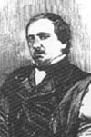
(London 1856): only seven moves have
been played each side but after White’s
next move Black resigns:

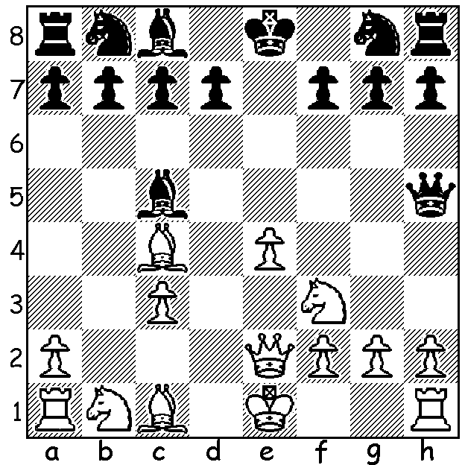

Our second article on Ernst Falkbeer (1819 -85) concentrates on his famous Falkbeer Counter Gambit which helped to diminish the popularity of the Kings Gambit. Chess Website states: ‘Many games do not last more than 30 moves as it is a slugfest …… it is usually complete chaos.’ Here then are some quick Black wins in the main line 1.e4 e5 2.f4 d5 3.exd e4:

John Schulten - Paul Morphy
New York 1857
4.Nc3 Nf6 5.d3 Bb4
6.Bd2 e3 7.Bxe3 0-0
8.Bd2 Bxc3 9.bxc3 Re8+
10.Be2 Bg4 11.c4 c6
12.dxc Nxc6 13.Kf1? Rxe2!
14.Nxe2 Nd4 15.Qb1 Bxe2+
16.Kf2 Ng4+ 17.Kg1 Nf3+!
18.gxf3 Qd4+ 19.Kg2 Qf2+
20.Kh3 Qxf3+ 21.Kh4 Nh6
22.Qg1 Nf5+ 23.Kg5 Qh5#

Jakob Rosanes - Adolf Anderssen
Breslau 1862
4.Bb5+ c6 5.dxc Nxc6
6.Nc3 Nf6 7.Qe2 Bc5
8.Nxe4 0-0 9.Bxc6 bxc6
10.d3 Re8 11.Bd2 Nxe4
12.dxe4 Bf5 13.e5 Qb6
14.0-0-0 Bd4 15.c3 Rab8
16.b3 Red8 17.Nf3 Qxb3!!
18.axb3 Rxb3 19.Be1 Be3+!
White resigns

Isidor Gunsberg - Curt von Bardeleben
Hastings 1895
4.Qe2 Nf6 5.Nc3 Bd6
6.Nxe4 0-0 7.Nxf6+ Qxf6
8.Qf3 Bf5 9.d3 Bb4+
10.Kd1 Nd7 11.c3 Bxc3!
12.bxc3 Qxc3 13.Rb1 Nc5
14.Qf2 Nxd3 15.Qg3 Rad8
16.Bxd3 Bxd3 17.Rb2 Rxd5
18.Rd2 Re8 White resigns

Rudolf Charousek - Geza Maroczy
Budapest 1895
4.Bb5+ c6 5.dxc Nxc6
6.d4 Qa5+ 7.Nc3 Bb4
8.Bd2 Nf6 9.Bxc6+ bxc6
10.Nge2 0-0 11.a3 Bxc3
12.Nxc3 Qb6 13.Ne2 Bg4
14.c3 e3! 15.Bc1 Nd5
16.0-0? Qa6 White resigns

Geza Maroczy - Rudolf Charousek
Budapest 1896
4.Qe2 Nf6 5.Nc3 Bd6
6.Nxe4 0-0 7.Nxf6+ Qxf6
8.d3 Na6 9.Qf3 Re8+
10.Kd1 Bd7 11.Ne2 Re7
12.Nc3 Nc5 13.Ne4 Nxe4
14.dxe4 Qd4+ 15.Bd3 Rae8
16.c3 Ba4+ 17.Kd2 Rxe4!!
18.b3 Bb4 19.Bb2 Re3
20.Qf1 Bb5 White resigns

The WILLETTON OPEN (WA Grand Prix), Moresby St. Centre, South Perth, August 2-3. See cawa.or.au for details and entry.

SOLUTION: 8.g4!! if 8…Qxg4 9.Bxf7+! Kf8 (9…Kxf7? 10.Ne5+) 10.Rg1 Qxg1+ (10…Qh3 11.Rg3)
11.Nxg1 Kxf7 12.Qc4+/Qh5+ …13.Qxc5): if 8…Qg6 9.Ne5 / 10.Nxf7: if 8…Qh3 9.Bxf7+! Kf8 10.Bxg8 Rxg8 11.Rg1.

