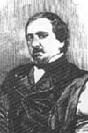
Henry Bird - Ernst Falkbeer (London 1856):
what is Black’s best move?

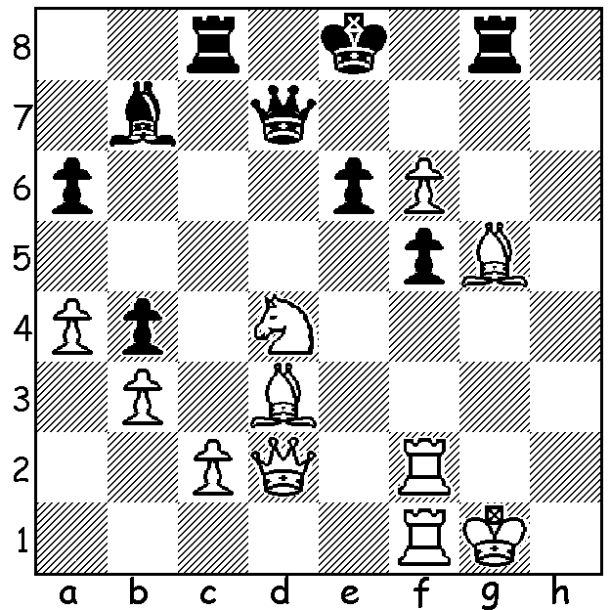 Falkbeer

Our third article on Ernst Falkbeer (1819 -85) looks at the second most popular line in combatting his famous Falkbeer Counter Gambit* (1.e4 e5 2.f4 d5), namely 3.Nf3 rather than 3.exd, with some more short and exciting games. Last week’s games showed all Black wins while here we see White wins. (This is not to imply 3.Nf3 is better. The website Chess Games gives 44% wins to Black’s 37% after 3.exd and 36% White wins to Black’s 42% after 3.Nf3.) All three games today begin 1.e4 e5 2.f4 d5
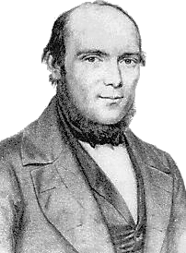
3.Nf3 dxe 4.Nxe5 Bd6:

Adolf Anderssen - Emil Schallopp (1864)
5.Bc4 Bxe5 6.fxe5 Qd4
7.Qe2 Qxe5 8.d4 Qxd4
9.Nc3 Nf6 10.Be3 Qd8
11.0-0 h6 12.Bc5 Nbd7
13.Qxe4+! Nxe4 14.Bxf7#

Siegbert Tarrasch - Karl Eckart (1892)
5.d4 exd3 6.Bxd3 Nf6
7.0-0 0-0 8.Nc3 Bxe5
9.fxe5 Qd4+ 10.Kh1 Qxe5
11.Bf4 Qc5 12.Bxc7! Bg4(a) Anderssen
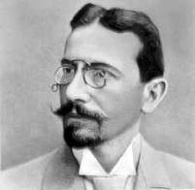
13.Qd2 Qxc7 14.Rxf6! Qa5
15.Rf4 Be6 16.Rh4 f5
17.Re1 Qd8 18.Qf2 Bc8
19.Nd5! Nc6 20.Bc4 Kh8
21.Re7!!(b) Nxe7 22.Rxh7+! Kxh7
23.Qh4+ Kg6 24.Nf4#

a) 12…Qxc7 13.Rxf6! gxf6 14.Qh5 f5
15.Qg5+ Kh8 16.Qf6+ Kg8 17.Nd5 wins.
b) Brilliant interference sacrifice destroying
Black’s queen cover of h4. Tarrasch

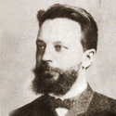
Mikhail Tchigorin - Karl Walbrodt (1896)
5.Qe2 Qe7 6.Qxe4 f6
7.d4 fxe5 8.fxe c6
9.Bc4 Bc7 10.0-0 Be6
11.Bg5 Qxg5 12.Bxe6 Nh6
13.Bc8 Nd7 14.Bxb7 Ke7
15.Bxc6 Raf8 16.Nc3 Rxf1+
17.Rxf1 Rf8 18.Nd5+ Kd8
19.Nf4 Re8 20.Qd5 Qe7
21.Bb5 g5 22.Qa8+ Bb8
23.Nd5 Qe6 24.Bxd7 Kxd7
25.Qb7+ resigns Tchigorin

The WILLETTON OPEN (WA Grand Prix), Moresby St. Centre, South Perth,this Sat & Sun, August 2-3. See cawa.or.au for details and entry. Phone or text 0439798607 to register and arrive on Sat. before 12.15. Late entries accepted up to noon.

NEW AUSTRALIAN ONLINE MAGAZINE: Check out 50movesmagazine.com to find out details.
Cost is $40 per year (6 issues) or $8 a single issue. Contributors include the legendary Ian Rogers, Australian Open champion Max Illingworth, ex-Australian champion Guy West and Moulthun Ly & Junta Ikeda, both members of this year’s Australian Olympiad team. (And what about donating towards the $36,000 expenses of the two Australian teams via acfappeal.aunz.org)

SOLUTION: White is two pieces up but his king is very exposed. Black had previously played 27…f6!! to which White had replied with the natural 28.exf. Now Black played 28…Qxd5!! White could win the queen with 29.Bb5+ but loses quickly after 29…Kf7! (showing the reason for 27…f6) 30.Qxd4 Rxg5+ 31.Kh2 Rh8+ mating. Instead Bird showed great ingenuity in continuing 29.f7+! Kxf7 30.Bxf5! Qxd2 31.Bg6+! Kxg6 32.Bxd2 Kh7+ 33.Kh2 Rc5 34.Rf7+ Kh8 but now was forced to resign.

*The first recorded Fa;kbeer Counter Gambit was in fact played by Giaochino Greco in 1620!

