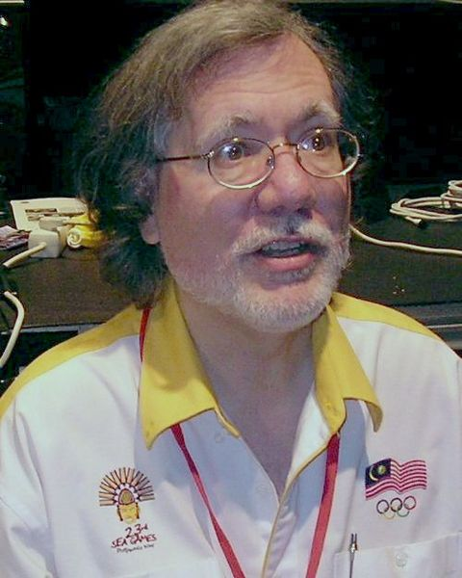
A spectacular finish from Australia’s
Ian Rogers (White v Sznapik) from the
1988 Thessalonica Olympiad (4 moves):
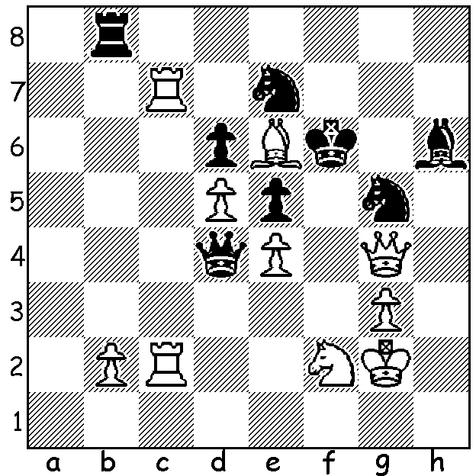

Ian Rogers

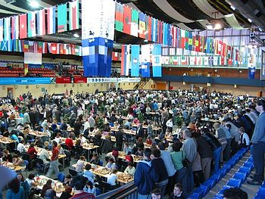
The 41st CHESS OLYMPIAD has begun in
Tromso in the north of Norway with Australia
fielding teams in the Open & Women’s events.
In all 310 teams from 175 nations have entered
with over 2000 players involved. The games are
being broadcast live on Norwegian TV every day
for hours and can be followed worldwide on a
large number of chess websites. Some early
problems included the non-appearance of some
teams, delays in starting due to lengthy security
checks on players (for mobile phones, etc, rather
than explosives) and the almost universally
condemned zero-tolerance rule forfeiting players
not in their seats ready at start of play (one
unfortunate 11 year old girl burst into tears on
being forfeited). Australia’s two teams have
started in identical fashion with 4-0 wins against Play under way at Tromso
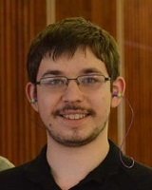
US Virgin Islands & Kenya respectively before

losing Rd 2 1-3, the men to defending champions
Armenia and the women to Ukraine, followed by
disappointing 2-2 draws with El Salvador and
Monaco respectively. Notable results included
David Smerdon’s draw against world number 2
Levon Aronian, Max Illingworth’s draw with
Sergei Movesian and Thu Giang Nguyen’s draw
with former women’s world champion Anna
Ushenina. Here is an entertaining game from
the event by a master of attack, Alexei Shirov: David Smerdon and Max Illingworth

Alexei Shirov (Latvia) - Sarunas Sulskis (Lthuania)
2014 Chess Olympiad
Two Knights Defence, Fried Liver Attack

1.e4 e5 2.Nf3 Nc6
3.Bc4 Nf6 4.Ng5 d5
5.exd Nxd5(a) 6.Nxf7 Kxf7
7.Qf3+ Ke6 8.Nc3 Nb4(b)
9.a3!? Nxc2+ 10.Kd1 Nxa1(c)
11.Nxd5 Kd6 12.d4 Be6
13.Re1 b5 14.Nb4! bxc4
15.Qc6+ Ke7 16.Bg5+ Kf7
17.Bxd8 Rxd8(d) 18.Qxc7+ Rd7
19.Qxe5 Rd6 20.d5 Bd7
21.Qf4+ Kg8 22.Qxc4 a5
23.Nd3 a4 24.Nc5 h5
25.Nxd7 Rxd7 26.d6+ Kh7 Alexei Shirov
27.Re6 g6(e) 28.Rxg6! resigns

- Very few players would risk this move which leads to a dangerously exposed king.
- 8….Ne7 9.0-0 c6 10.Re1 Bd7 11.d4 Kd6 12.Rxe5 Ng6 13.Nxd5 Nxe5 14.dxe5+ Kc5 15.Qa3+ Kxc4 16.Qd3+ Kc5 17.b4# is a Greco win in 1620 (an even earlier record of this gambit was Polerio-D’Arminio 1-0, 1610). After the text move 9.Qe4 is the most common reply.
- Somewhat safer is 10…Nd5 11.Bxd5+ Kd6=.
- Black has more than enough pieces for the queen but can he co-ordinate them?
- If 27…Rxd6 28.Rxd6 Bxd6 29.Qd3+ wins

PERTH CC OPEN: The Perth Chess will hold a rateable 7 Round Open tournament on its Wednesday club night commencing August 13. Details perthchessclub.org.au & entries to robandnat@bigpond.com

NEW AUSTRALIAN ONLINE MAGAZINE: Check out 50movesmagazine.com to find out details.
Cost is $40 per year (6 issues) or $8 a single issue. Contributors include the legendary Ian Rogers, Australian Open champion Max Illingworth, ex-Australian champion Guy West and Moulthun Ly & Junta Ikeda, both members of this year’s Australian Olympiad team. The first edition runs to 82 pages, providing tournament games and analysis from Australia and worldwide, opening analysis, interviews and much more. (And what about donating towards the $36,000 expenses of the two Australian teams via acfappeal.aunz.org)

The WILLETTON OPEN, played last week end, was won by WA champion Tristan Boyd with 5/6 (+5 =2). He had to struggle to hold a difficult ending in the final game to finish against Ihsan Ferozkohi who, together with junior Patrick Gong and Tom Donaldson, finished second with 4.5. Of the 24 players entered nine were juniors who were all able to gain valuable experience against their elders.

SOLUTION: 1.Qf5+!! (clearance and deflection sacrifice, vacating4 and preventing king escape to 2nd rank) 1…Nxf5 2.Ng4+ Kg6 3.Bxf5+ Kh5 4.Nf6#.

