From the Olympiad, Andres Guerrero (Venezuela) – Judit Polgar (Hungary): threatened with 1…Q/Rxh2# White plays 1.g3. Can you now find a Black win and also find a better first for White?

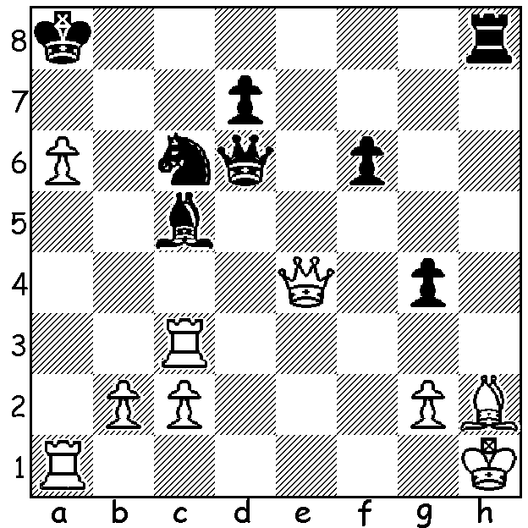

By the time you read this the 41st Chess Olympiad in Tromso, Norway, will have been completed but at the time of writing there are two rounds to go with China (+6 =3) & France (+7 =1 -1) leading the Open and Russia (9/9) leading the Womens. Two former winners and favourites in the Open, Russia & Armenia (both +5 =3 -1) remain with only slim chances. Australian Open & Women are both mid-table with +5 =1 -3 & +4 =1 -4 respectively.

Here are a couple of top board finishes:

Le Quang Liem (Vietnam) – Michael Adams (England) Black to play:
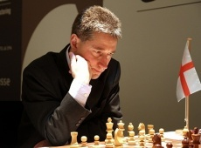
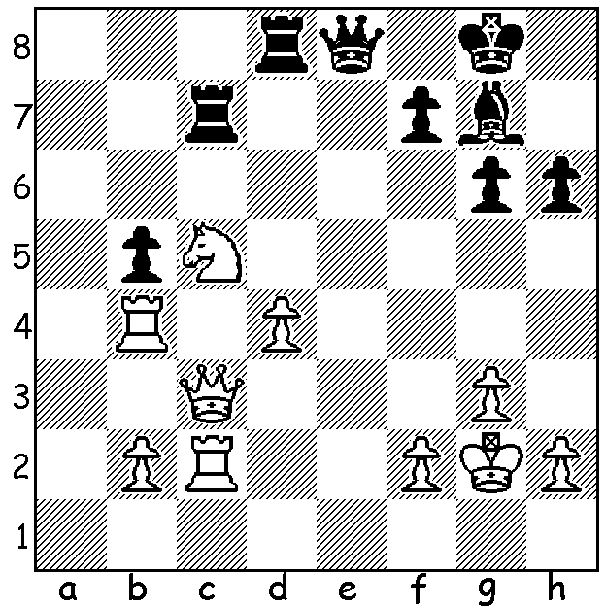

1…Rxc5!! 2.Qxc5 Bf8 3.Qxb5 (3.Qc3 Bxb4 4.Qxb4 Qe4+) 3…Qe4+ 4.Kg1 Qxc2 5.Ra4 Qb1+ 6.Kg2 Qe4+ 7.f3 Qc2+ 8.Kh3 Qd1 9.f4 h5 10.Qc4 Rxd4! resigns (11.Qxd4 Qf1+ 12.Kh4 Be7+ mating).

Kirsan Kazimdzhanov (Uzbekistan) – Vladimir Kramnik (Russia) White to play:
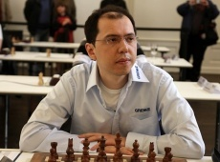
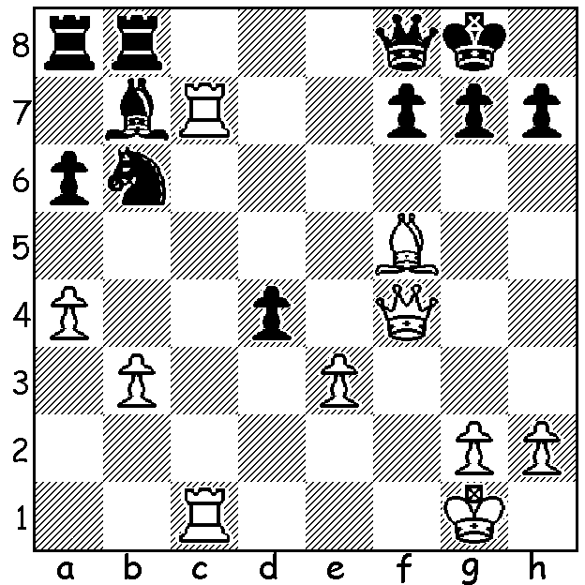

1.Rxf7!! Kxf7 (1…Qxf7 2.Bxh7+! Kf8 3.Qd6+ Qe7 4.Rf1+ Ke8 5.Bg6+ or 3…Ke8 4.Bg6) 2.Bxh7+ resigns (2…Ke8 3.Bg6+ Kd7 4.Qc7+ Ke6 5.Qxb6+ Qd6 6.Nf4+ Ke7 Rc7+ wins: 2…Ke7 3.Qe5+ Kd7 4.Bf5+ Kd8 5.Qc7+ Ke8 6.Bg6+: 2…Ke6 3.Nxd4+ Ke7 4.Qc7+ Ke8 5.Bg6+).

And a beautiful finish from the Womens: Hakyung Lim (S. Korea) - B. Bjenke (Norway): Black to play:

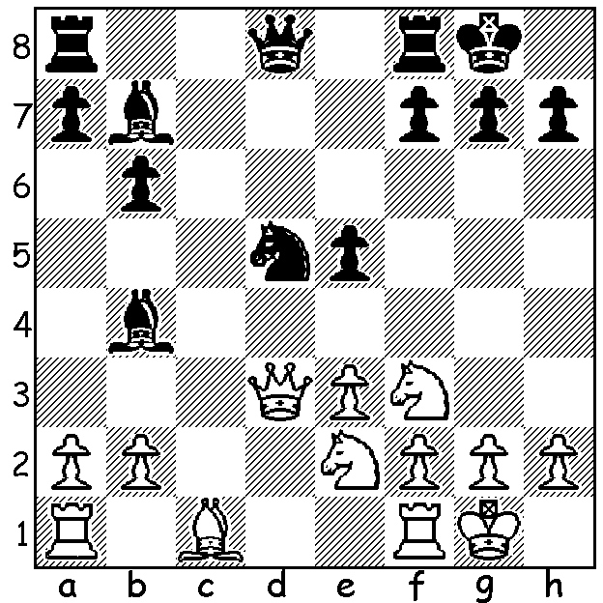

1…Nc3!! 2.Qc4 (2.Qc2 Be4) 2…Qd5! 3.Qxb4 Nxe2+ 4.Kh1 Qxf3! Resigns

The WA Championship will be played over 7 rounds at weekends Sept 13 to Oct 5 at N. Woodvale Primary. Details cawa.org.au

SOLUTION: 1.g3? Rxh2+! 2.Kxh2 Qd2+ resigns (3.Kh1 or 3.Qg2 3…Qh6+ mates): White missed the interruption sacrifice 1.Rh3!! with excellent chances (1…gxh3?? 2.Bx

