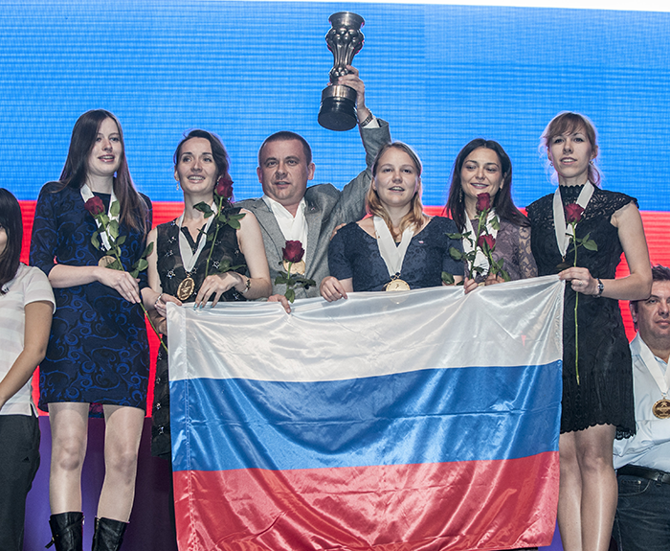
Russia’s top board at the Women’s
Olympiad, Kateryna Lagno (White),
gains a winning position against
Jordan’s Lougain Dahdal (4 moves):

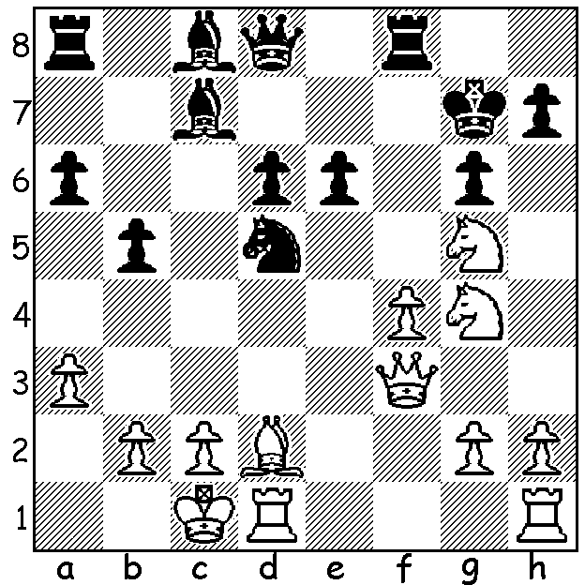 The victorious Russian Women’s Team

OLYMPIAD TEAMS EMBROILED IN UKRAINE CONFLICT
The 41st Women’s Chess Olympiad in Tromso, Norway, was won by Russia for the third time running with 20/22 (+10 -1). Second and third were favourites China and Ukraine (both +8 =2 -1). Australia finished well up the table =27/136 (+6 =1 -4) with all players achieving a plus score. Prior to the start of the tournament the organizing committee had banned the Russian team for failing to nominate its team before the stipulated deadline. Russia’s delay was caused by efforts to include in its team Kateryna Lagno (see position above) from the Crimea who had previously represented Ukraine. However FIDE overturned the ban allowing the Russian team, including Lagno, to play. Her contribution was invaluable, especially in the vital match against China where she defeated women’s world champion Hou Yifan. Interestingly Russia’s only loss was against Ukraine. Here’s a game by Board 2 of the successful Russian team:

Ildiko Madl (Hungary) - Valentina Gunina (Russia)
2014 Women’s Olympiad
Caro-Kann Defence, Main Line
1.e4 c6 2.d4 d5
3.Nc3 dxe 4.Nxe4 Bf5
5.Ng3 Bg6 6.Nh3 e6
7.Nf4 Bd6 8.c3 Qc7
9.Ngh5 Bxh5 10.Nxh5 g6
11.Ng3 Nd7(a) 12.Qf3 e5
13.Bc4 0-0-0! 14.Qxf7 exd
15.0-0(b) Ngf6 16.Bd2 Rdf8
17.Qg7 h5 18.f4(c) Qb6
19.Kh1 h4 20.Ne2 h3!
21.Qxg6(d) Rhg8! 22.Bxg8 Rxg8
White resigns(e)

- Black has an appreciable lead in development.
- 16.Be6 dxc 17.Bxd7+ Qxd7 18.Qxd7+ Kxd7 19.bxc3 would avoid the coming attack.
- 20.h3 would keep White in the game
- 21.Be6 is better but Black remains on top after 21…hxg+ 22.Kxg2 Qxb2.
- White doesn’t relish continuing with 23.Qxg8+ Nxg8 when she has 2 rooks for a queen but with one fewer minor piece.


An extremely short game of only 8 moves was played between Nava Starr (Canada) and Luzia Pires (Angola). While Starr is a Women’s International Master, 8 times Canadian women’s champion and has played in Olympiads since 1976 her opponent is rated below 1550 and was only born in 2003. Therefore an 8 move game might not seem too surprising:

Nava Starr – Luzia Pires
2014 Women’s Olympiad
Kings Pawn, Three Knights
1.e4 e5 2.Nf3 Nc6
3.Nc3 Bc5 4.Nxe5!(a) Bxf2+
5.Kxf2 Nxe5 6.d4 Qf6+
7.Kg1(b) Ne7 8.dxe5??(c) Qb6+
White resigns(d)

Nava Starr
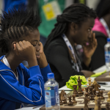
- This ensures an advantage to White who gains
central control. Black’s alternative reply now is
4…Nxe5 (5.d4 Bd6 6.dxe5 Bxe5 7.f4! Bxc3+ 8.bxc3
9.Qd4).
b) 7.Ke1 seems better with threats on the knight, Nd5
and speedy development of the rook to f1.
c) Either an example of ‘chess blindness’ or extreme
carelessness due to over-confidence: the simple 8.h3
leaves White in a dominating position.
d) Not the expected outcome - a David v Goliath shock
result.
Luzia Pires (foreground)

THE 2014 WA CHAMPIONSHIP will be held Saturdays and Sundays (7 rds) Sept 13 to Oct 5 with multiple prizes for winners and place-getters (champion $500, women’s, senior, reserve champions plus top junior all $200 for first). Details on cawa.org.au & enquiries norbert.muller@iinet.net.au

SOLUTION: 1.Qxd5! exd5 2.Bc3+ Rf6 (2…Kg8 3.Nh6#) 3.Bxf6+ Qxf6 4.Nxf6 Kxf6 & White the exchange up wins easily

