As stated last week, both Australian teams performed well at the Tromso Olympiad. The Open team scored +6 =2 -3, 14/22, coming 24th/150 (ranked 60th) while the Women scored +6 =1 -4, 13/22, coming =27th/136 (ranked 51st). Open scores David Smerdon +2 =4 -3, 4/9, Moulthon Ly +2 =3 -4, 3.5/9, Max Illingworth +5 =2 -2, 6/9, Junta Ikeda +5 -3, 5/8, Anton Smirnov +6 =3, 7.5/9. While David’s play was, as expected, a little erratic he did draw against world number 2, Levon Aronian in a game that went to 72 moves. Mouthon, an IM, may have been disappointed in his score but he was outrated in most games and faced 6 GMs. However it was our lower boards that scored particularly well, especially 13 year old Anton in going through undefeated and more than justifying the selection committee’s faith in him. All the Women achieved plus scores - Irina Berezina +3 =3 -1, 4.5/7, Nguyen Thu Giang +4 =5 -1, 6.5/10, Emma Guo +7 =1 -2, 7.5/10, Biljana Dekic +5 -3, 5/8, Sally Yu +4 =2 -3, 5/9. Here’s a position from the Olympiad won by Australia’s Junta Ikeda against Thao Olebile (Botswana). What’s White’s next move? (below: Australian Olympiad teams)
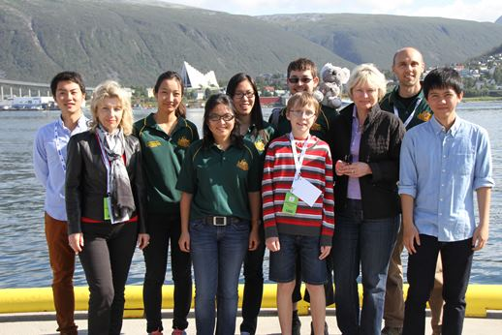
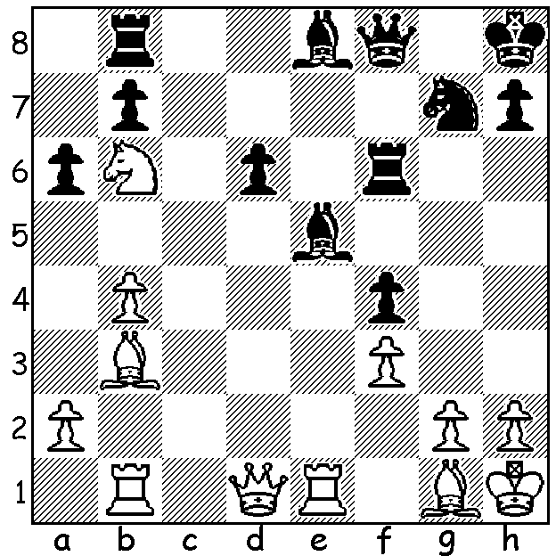

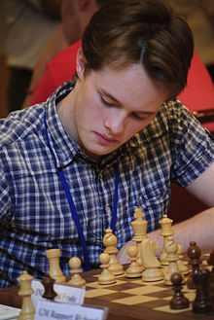
Last week we saw a gigantic upset in the Women’s Olympiad. This week we see a shock result in the Open with the defeat of one of the leading GMs of the day beaten by the top board of Norway’s second team⃰. The winner, Frode Urkedal, was only born in 1993, while the loser, Vassily Ivanchuk, born 1969, has been among the top players in the world since 1988 and was once rated world number 2. He is presently ranked 17th on 2744, nearly 250 more than the Norwegian:

Frode Urkedal (Norway 2) - Vassily Ivanchuk (Ukraine)
2014 Olympiad, Rd 1: Dutch Defence
1.Nf3 f5 2.d3 Nc6
3.d4(a) e6 4.g3 d5
5.Bg2 Rb8(b) 6.0-0 Nf6
7.Bf4 b5 8.b3 Ba6
9.Qc1 Bd6 10.Nbd2 0-0
11.e3 Ne4 12.Re1 Qe7

13.a3(c) Na5 14.Bf1 Rb6
15.c3 g5 16.Bxd6 cxd6(d)
17.b4 Nb7 18.a4(e) Rc8
19.Nxe4 fxe4 20.Nd2 Nd8
21.axb Bxb5 22.Bxb5 Rxb5
23.Ra3 Rxb4?(f) 24.cxb4 Rxc1
25.Rxc1 Qb7 26.Rac3! Nf7
27.Rc8+ Kg7 28.R1c7 Qxb4
29.Nf1 resigns(g)

a) This move, losing a tempo, may seem strange but is not new and seeks to show …Nc6 to be out of place in the Dutch (a d5 advance is possible next move). Black counters with a stonewall set-up but with knight rather than pawn on c6. Taking 2 moves to advance a pawn to the 4th rank in the first stages of the opening can be seen even earlier in the French Defence, Tchigorin Attack – 1.e4 e6 2.Qe2 e5.
b) As White is tardy in playing c4 Black makes efforts to prevent this natural White advance.
c) Black threatened to win the queen with …Ba3 & …Nc3.
d) Controls e5 and opens up the c file making c4 even harder for White (…Rc8).
e) White finds an alternative way of opening up the queenside.
f) This loses outright as Black’s queen is no match for the 2 rooks.
g) Black is powerless to prevent White doubling rooks decisively on the 7^{th..}
⃰⃰⃰⃰ Norway, as host nation was permitted to have more than one team.
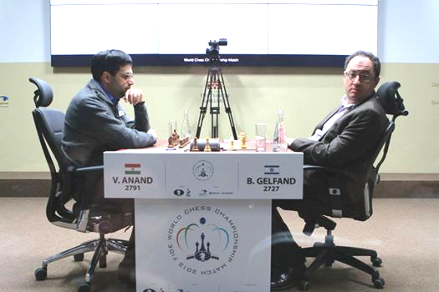
THE 2014 WA CHAMPIONSHIP
will be held Saturdays and Sundays (7 rds Sept 13
to Oct 5 with multiple prizes for winners and
place-getters (champion $500, women’s, senior,
reserve champions plus top junior all $200 for first).
Enter by Friday 12 September.
Details on cawa.org.au &
enquiries norbert.muller@iinet.net.au

REMINDER: The film ‘Album 61’ about Boris
Gelfand and hisattempt to wrest the world title from
Paradiso at 2pm, Sunday 7th September.

SOLUTION: 1.Rxe5! and if 1…dxe5 2.Bc5 wins the queen. Anand v Gelfand, World Championship 2012

