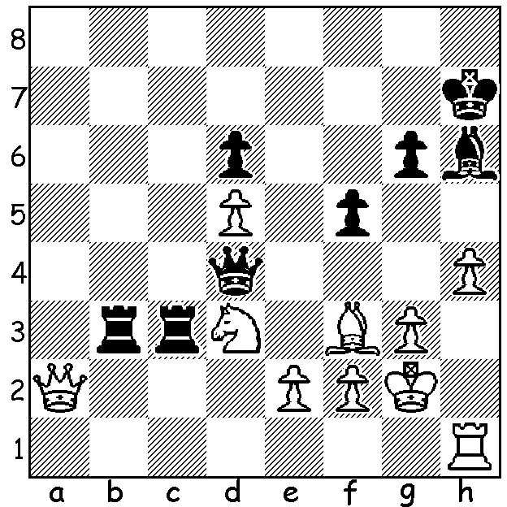

Alexander Grischuk – Fabiano Caruana 2014:
White with 2 pawns for the exchange appears to
have a solid defensive position so how does
Black win (4 moves)?

The 2nd Sinquefield Cup (Saint Louis, USA 27 Aug – 7 Sept) could be considered the strongest tournament ever with six of the world’s top ten players competing in a double round-robin. No one could have predicted that the event would prove such a one-horse race, especially as the winner was not 23 year old Norwegian world champion Magnus Carlsen, who had won the event in 2013, but 22 year old Italian Fabiano Caruana who leapt out the blocks to notch up an amazing seven wins in as many games. With his final three games drawn Caruana finished with 8.5/10, winning more games than all the others combined and 3 points ahead of Carlsen. Other scores: Veselin Topolov (Bulgaria, aged 39) 5, Levon Aronian (Armenia, 31) & Maxime Vachier-Lagrave (France, 23) 4, Hikaru Nakamura (USA 26) 3.

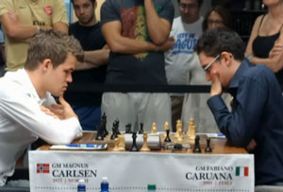
Magnus Carlsen - Fabiano Caruana
2014 Sinquefield Cup, Rd 3
Bishops Opening
1.e4 e5 2.Bc4 Nf6(a)
3.d3 c6 4.Nf3 d5
5.Bb3 Bb4+ 6.c3 Bd6
7.Bg5 dxe 8.dxe h6
9.Bh4 Qe7 10.Nbd2 Nbd7
11.Bg3 Bc7 12.0-0 Nh5
13.h3(b) Nxg3 14.fxg3 Nc5
15.Bxf7+(c) Kxf7 16.Nxe5+ Kg8
17.Ng6 Qg5 18.Rf8+ Kh7
19.Nxh8(d) Bg4! 20.Qf1 Nd3! Carlsen v Caruana in their 2nd Sinquefield game
21.Qxd3(e) Rxf8 22.hxg4 Qxg4
23.Nf3 Qxg3 24.e5+ Kxh8
25.e6 Bb6+ 26.Kh1 Qg4! 27.Qd6(f) Rd8 28.Qe5(g) Rd5!
29.Qb8+ Kh7 30.e7 Qh5+ 31.Nh2 Rd1+ 32.Rxd1 Qxd1+
33.Nf1 Qxf1+ 34.Kh2 Qg1+ White resigns(h)

a) Seemingly the first time Carlsen has essayed the obscure and out-dated Bishops Opening. White has a number of possibilities now – 3.Nf3 (3…Nc6 Two Knights Defence), 3.f4 (Kings Gambit), 3.Nc3 (3…Nxe4! 4.Qh5 Nd6 Vienna Game) and 3.d4 dxe 4.Nf3 (Ponzianos Gambit).
b) Not 13.Nxe5? Nxe5 14.Qxh5 Bg4 15.Qh4 g5 trapping the queen.
c) A dangerous but ultimately unsound sacrifice. Black cannot play 15…Qxf7 - 16.Nxe5 Qe6 17.Qh5+ Ke7 Ng6+ winning.
d) If 19.Rxh8+ Kxg6 20.Nf1 Bg4! Leaves Black a piece up.
e) White cannot play 21.Rxa8 – 21…Qe3+ 22.Kh1 Nf2+ 23.Kh2 Qxg3+ 24.Kg1 Nxh3+ 25.Kh1 Qh2#.
f) Not 27.Re1? Rxf3! 28.Qxf3 Qh4+ 29.Qh3 Qxe1+.
g) 28.e7 Rxd6 29.e8=Q+ Kh7 is no improvement.
h) The passed pawn is lost – 35.Kh3 Qe3+

THE 2014 WA CHAMPIONSHIP will be start tomorrow with today the last opportunity to enter. Multiple prizes for winners and place-getters (champion $500, women’s, senior, reserve champions plus top junior all $200 for first). Details on cawa.org.au & enquiries norbert.muller@iinet.net.au

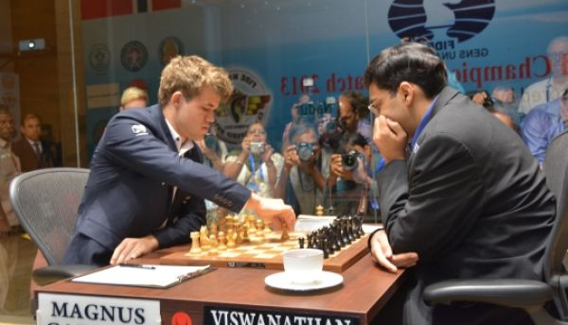
The WORLD CHAMPIONSHIP match
between defending champion Magnus Carlsen
and previous champion Vishwanathan Anand,
scheduled for 7 -28 November at the Winter
Olympic site in Sochi, Russia, will go ahead
despite some concerns the Ukraine-Russia
dispute would cause its cancellation.

SOLUTION: 1…Rxd3! (removing the guard)
2.exd3 Rb2 3.Q moves Qxf2+ 4.Kh3 Qxf3.

Carlsen v Anand, World Championship 2013

