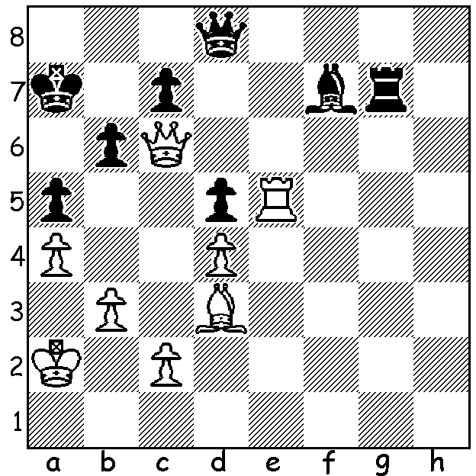

Fabiano Caruana – Ruslan Ponomariov 2014:
it seems impossible but White has a mate in 3 moves:

Last week’s column reported on the 2nd Sinquefield Cup (St Louis, USA, 27 Aug – 7 Sept), won in amazing style by Fabiano Caruana who won his first 7 games before finishing with 8.5/10. His rating performance in the event, which was possibly the strongest ever with 6 of the world’s top players, was a staggering 3100+ (world champion Magnus Carlsen has the highest rating with 2870). Caruana was born July 1992 in Miami, USA, of Italian parents. He played his first tournament at 5 years and aged 12 relocated to Madrid to commence training for a life as a chess professional. In 2007 he won his first Italian championship (9.5/11) as well as moving to Budapest for further study. He became a Grandmaster just short of his 15th birthday and is now the 3rd highest rated player on 2801 (behind Carlsen and Aronian).

Fabiano Caruana (Italy) – Emanuel Berg (Sweden)
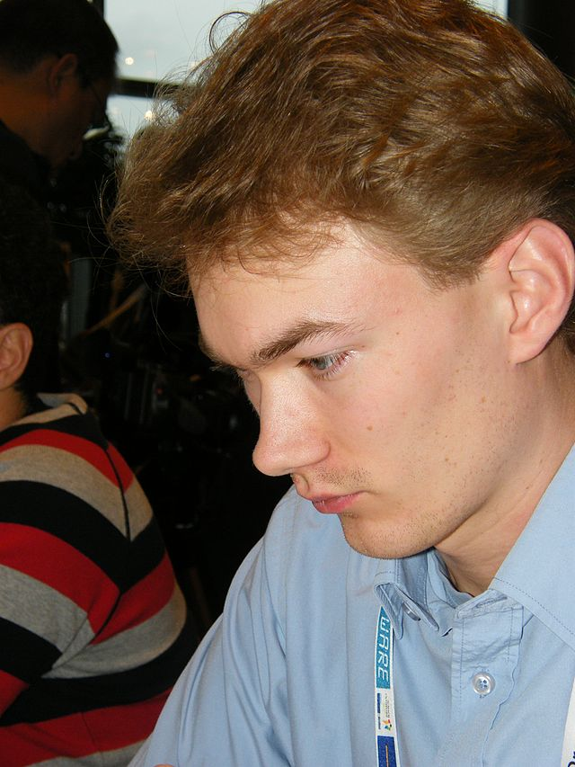
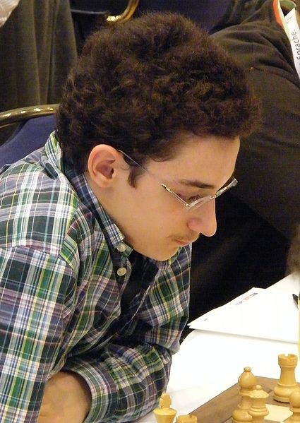
2008 Olympiad
French Defence: Rubinstein Variation
1.e4 e6 2.d4 d5
3.Nc3 dxe 4.Nxe4 Nd7
5.Nf3 Ngf6 6.Nxf6+ Nxf6
7.Bd3 c5(a) 8.dxc Bxc5
9.Qe2 0-0 10.0-0 b6
11.Bg5 Bb7 12.Rad1 Qc7
13.Ne5(b) Rfd8 14.Kh1 Be7
15.Rde1(c) h6 16.Bh4 Nd5
17.Bg3 Bd6 18.Qe4 Nf6
19.Qh4 Nd7 20.Nxf7!! Kxf7
21.Rxe6!(d) Nc5 22.Rxd6 Rxd6
23.Qf4+ Ke7 24.Re1+ Kd7
25.Bb5+ Bc6 26.Qf5+ Ne6 Caruana Berg
27.Bxd6 Qxd6 28.Rxe6! resigns(e)

a) The Rubinstein Variation destroys White’s centre but lacks the counter-attacking opportunities one would get from say the Winawer 3…Bb4.
b) 13.Bxf6 gxf6 14.Be4 with only a small advantage.
c) As Black’s rook no longer protecting f7 there is always the possibility of Nxf7 …Kxf7 Qxe6+.
d) Black cannot take – 21…Kxe6 22.Bc4+ Kf5 (22…Bd5 23.Qe4+) 23.Qh5+ g5 (23…Ke4 24.Qe2+ or 24.Bd3+ mating) 24.Qf7+ Nf6 25.Be6+ Ke4 26.Qg6+ Kd4 27.Qd3+ Kc5 28.Qc4#.
If 21…Nf6 22.Bc4 Kf8 (22…Nd5 23.Rxd6 Rxd6 24.Qf4+ Ke7 – 24…Re6 25.Rxe6+ Kxe6 26.Bxd5+ /27.Qxc7 – 25.Qf7+ Kc8 26.Re8+ or 22…Bd5 23.Rxf6+ Kxf6 24.Bxd5+) 23.Rxf6+ gxf6 24.Qxf6+ Ke8 25.Re1+ Kd7 26.Qf5+ Kc6 27.Qb5#.
If 21…Bxg3 22.Re7+ (21.Qe7+ also wins) 22…Kg8 23.Rxg7+! Kxg7 24.Qe7+ Kg8 25.Qh7+ Kf8 26.fxg6+.
However 21….Ne5 seems to quell the attack – 22.Rxe5 (or 22.Rxd6) Bxe5 23.Qh5+ Kg8 24.Bxe5 with 2 pawns for the exchange and the better position.
e) 28…Qxe6 29.Bxc6+ Ke7 30.Qxe6+ Kxe6 31.Bxa8 or 28.Qd1+ Re1+.

2014 OLYMPIAD: Apart from the results three significant items from the Olympiad:
Ex-world champion Gary Kasparov failed in his attempt to become FIDE president, losing the vote 61 -110 to Kirsan Ilyumzhinov, who was president of Kalmykia in the Russian Federation 1993 - 2010, FIDE president since 1995 and who has provided a significant portion of his personal fortune to the promotion of chess.
Judit Polgar, the greatest woman player ever who reached Number 8 in world rankings in 2005, announced her retirement after scoring 4.5/6 to help Hungary finish in second place in the Open.
Two competitors died at the Olympiad. During the last round Kurt Meier (Seychelles) aged 67 collapsed at the board and died after being taken to hospital while a Uzbekistan player was found dead in his hotel room some hours later.

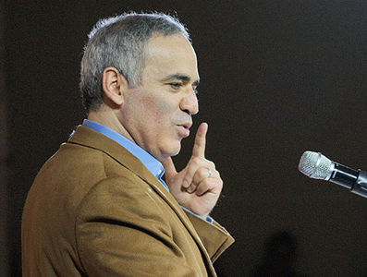

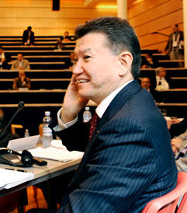

At the Olympiad: Gary Kasparov, Kirsan Ilyumzhinov and Judit Polgar

SOLUTION: 1.Rd7!! (deflection sacrifice) 1…Qxe7 2.Ba6! (another deflection sacrifice) 2…Kxa6 3.Qa8# (2…Qa3+ defers the mate one move).

