Judit Polgar – Viswanathan Anand Anand – Judit Polgar 1988
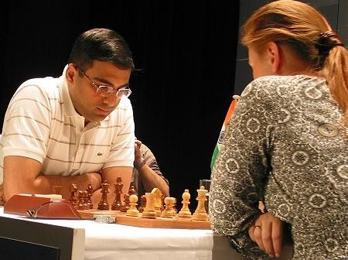
(Wijk aan Zee 1998): a sensational
combination leads to a won ending
a piece up (6 moves)

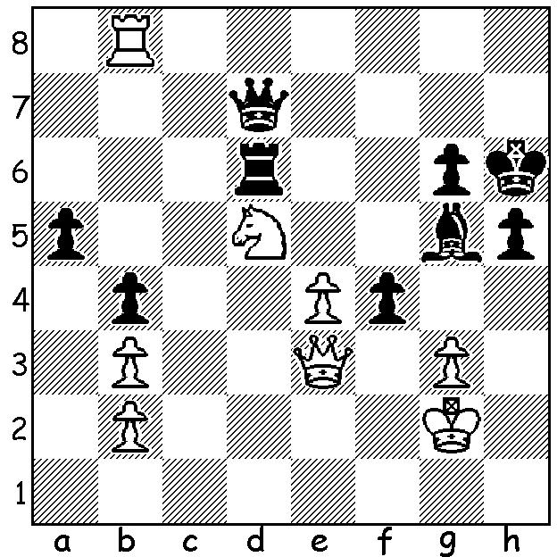

Last week we looked at the early life and career of the world’s greatest female player, Judit Polgar, born in Hungary in 1976, who became a Grandmaster at 15. She declined to play in women’s events but strove to prove herself the equal of any men, reaching a ranking high of 8th in 2005. (An exception was in 1990 when she joined her sisters Suzan and Sofia to take Hungary to the Women’s Olympiad gold medal).
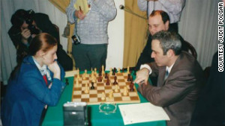
She has beaten almost all her leading contemporaries including 10 players with claims to have been world champion. She has represented Hungary regularly in the Olympiads, helping her country to two silver medals. While ex-world champion Mikhail Tal
predicted the then teenage Polgar could become
world champion, Gary Kasparov, who suffered a
loss to Polgar in the 2011 Russia v Rest of World
match, was less than complimentary, once
describing her as a ‘circus puppet’ and expressing
the chauvinistic view that women should stick to
having children. Here is a win against Alexei
Shirov who reached a world ranking of 4 and
qualified to play Kasparov for the world title only
for lack of financial backing to stymie the match. Judit Polgar v Gary Kasparov 2001

JUDIT POLGAR - ALEXEI SHIROV
Amsterdam 1995: Modern Defence
1.e4 g6 2.d4 Bg7
3.Nc3 c6 4.Bc4 d6
5.Qf3 e6 6.Nge2 b5
7.Bb3 a5 8.a3 Ba6
9.d5(a) cxd 10.exd e5
11.Ne4 Qc7 12.c4!(b) bxc
13.Ba4 Nd7 14.N2c3 Ke7(c)
15.Nxd6! Qxd6 16.Ne4 Qxd5(d)
17.Bg5+ Ndf6 18.Rd1 Qb7
19.Rd7+ Qxd7 20.Bxd7 h6(e)
21.Qd1! resigns

a) Gains e4 for a knight but seemingly buries her white-squared bishop.
b) At the cost of a pawn the bishop re-emerges.
c) 14…Kf8 is better.
d) If 16…Qc7/b8 17.d6+ Ke8 18.Bxd7 Kxd7 19.Qxf7+.
e) If 20…Bb7 21.a4 h6 22.Bb5! hxg5 23.Qa3+ Kd8 24.Qd6+ Kc8 25.Nc5.

And another Polgar quickie:

JUDIT POLGAR - FERENC BERKES
Budapest 2003: French, Burns Variation
1.e4 e6 2.d4 d5
3.Nc3 Nf6 4.Bg5 dxe
5.Nxe4 Be7 6.Bxf6 Bxf6
7.Nf3 0-0 8.Qd2 Nd7
9.0-0-0 Be7 10.Bd3 b6
11.Neg5 h6 12.Bh7+(a) Kh8
13.Be4 hxg5 14.g4!(b) Rb8
15.h4 g6 16.hxg+ Kg7
17.Qf4 Bb7(c) 18.Rh7+! Kxh7
19.Qh2+ Kg8 20.Rh1 Bxg5+
21.Nxg5 Qxg5+ 22.f4 Qxf4+
23.Qxf4 Bxe4 24.Qxe4 resigns(d)

a) A piece sacrifice to open the h file.
b) Not 14.Bxa8 g4 15.Ne5?? Bg5.
c) 17…Rh8 loses to 18.Rxh8 Qxh8 19.Ne5 Nxe5 20.Qxe5+ Kg8 21.Qxc7.
d) White’s attack persists – 24…Kg7 25.d5!

SOLUTION: 1.Rh8+ Kg7 2.Qd4+!! Bf6 3.Qxf6+! Rxf6 4.Rh7+! Kxh7 5.Nxf6+ Kg7 6.Nxd7 – breathtaking brilliance!

