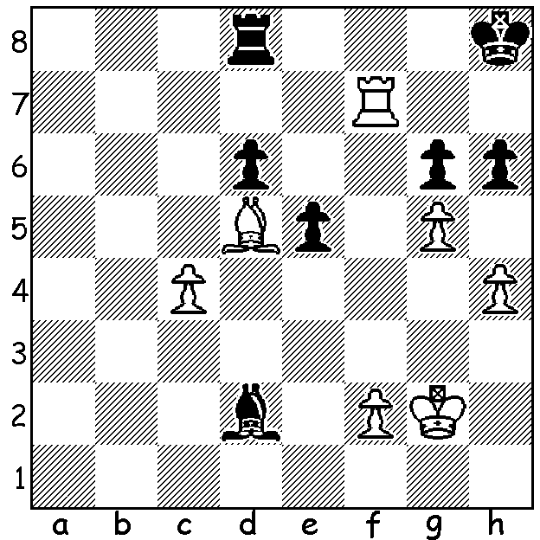

Judit Polgar – Romain Edouard
(12th European Ch 2011): despite
White’s positional advantage, with
material level and opposite colour-
squared bishop, one might expect a
draw but Polgar finds a winning
move with the game lasting only
another 3 moves:

Today is the final week of our look at the life and career of the world’s greatest female player, Judit Polgar, born in Hungary in 1976, who became a Grandmaster at 15 and declined to play in women’s events, instead striving to prove herself the equal of any man and reaching a ranking high of 8th in 2005.
She married Gustav Font, a veterinarian, in 2000 and gave birth to a son Oliver in 2004 and a daughter Hanna in 2006. After taking time off for the birth of her son her return to chess saw her return to 8th in world rankings and reach her highest rating of 2735. However with a marriage and two children chess was no longer her number 1 passion. “My goal,” she said, “is to raise my children to be happy and successful. I choose the tournaments I play in …I want to play chess while I’m still fascinated by it. The moment I stop having fun I quit.” That time came on August 14 near the end of the Tromso Olympiad where she scored 4.5/6. However chess will still be an important part of her life through the Judit Polgar Chess Foundation which aims to bring all the educational benefits of chess to children throughout the world.

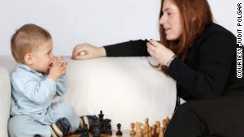



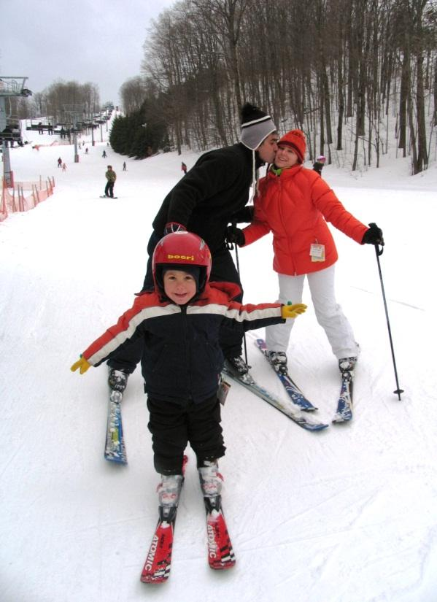
with husband Gustav in Botswana

with son Oliver

skiing with husband and son

Christmas with mother
Klara, and children, Oliver
& Hanna

Today’s game then is one played after the birth of her second child against Kramnik’s challenger Veselin Topalov in the bitter ‘toiletgate’ world championship match earlier in the year (2.5 – 1.5 to Kramnik in play-off after tied match 6-6):

JUDIT POLGAR - VESELIN TOPALOV
2006 Essent Tournament, Rd 2
Sicilian Scheveningen, Keres Attack
1.e4 c5 2.Nf3 d6 3.d4 cxd
4.Nxd4 Nf6 5.Nc3 a6 6.Be3 e6
7.g4 h6 8.Bg2 g5 9.Qe2 Nbd7
10.0-0-0 Ne5 11.h3 Nfd7 12.f4 gxf
13.Bxf4 b5 14.Rhf1 Bb7 15.Qf2!(a) Rc8
16.Nce2 Bg7 17.Ng3 Rh7 18.Nh5 Bh8
19.Kb1 Nc5 20.Bg3(b) Nxe4 21.Bxe4 Bxe4
22.Bh4 Qc7 23.Bf6 Bg6 24.Bxh8 Rxh8(c)
25.Nf6+ Kd8 26.h4 Qc5 27.h5 Bh7
28.Qh4! Bxc2+ 29.Nxc2 Qxc2 30.Ka1 Rc4
31.Ne4+ Kc7 32.Nxd6 Rf4! 33.Qe7+ Kb6
34.Qb7+ Ka5 35.Qa7 b4 36.Rfe1 Nf3
37.Rc1 Nxe1 38.Rxc2 Nxc2+ 39.Kb1 resigns(d)

a) Preparing a knight tour c3 to f6.
b) Missing 20.Nf5! exf5 21.Bxe5 Bxe5 22.Qxf5 winning.
c) Not 24…Bxh5? 25.Bxe5 dxe5 26.Nxe6!
d) Black cannot prevent all of White’s mating threats. Polgar went on to finish 1st= with Shakhriyar Mamedyarov with 4.5/6.

SOLUTION: 1.h5! (a fine pawn-lever sacrifice) if 1…gxh 2.g6 will soon win. Black played 1…Rg8 but resigned after 2.Rd7 Rg7 3.Bf7.

