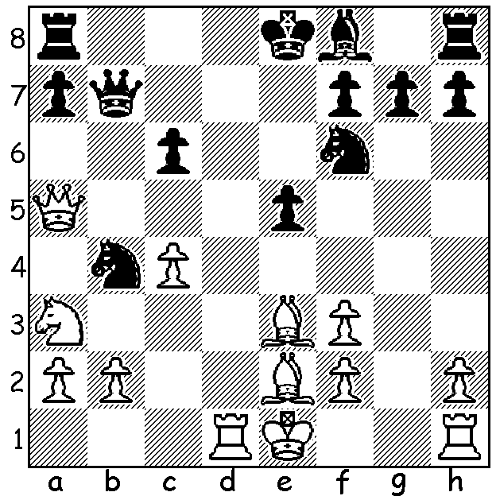

George Carolin-Unkovich – Robert Maris
(2014 WA Ch. Rd 7):
Black gains a winning advantage in 4 moves:

The recently completed WA Championship was won comprehensively by Yita Choong with 6.5/7, a point and a half ahead of Robert Maris and Akef Saleh with Kathryn Hardegen, Natalie Taylor and David Ellis a further half point behind. Yita thus adds to his title wins of 2011 & 2012 while Kathryn and Natalie (both 4.5/7) are to play-off for the WA Women’s title. Other titles and prize-winners: Senior champion Akef, Best Junior George Carolin-Unkovich (4), Under 1800 Rating 1st Sri Krishna Dharmapuri (4), =2nd Robin Shaw, Ignatius Yap & Sean Xiong (3.5), Under 1400 Rating 1st Alex Jones (3.5), =2nd Graeme Mc Quilkin & Gurpartap Singh (3) (George, Sri Krishna, Ignatius and Sean are all among the leading WA juniors able to compete with the top players of the state).

George Carolin-Unkovich - Yita Choong
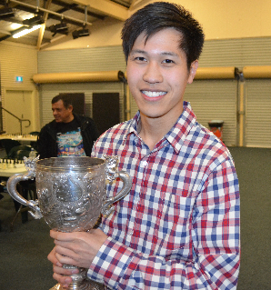
Rd 2: Caro-Kann Advance
1.e4 c6 2.d4 d5
3.e5 c5 4.c3 Nc6
5.Nf3 Bg4 6.Bb5 e6
7.Bxc6+ bxc6 8.0-0 Qd7
9.Be3 Bxf3 10. Qxf3 f6
11.dxc fxe 12.Qh5+ g6
13.Qxe5 Bg7 14.Qg3 Nf6
15.Bd4? Ne4 16.Qe3 e5
17.Bxe5 Bxe5 18.f3 0-0
Black maintains a winning material advantage – if 19.fxe4 Bxh2+!

Yita Choong - Robert Maris
Rd5: Scandinavian Defence
1.e4 d5 2.exd Qxd5 Yita Choong after receiving
3.Nc3 Qd6 4.d4 Nf6 WA championship trophy
5.Bc4 a6 6.Nge2 b5 (Akef Saleh in background)
7.Bb3 Bb7 8.Bf4 Qb6
9.Qd2 e6(a) 10.0-0-0 Nbd7
11.d5 e5 12.Be3 Bc5
13.Bxc5 Nxc5 14.Qg5 Qd6
15.Qxg7 Rg8 16.Qh6 Rxg2
17.f4 Rg6 18.Qh3 b4
19.Na4 Nce4 20.Rhf1 Bc8
21.Qe3 Bg4 22.fxe Qxe5
23.Rde1 Bxe2 24.Rxe2 Kf8
25.Nc5 Re8 26.Rxf6! & wins.
a) If 9….Bxg2 10.Rg1 gives White a dangerous lead in development (10…Bb7 11.a4 ).

Yita Choong - Kathryn Hardegen
Rd 7: Irregular Defence
1.e4 d6 2.d4 Nf6
3.Nc3 c6 4.f4 Qa5
5.Bd3 e5 6.Nf3 Bg4
7.Be3 exf 8.Bxf4 Qb6
9.Qd2 Bxf3 10.gxf3 Qxd4
11.0-0-0 Nbd7 12.Be3 Qb4
13.f4 Be7 14.Rhg1 g6
15.Rg5 b5 16.Qe2 Nc5
17.e5 Nxd3+ 18.Rxd3 Ne4
19.Nxe4 Qxe4 20 Rd4 & wins
(the queen is lost – 20.Qh1+ Rg1)

Perhaps the surprise of the tournament was Perth’s president, veteran Fred Maris, drawing with Yita despite being outrated by over 700 points:

Fred Maris - Yita Choong
Rd 4: Caro-Kann Advance
1.e4 c6 2.d4 d5
3.e5 c5 4.dxc Nc6
5.Bb5 Qa5+ 6.Nc3 e6
7.Be3 Nh6 8.a3 Nf5
9.Bd4 Nfxd4 10.Qxd4 Qxb5!
11.Nxb5 Nxd4 12.Nxd4 Bxc5
13.Nge2 a5 14.Kd2 0-0
15.f4 f6 16.Rhf1 Bd7
17.c3 a4 18.g4 Ra6
19.h4 Rb6 20.Kc2 Rc8
21.h5 Bb5 22.Nxb5 Rxb5
23.Rfd1 Ba7 24.Rd3 Rc4
25.Nd4 Bxd4 26.Rxd4 fxe
27.fxe Rxd4 28.cxd4 Rb3
29.Rf1 Rg3 30.Rf4 g5
31.hxg6 hxg 32.g5! Rxg5
33.Rf6 Rf5 34.Rxg6+ Kf7
35.Rg4 Rf3 and drawn after move 39.

SOLUTION: 1…Nd3+! (clearance sacrifice 2.R/Bxd3? Bb4+) 2.Kf1 Bb4 3.Qa4 Nxb2 4.Qb3 Nxd1.

