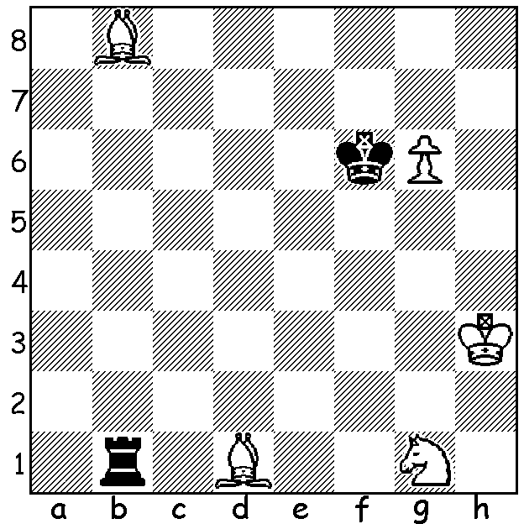

The DEFLECTION SACRIFICE
(or Decoy Sacrifice) lures a hostile piece
from an effective to a disadvantageous
square. In this problem by A. Wotawa
1954 deflection sacrifices ensure the
promotion of White’s pawn (6 moves):

Two Australians, Darryl Johansen and Anton Smirnov, won this year’s George Trundle Masters in Aukland (10 players) with 6.5/9 each. In the final round Darryl, who went through undefeated, drew his final game allowing Anton, who won brilliantly, to draw level. Darryl, now 55, was the second Australian to gain the title of Grand Master, has been Australian champion six times, has represented Australia in 14 Olympiads and has attained a world ranking of 91st (1983), while Anton, the son of the Russian IM Vladimir Smirnov, is only 13 and played his first Olympiad this year scoring a sensational 7.5/9 which secured him the International Master title. Here is his last round win in Aukland:

Anton Smirnov - Leonard McLaren
2014 George Trumdle Masters (Aukland) Rd 9
Sicilian Scheveningen
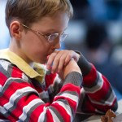
1.e4 c5 2.Nf3 d6
3.d4 cxd 4.Nxd4 Nf6
5.Nc3 e6 6.Be3 a6
7.Be2 Be7 8.f4 Nc6
9.g4 d5 10.e5 Nd7
11.g5 Nxd4 12.Qxd4 h6
13.g6! f5(a) 14.0-0-0 Bc5
15.Qd2 Qb6 16.Bxc5 Nxc5
17.Qd4 0-0 18.Bf3 Kh8
19.Rhe1 Rd8 20.b4! Nd7
21.Nxd5! exd5 22.e6 Qxd4
23.Rxd4 Nf6 24.e7 Re8
25.Bxd5 Bd7 26.Bf7 Bc6
27.Bxe8 Rxe8 28.Rd8 Bf3
29.Re6 Bc6 30.Rxc6! bxc6
31.Rxe8 Nxe8 32.c4 Nc7 Anton Smirnov
33.a4 Kg8 34.b5 cxb
35.cxb axb 36.axb resigns

a) Black keeps the position closed but White’s advanced pawn will prove vital.

And here’s a win from Darryl showing his skill in flexible English positions:
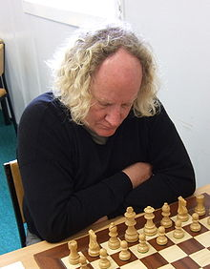
Darryl Johansen - Michael Steadman
2014 George Trundle Masters, Rd 1
English Opening
1.c4 e6 2.Nf3 Nf6
3.Nc3 Bb4 4.g3 0-0
5.Bg2 d5 6.a3 Bxc3
7.dxc3 c6 8.0-0 Nbd7
9.Nd2 Re8 10.b4 b5
11.cxb cxb 12.c4! bxc
13.Nxc4 Qc7 14.Na5 Ba6
15.Bb2 Rac8 16.Rc1 Qd6
17.Qd2 Nb6 18.Rfd1 Qe7
19.Nc6 Qd7 20 Ne5 Qb5
21.e3 Qa4 22.Rxc8 Rxc8
23.Rc1 h6 24.Rxc8 Nxc8
25.Nd3 Nd7 26.Qc3 Qd1+
27.Bf1 f6 28.b5! resigns(a) Darryl Johansen

a) The deflection sacrifice wins – 28...Bxb5 29.Qxc8+ / 30.Qc1 or 28…Bb7 29.Qc7.
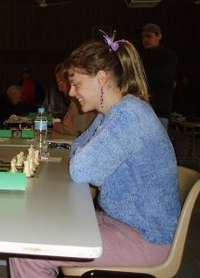
Congratulations to Natalie Maris in once again winning
the WA Women’s Championship after defeating Kathryn
Hardegen 2-0 in two long hard fought play-off games after
the two ladies tied =4th in the WA Championship with 4.5/7.
The win also enabled Natalie to claim the WA Reserves
Champion title.

SOLUTION: 1.Be5+! (the first deflection luring the king
away from the pawn) 1…Kxe5 (not 1.Kxg6 2.Bc2+) 2.g7 Rb8
3.Bb3!! (the second ) 3…Rxb3+ (White threatens 4.g8=Q
leaving him sufficient mating material with B + N) 4.Nf3+!
(the third) 4…Rxf3+ 5.Kg2 and the rook is now unable to
attack the pawn which will queen (queen v rook is a simple
win). The deflection sacrifice allowing a capture with check
is known as Mitrofanovs Deflection.

Natalie Maris

