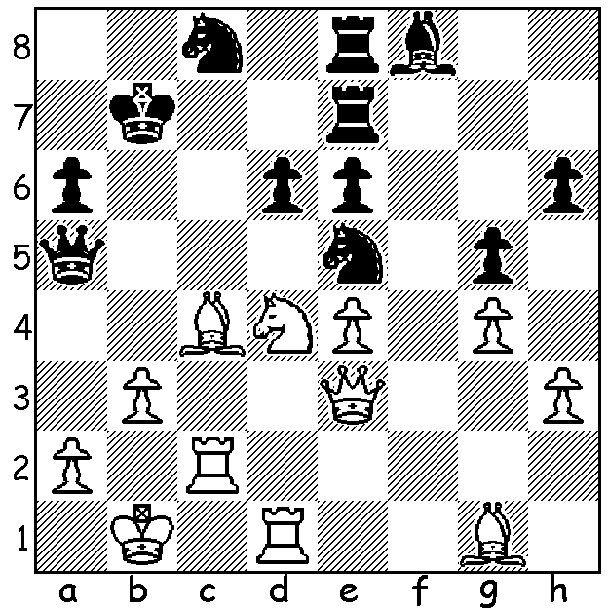

From the recent World Junior Championship,
Lu Shanglei (China) – Karen Grigoryan (Armenia),
White utilises every piece in a mating attack (5 moves):

The 2014 World Junior Championship, played this year in Pune, India, was won by Lu Shanglei (China) with 10/13, a half point ahead of Wei Yi (China), favourite Vladimir Fedoseev (Russia) and Jan-Krysztof Duda (Poland). The Girls Champion was Alekandra Goryachkina (Russia) with 11/13, a point and a half ahead of the runners-up, winning the title for the second time. Australia had representatives in all divisions, both Open and Girls, Under 8, 10, 12, 14, 16 and Under 18, and although not featuring in the prize list all performed creditably, especially Zhi Lin Guo (Girls Under 16) who gained over 100 rating points. Our game today features the exciting play of the new champion who came into the tournament ranked only 13th:

Lu Shanglei - Shardul Gagare (India)
2014 World Junior, Rd 3
Caro-Kann Defence
1.e4 c6 2.Nc3 d5
3.d4 g6 4.Nf3 Bg7
5.h3 dxe 6.Nxe4 Nd7
7.Bc4 Ngf6 8.Nxf6+ Nxf6
9.0-0 0-0 10.Re1 Qc7
11.Ne5 Nd5 12.Bb3 b5
13.c3 a5 14.a4 Bb7(a)
15.Bxd5 cxd5 16.axb f6
17.b6! Qd6(b) 18.Nd3 e5
19.Nc5 Rf7 20.Qb3 Qc6
21.Be3 e4 22.Ra4(c) f5
23.c4(d) f4 24.cxd Qc8(e)
25.d6!?(f) fxe3 26.fxe Qf5
27.Nxb7(g) Qf2+ 28.Kh2 Qxe1
29.d7 Bf6(h) 30.Nd6 Rf8
31.Ra1!?(i) Qxa1 32.Nxf7 Qe1(j)
33.b7 a4 34.Qe6 Bh4
35.Nd8+ Kg7 36.b8=Q Bf2
37.Qe7+ Kg8 38.Qf7+! resigns (k)

a) With this pawn sacrifice Black hopes to use his 2 bishops to open the centre and press on the kingside.
b) Not 17…Qxb6? 18.Nd7.
c) Planning to double rooks and win the a pawn.
d) 23.Bf4 would slow Black’s kingside advance.
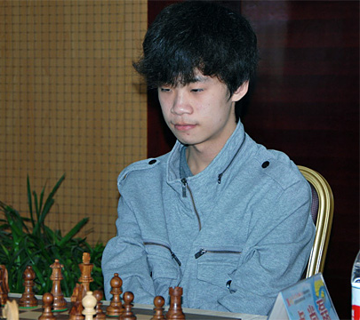
e) Exchanging queens with 24…Qxd5 would deprive
Black of attacking chances.
f) A drastic measure to stop Black’s counter attack:
however 25.Bd2 was safe –25…Qf5 (25…f3 26.Nxb7
or 25…e6 26.fxe f3 27.Rf1) 26.Nxb7 Rxb7 27.d6+ Kh8
28.d5 winning.
g) If 27.Raa1 Bd5.
h) Very logical, defending d8 and threatening …Bh4
with mating threats: however 29…Qh4 was better.
i) An astounding rook sacrifice to divert the queen
from the e1-h4 diagonal and gain one tempo.
j) Black’s queen hurries back but better was 32…a4!
(33.Qe6 Rxf7 34.Qxf6! Rxf6 35.d8=Q+ and the best
White can hope for is a draw).
k) 38…Rxf7 39.Ne6+ Rf8 40.Qxf8#. A spectacular
finish to cap off White’s most imaginative play. Lu Shanglei

SOLUTION: 1.Bxe6! Rxe6 2.Nxe6 Rxe6 3.Rdc1 Re8 4.Rxc8! resigns (4…Rxc8 5.Qa7#).

