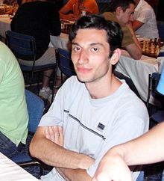
Baadur Jobava – Sergey Karjakin 2013:
find the winning move for White:

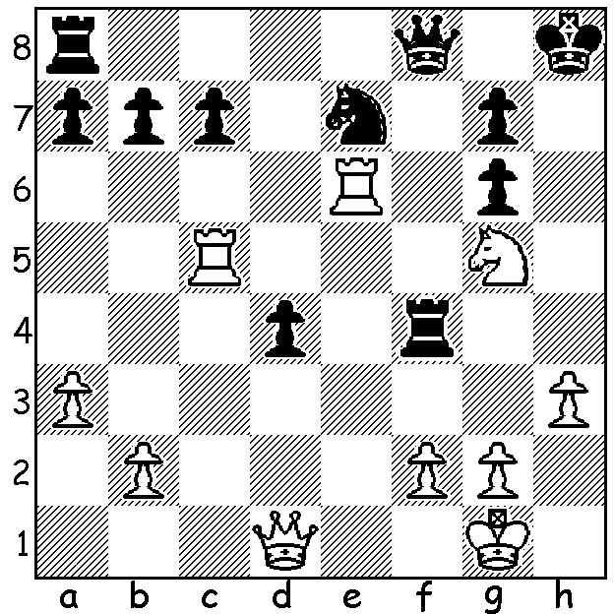 Baadur Jobava

The most recent World Grand Prix event in Tashkent, Uzbekistan, was won by Dmitry Andreikin (Russia) with 7/11 (+3 =8). Close behind were Hikaru Nakamura (USA) & Shakhriyar Mamedyanov (Az). Other scores: Maxine Vachier-Lagrave (Fr), Sergey Karjakin (Rus) & Baadur Jobava (Geo) 6, Teimour Radjabov (Az) 5.5, Anish Giri (Neth) 5, Dmitry Jakovenko (Rus) 4.5, Rustan Kasimdzhanov (Uz) & Boris Gelfand (Isr) 3.5. After his recent successes it was a disappointing result for Caruana, as it was for Gelfand, a former challenger for the world title. Four players, including Radjabov who drew every game, failed to register a win. One player who stood out for his aggressive play and willingness to try out off-beat openings was 30 year old Baadur Jobava, Georgia’s top player. Examples were: 1.d4 e6 2.c4 Bb4+ (the Franco-Indian Defence, Black v Nakamura 0-1), 1.e4 e5 2.Nf3 Nc6 3.Be2 (a Reversed Hanham Philidor, White v Caruana 0.5-0.5), 1.e4.c6 2.Nf3 d5 3.Nc3 dxe4.Nxe4 Nf6 5.Nxf6+ exf6 (Caro-Kann, Black v Karjakin 0.5-0.5), 1.d4 e6 2.c4 b6 3.e4 Bb7 (Owens Defence, Black v Gelfand 0-1). Mamedyanov was in the running for first place and the aggressive Jobava was the perfect opponent in the final round:

Baadur Jobava - Shakhriyar Memedyarov
Tashkent Grand Prix, Rd 11 (Oct 2014)
Benoni Defence
1.d4 Nf6 2.c4 c5
3.d5 e6 4.Nc3 exd
5.cxd d6 6.e4 g6
7.Nf3 Bg7 8.h3 0-0
9.Bd3 b5(a) 10.Nxb5 Nxe4!?
11.Bxe4 Re8 12.Ng5(b) Qa5+
13.Nc3 Ba6 14.Bd2 Nd7
15.Qc2 Rab8 16.0-0-0 Ne5
17.Rhe1(c) Rec8(d) 18.Na4 Rb4!
19.f4 Nc4 20.Bf5! Rcb8(e)
21.Bxb4 Qxb4 22.a3(f) Nxa3!
23.bxa3 Qxa3+ 24.Kd2 Qg3
25.Rb1(g) Qxf4+ 26.Kd1 Rxb1+
27.Qxb1 Qd4+(h) 28.Kc1 Qf4+
29.Kd1 gxf5 30.Re8+ Bf8
31.Nxc5(i) Qd4+ 32.Kc1 Qxc5+
33.Qc2 Qg1+ 34.Qd1 Qc5+
35.Qc2 Qg1+ 36.Qd1 Qxg2
37.Qh5 Qg1+ Draw(j)

a) The double-edged Benoni is an ideal defence when badly wanting to win. Memedyanov is prepared to play an ultra-sharp line, sacrificing a piece and unconcerned about recovering the lost material.
b) 12.Nd2 may be better.
c) 17.Na4 Qd8 18.Rde1 f5 19.f4 fxe4 20.fxe5 Bd3 21.Qd1 Bxe5 22.Nxe4 Bxe4 23.Rxe4 Bxb2+ 24.Nxb2 Rxe4 etc (I Bern – H. Olafsson 1994, 1-0).
d) Not 17…Nc4 18.Bd3 Rxe1 19.Rxe1 Nxb2 20.Bxa6 Qxa6 21.Qxb2 Rxb2 22.Re8+ Bf8 23.Kxb2 winning.
e) If 20.gxf5 21.Qxf5 Qxa4 22.Qxf7+ Kh8 23.Bc3 Ne5 24.Qf5 wins.
f) 22.Qb3 was better.
g) To lessen Black’s attacking force.
h) Or 27…Qxa4+.
i) 31.Qb8 allows a perpetual check.
j) With mate threatened Black will finally take the perpetual check.

WORLD CHAMPIONSHIP: Magnus Carlsen begins his defence of his world title today (Fr 7 Nov) against 2014 Candidates winner and ex-champion Viswanathan Anand in Sochi, Russia.

SOLUTION: 1.Rxg6! and if 1…Nxg6 2.Qh5+ Kg8 3.Qh7+. Black played 1…Rh5 but resigned after 2.Ne6.

