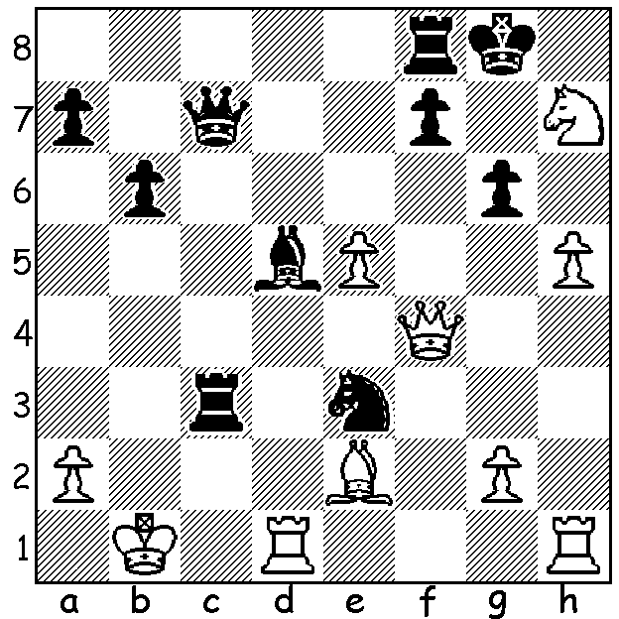

Alexander Beliavsky – Vishwanathan Anand 1991:
with both sides poised for the kill, Black gets in first
(5 moves):

WORLD CHAMPIONSHIP: The 23 year old Norwegian Magnus Carlsen began his defence of his world title last Saturday against the 2014 Candidates winner and ex-champion, the 44 year old Viswanathan Anand, in the Russian Olympic village of Sochi. At time of writing two games have been played, a draw and a win to Carlsen. In the first Carlsen nullified an early Anand advantage, coming close to victory and in the second put the Indian under intense pressure before a blunder brought the game to an abrupt end.

Viswanathan Anand - Magnus Carlsen
2014 World Championship, Game 1
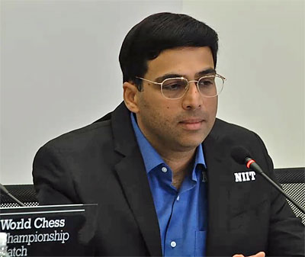
Grunfeld Defence, Exchange Variation
1.d4 Nf6 2.c4 g6
3.Nc3 d5 4.cxd Nxd5
5.Bd2(a) Bg7 6.e4 Nxc3(b)
7.Bxc3 0-0 8.Qd2 Nc6
9.Nf3 Bg4 10.d5 Bxf3
11.Bxg7(c) Kxg7 12.gxf3 Ne5
13.0-0-0 c6(d) 14.Qc3 f6
15.Bh3(e) cxd 16.exd(f) Nf7
17.f4 Qd6 18.Qd4 Rad8
19.Be6(g) Qb6 20.Qd2 Rd6
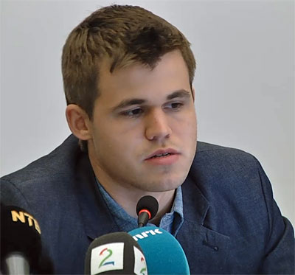
21.Rhe1 Nd8 22.f5 Nxe6
23.Rxe6 Qc7+ 24.Kb1 Rc8(h)
25.Rde1 Rxe6 26.Rxe6 Rd8
27.Qe3! Rd7 28.d6(i) exd
29.Qd4 Rf7 30.fxg hxg
31.Rxd6 a6 32.a3 Qa5
33.f4 Qh5 34.Qd2 Qc5
35.Rd5 Qc4 36.Rd7 Qc6
37.Rd6(j) Qe4+ 38.Ka2 Re7
39.Qc1 a5! 40.Qf1(k) a4
41.Rd1 Qc2 42.Rd4 Re2(l)
43.Rb4! b5 44.Qh1! Re7
45.Qd5! Re1 46.Qd7+ Kh6
47.Qh3+ Kg7 46.Qd7+ DRAWN

a) An alternative to the aggressive 5.e4 Nxc3 6.bxc3.
b) Previously Carlsen has played 6…Nb6.
c) This is an innovation.
d) Not 13…Nxf3?? 14.Qc3+.
e) Winning a pawn with 15.f4 Nf7 16.dxc Qc7 17.cxb Qxb7 18.Qe3 Rab8 18.b3 a5 leaves Black with a dangerous attack. The move chosen takes away c8 from a Black rook .
f) Preferring a more active position than the tidier 16.f4 Nf7 17.Rxd5.
g) White might have done better with 19.Rhe1 building pressure against the backward pawn.
h) Threat 25…Rxd5! 26.Qxd5? Qc2+ 27.Ka1 Qc1+.
i) 28.fxg hxg 29.h4 to open up the kingside looks natural.
j) 37.Rxf7+ looks drawish.
k) Again counter attack with 40.Qc8 (40…a4 41.Rd8 Qe6+ 42.Qxe6 Rxe6 43.Rd7+ Kh6 44.Rxb7) looks equal.
l) Better is 42...Re3! threatening 43…Rxa3+ and keeping White on the defensive.
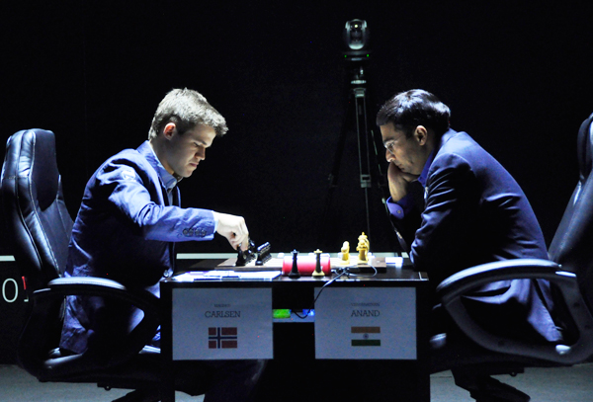
The popular CHRISTMAS OPEN is the final Grand Prix
event of the year (Sat 29 & Sun 30 Nov). Entries to Gordon
Dunlop preferably by Friday 28 (93686412).
See cawa.org.au for details.

The final film of the British Film Festival (7pm Sun 16 Nov
with drinks and snacks 6.30) is The Imitation Game dealing
with the Bletchley codebreakers, instrumental in breaking the
German Enigma Code during WWII. A number of leading
British chess players, including most of the English team
called back from the Buenos Aires Olympiad, were among
those recruited.

SOLUTION: 1…Rxb3+! (clearance sacrifice) White resigns Carlsen – Anand, Game 1
(2.axb3 Qc2+ 3.Ka1 Qc3+ 4.Ka2 Qxb3+ 5.Ka1 Qxa2# or 4.Kb1
Qxb3+ 5.Kc1 Qc2#).

