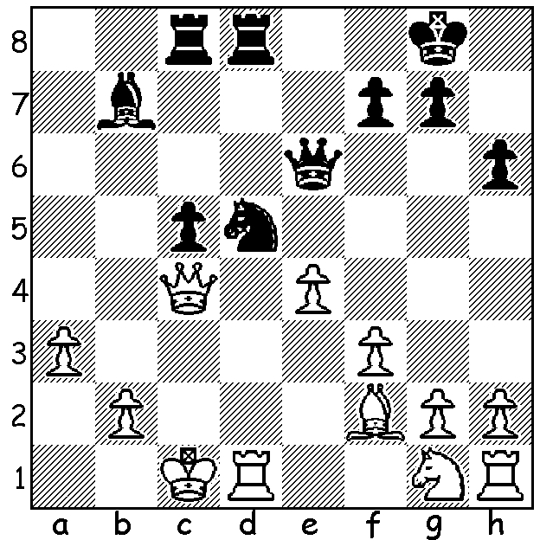

Ten year old Magnus Carlsen
finds a winning move
v Glen Gaasland in 2001:

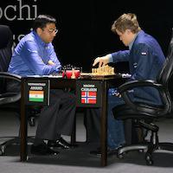
WORLD CHAMPIONSHIP
Defending champion Magnus Carlsen retained his title with
a win against challenger and former champion Viswanathan
Anand in Game 11, giving him a unassailable lead of 6.5 – 4.5.
Anand again played the solid Berlin Defence and seemed to be
getting the better position. With a draw Anand would have a
chance to square the match with a win with White in the final
game, heralding the need for rapid-play games to find the winner.
However an ill-advised exchange sacrifice handed the game to
Carlsen, bringing the match to a disappointing early finish:

Magnus Carlsen - Viswanathan Anand
2014 World Championship, Game 11 Start of Game 11
Ruy Lopez: Berlin Defence
1.e4 e5 2.Nf3 Nc6
3.Bb5 Nf6 4.0-0 Nxe4
5.d4 Nd6 6.Bxc6 dxc6
7.dxe5 Nf5 8.Qxd8+ Kxd8
9.h3 Bd7 10.Nc3 h6
11.b3 Kc8 12.Bb2 c5
13.Rad1 b6 14.Rfe1 Be6
15.Nd5 g5(a) 16.c4 Kb7
17.Kh2 a5 18.a4(b) Ne7
19.g4 Ng6 20.Kg3 Be7(c)
21.Nd2 Rhd8 22.Ne4 Bf8
23.Nef6 b5!! 24.Bc3(d) bxa
25.bxa Kc6 26.Kf3 Rdb8
27.Ke4 Rb4?(e) 28.Bxb4 cxb4(f)
29.Nh5 Kb7 30.f4 gxf
31.Nhxf4 Nxf4 32.Nxf4 Bxc4
33.Rd7 Ra6 34.Nd5 Rc6
35.Rxf7 Bc5 36.Rxc7+! Rxc7
37.Nxc7 Kc6(g) 38.Nb5 Bxb5
39.axb5+ Kxb5 40.e6 b3
41.Kd3 Be7 42.h4 a4
43.g5 hxg 44.hxg a3
45.Kc3 resigns

a) Preventing Nf4.
b) Necessary to prevent 18…a4 but White’s queenside pawns are now a likely target for Black’s white-square bishop.
c) 22...Bg7 would be met by 23.h4. White now rejects 24.Nxe7 as Black would be left with the more powerful bishop.
d) White dare not accept Black’s brilliant pawn sacrifice: 24.cxb c6! 25.bxc6+ Kxc6 or 24.axb a4 25.bxa Rxa4 26.Rc1 Nf4! are both good for Black.
e) This exchange sacrifice is the losing move. 27….Bg7 or …Be7 planning 28…Bxf6 and 27…Rb3 were good alternatives.
f) 28…axb4 would have given more chances.
g) If 37…Kxc7 38.Rc1 recovers the piece.

The popular CHRISTMAS OPEN is the final Grand Prix event of the year (tomorrow, Sat 29, 12.3pm -7.30pm & Sun 30 Nov, 10am – 5.30pm at N. Woodvale Primary). Entries to Gordon Dunlop, preferably today (93686412). See cawa.org.au for details.

WA Juniors thinking of playing in the Australian Junior Championships should ask about financial support from CAWA (0439798607 or 0419950619).

The opening film of the Lottery West Perth International Film Festival called The Dark Horse tells the inspiring story of Genesis Potini, a remarkable Maori man and sufferer of bipolar disorder, who takes on the task of teaching a motley group of children to play chess. ECU Joondalup Pines 28 & 30 Nov 8pm and Somerville UWA 1 – 7 Dec 8pm.

SOLUTION: 1…Ne3! - if 2.bxe3 Qxc4+: if 2.Qxe6 Rxd1#: if 2.Rxd8+ Rxd8 3.Qe2 Rd1+.

