Alexander – Bogoljubov 1951: C H O’D Alexander
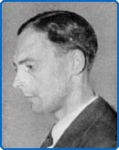
White to play and win (3 moves):

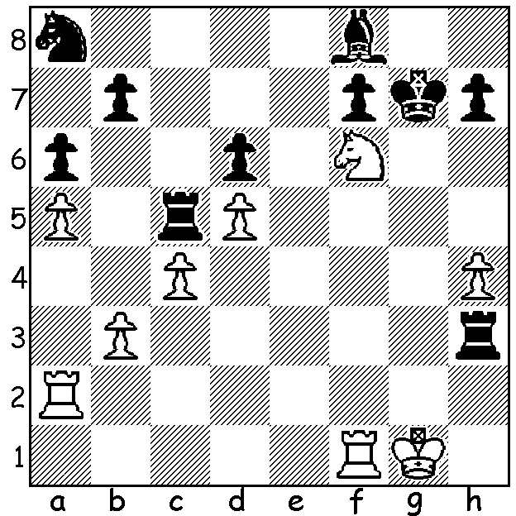

I enjoyed watching the final film of the British Film Festival, The Imitation Game, which deals with the Bletchley codebreakers, instrumental in breaking the German Enigma Code during WWII. The film can be watched in forthcoming days at at least two outdoor cinemas. A number of leading British chess players, including most of the English team called back from the Buenos Aires Olympiad, were among those recruited to Bletchley. One in particular, C Hugh O’D Alexander (1909 – 1975), figures very prominently in the film. Alexander was the UK’s leading player from the late 30s to the early 50s and was twice British champion. He represented England in six Olympiads, defeated future world champion Mikhael Botvinnik in the 1947 UK v USSR radio match, won Hastings in 1947 ahead of Savielly Tartakover and again in 1954 ahead of David Bronstein whom he beat in a long memorable game. He would almost certainly have become a Grandmaster had his work as head of the cryptanalysis division of GCHQ not restricted his opportunities and the secret nature of his work prevented his travel to Iron Curtain countries. Here is a game against Hungary’s leading player, Laszlo Szabo (1917 – 1998), one of the top 12 GMs in the world at his peak:

C H O’D Alexander – Laszlo Szabo
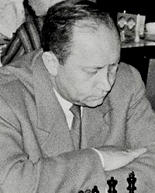
Hilversum, Netherlands, 1947
Sicilian, Scheveningen Variation
1.e4 c5 2.Nf3 Nc6
3.d4 cxd 4.Nxd4 Nf6
5.Nc3 d6 6.Be2 e6
7.Be3 Qc7 8.f4 a6
9.0-0 Na5 10.Kh1 Be7
11.Qe1 Nc4 12.Bc1 0-0
13.b3 Na5 14.Bd3 Nd7
15.Bb2 Bf6 16.Nf3 Nc5
17.e5! Nxd3 18.cxd3 dxe
19.fxe Be7 20.Ne4 Qd8
21.Nf6+! gxf6 22.Qg3+ Kh8
23.exf6 Bxf6 24.Ne5 Bxe5
25.Bxe5 f6 26.Rxf6! resigns
(26…Rxf6 27.Rf1) Laszlo Szabo

The Christmas Open (WA Grand Prix) was won by Ihsan Ferozkohi with 5.5/6 after managing to hold runner-up Marc Vlestra (5) to a draw in a long and difficult game. Third equal were Eddy Seah, Patrick Gong and Andrew Hardegen (4). At the prize-giving trophies were presented to some of the WA Junior champions – Open Jayden Williams from the Albany region and Ignatius Yap, Under 16 Sahil Parekh, Under 14 Sri Krishna Dharmapuri, Under 12 Joseph Gansemer, Under 10 Kindu Dharmapuri.

I’m delighted to announce the formation of a new club south of the river, the Southern Suburbs CC, which will hold an introductory meeting 7.30 Tuesday 9 December at the library of Leeming Primary, 10 Meharry Rd. The club will start play on Tuesday 3 February. Please come along and see what the club can offer whatever your standard. Enquiries Andrew Hardegen 0407421084.

The WA Club Teams Lightning Championship will be played at Moresby St. Hall on Sunday 14 December 11.30 – 4.00. Get together a team of 3 club mates or friends (Open, Under 1850 or Under 1500). Information cawa.org.au and enquiries and submission of teams to Gordon Dunlop 93686412.
Prize-giving for the tournament and many other events (WA Championship, GP, etc) will follow the end of the final round.

The deadline for entry to the Australian Junior Championships (Canberra 17-25 Jan) is this Sunday, Dec 7. Details ajcc.org.au and contact 0439798607 or 0419950619 if you would like some financial support.

The Australian Open Championship will be held from 2 -11 January at Castle Hill, Sydney. Details ausopenchess.com with 8 Dec the last chance to get a reduced entry fee.

SOLUTION: 1.Rg2+ Kh6 (1…Kh8 2.Rg8#) 2.Rf5! (the quiet move): if 2…Be7 3.Rh5# and if 2…Rxh4 3.Ng8#.

