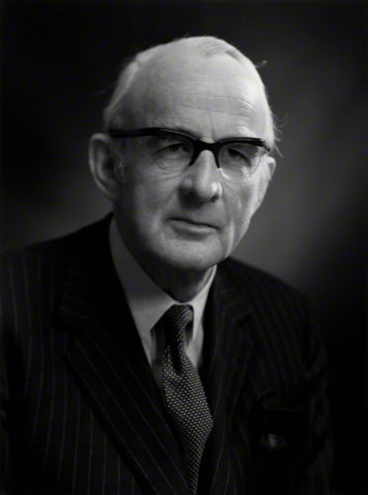
Milner-Barry – Znosko-Borovsky 1928:
White’s next move forces immediate resignation:

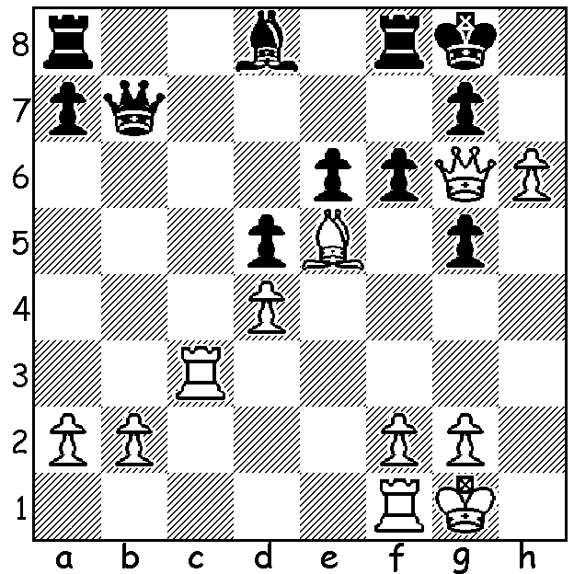 Sir Philip Stuart Milner-Barry

I’m following up from last week with more chess players recruited to the Bletchley Park codebreakers, instrumental in breaking the German Enigma Code during WWII. Other prominent players included Sir Philip Stuart Milner-Barry, Harry Golombek OBE, Jack Good, Donald Michael and Dr. James McRae Aitken. Milner-Barry (1906-95), twice a British chess Olympian who had two openings named after him (the gambit in the French Advance 1.e4 e6 2 d4 d5 3.e5 c5 4.c6 Nc3 5.Nf3 Qb6 Bd3 and in the Nimzo-Indian 1.d4 Nf6 2.c4 e6 3.Nc3 Bb4 4.Qc2 Nc6), described the intensity of code-breaking as ‘rather like playing a tournament game – sometimes several games – every day for five and a half years’. Golombek (1911-95) was three times British champion, a nine times chess Olympian and a prolific writer. Good (1916-2009) was a maths genius and Cambridgeshire champion who became a technical and scientific adviser to Stanley Kubrick for ‘2001 – A Space Odyssey’. Donald Michael (1923-2007) later became involved in the development of artificial intelligence and chess computers. Aitken (1908-83) was a British International and a 10 times Scottish champion who represented his country (Scotland) in 4 Olympiads. (I remember playing a final round 70+ move game against him in the 1970 West of England championship with the ensuing draw preventing my second West of England shared title.)

GOLOMBEK - BROWN
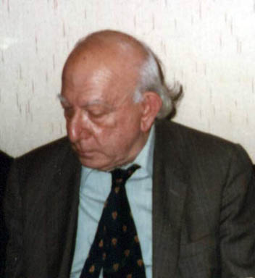
London 1939
Alekhines Defence
1.e4 Nf6 2.e5 Nd5
3.Nc3 Nxc3 4.bxc3 d5
5.f4 e6 6.Nf3 c5
7.d4 b6 8.Bd3 Ba6
9.0-0 Bxd3 10.Qxd3 c4
11.Qe2 g6 12.g4 h5
13.f5! hxg 14.fxe! gxf3
15.Qxf3 f5 16.exf6 Bd6
17.Bg5 Qc7 18.f7+ Kf8
19.Qf6! Bxh2+ 20.Kh1 Be5+
21.Qxh8+ Bxh8 22.e7+ resigns Harry Golombek

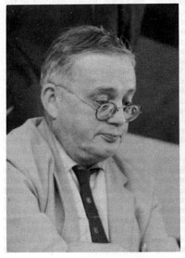
F E A KITTO - J M AITKEN
Bournemouth 1939
Ruy Lopez, Berlin Defence
1.e4 e5 2.Nf3 Nc6
3.Bb5 Nf6 4.0-0 Nxe4
5.d4 Nd6 6.dxe Nxb5
7.a4 Nd6 8.exd6 Bxd6
9.Nc3 0-0 10.Nd5 Be7
11.Bd2 d6 12.c4 Bg4
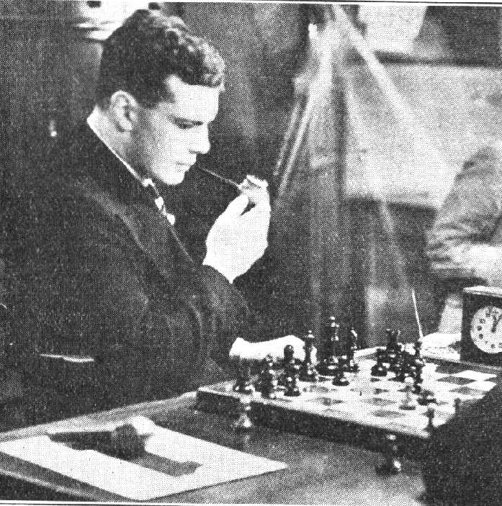
13.Bc3 Ne5 14.Re1 Bf6
15.Kh1 c6 16.Ne3 Bxf3
17.gxf3 Ng6 18.Qd3 Be5
19.Ng4 Bxc3 20.Qxc3 f5
21.Ne3 Qh4 22.Re2 Qh3
23.Nc2 Nf4 24.Rg1 Rf6
25.Re7 Kf8 26.Rexg7 Qxh2+
27.Kxh2 resigns

Black, a British international and West of England champion
in 1951 & 1955, realises he will lose his knight or the a8 rook
after 27…Rh6+ 28.Kg3 Ne2+ 29.Kg2 Nxc3 30.Kf1! Aitken (top) & Kitto

The WA Club Teams Lightning Championship will be played at Moresby St. Hall this Sunday, 14 December 11.30 – 4.00. Get together a team of 3 club mates or friends (Open, Under 1850 or Under 1500) or just come and help make up a team. Information cawa.org.au and enquiries and submission of teams to Gordon Dunlop 93686412. Prize-giving for the tournament and many other events (WA Championship, GP, etc) will follow the end of the final round.

SOLUTION: 1.Rc7! (obstruction sacrifice) Black resigns.

