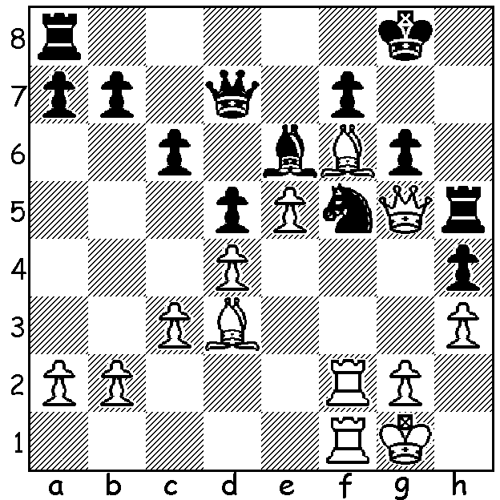

The theme this week is weakened pawn
structure around the castled king and the
power of a bishop or pawn established on f6:
David Ellis – John Steinbock 1989
(White to play, 5 moves):

The Russian Championship and Russian Womens Championship were played last month at the State Museum of Fine Arts in Kazan, Tartarstan with 10 players in each event. While the women’s competition produced many decisive results, draws proliferated in the principle section with White and Black winning only 20% of games each. Winner was 27 year old Igor Lysyj with 5.5/9, followed by Dmitry Jakovenko (5) and 5 players on 4.5, including 7 times winner Peter Svidler, Ian Nepomniachtchi and Alexander Morozevich, ranked second in the world in 2008. Only one player lost more games than the winner and four lost fewer games, but Lysyj, was rewarded for his aggressive approach which netted him four wins.

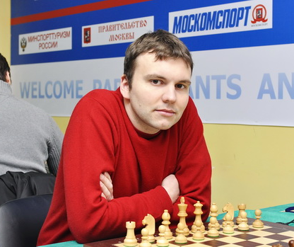
Alexander Morozevich - Boris Grachev
2014 Russian Championship, Super-Final Rd 2
Sicilian, Taimanov
1.e4 c5 2.Nf3 e6
3.d4 cxd 4.Nxd4 Nc6
5.Nc3 a6 6.Be2 Qc7
7.0-0 Nf6 8.Be3 Be7
9.f4 d6 10.Qe1 0-0
11.Qg3 Nxd4 12.Bxd4 b5
13.a3 Bb7 14.Kh1 Bc6 Igor Lysyj
15.Bd3 Qb7 16.Rae1 b4
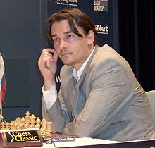
17.axb Qxb4 18.Ne2 Qb7
19.e5 Nh5 20.Qh3 g6
21.Ng3 Nxg3+ 22.hxg3 dxe
23.Bxe5 Bb4 24.Bf6! Be7(a)
25.Bxe7 Qxe7 26.f5! Rfe8(b)
27.f6 Qc5 28.Rf4 Qg5
29.Rh4 h5 30.Rf1 Rad8
31.Bxg6! Rd2(c) 32.Bxh5 Bxg2+
33.Qxg2 Rxg2 34.Kxg2 Qd2+
35.Rf2 Qc1(d) 36.Be2 Qe3(e)
37.Bd3 e5 38.Rg4+ Kh8
39.Rf5 resigns(f) Alexander Morozevich

a) This allows a White pawn to reach f6: better 24…Rfe8.
b) 26…gxf5 27.Bxf5.
c) Black must pin his hopes on counterattack as 31…Qxg6 (31…fxg6? 32.f7+) loses to 32.Rxh5.
d) Losing quickly: best was 35…Qd6 (36.Bg6! Rb8 37.Bh7+ Kf8 38.Bd3 Ke8) with reasonable chances.
e) If 36…Qxc2 37.Bb5! and if 36…Qxb2 37.Bd3 wins
f) 38…Kf8 39.Bh7 / 40.Rg8#.

A number of WA players will be competing in the Australian Open in Sydney and Junior Championships in Canberra:
Open Championship: Akef Saleh, Richard Lilly, Kathryrn Hardegen, Patrick Gong, Evan Yeung, Noelle Martin:
Junior Championships: Patrick Gong, Paddy Koh, Benjamin Hurst, Sri Krishna and Kudan Dharmapuri.
Last January we had a WA winner with George Carolin-Unkovich claiming the Australian Under 16 Championship. Here’s hoping we get another winner in 2015.

CORRECTION: In the second game last week White and winner was J M Aitken with F E A Kitto having Black.

SOLUTION: 1.Qxh5! gxh5 2.Rxf5! Bxf5 3.Rxf5 and facing 4.Rxh5 & 5.Rh8# Black played 3.Qxf5 leading to a lost endgame.

