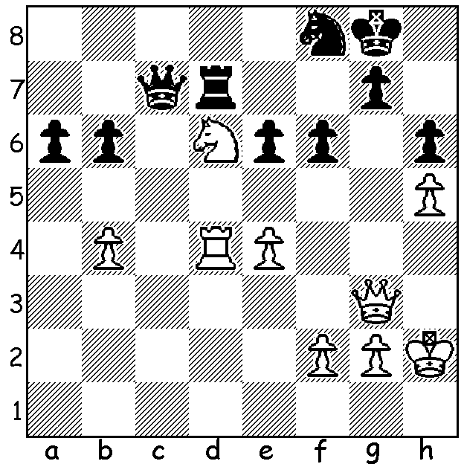

Gunina – Pogonina
(Russian Womens Championship 2014):
White to play and win (5 moves):

Our second look at the Russian Championships concentrates on the struggle in the women’s event with the winner 25 year old Valentina Gunina winning with the splendid score of 7/9. Her seven wins and two losses reveal her fighting spirit, as she frequently took risks to win. In fact, in contrast to the men where 60% of games were drawn, 36 of the 45 women’s games were decisive. The game below is a final round game pitting the winner against runner-up with both players needing a win to gain the title. The loser, Alisa Galliamova, 42, lost a close match in 1998 for the Womens World Championship to Xie Jun (China) by 6.5 – 8.5.

Alisa Galliamova - Valentina Gunina 2014
Russian Womens Championship, Super-Final Rd 9
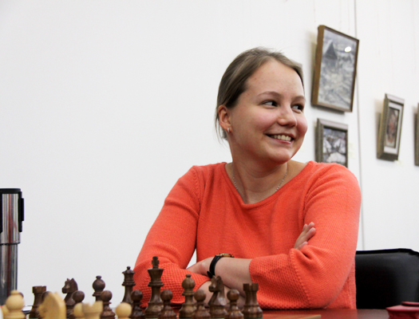
Queens Gambit, Semi-Slav Defence
1.d4 d5 2.c4 c6
3.Nc3 Nf6 4.e3 e6
5.b3 Bb4 6.Bd2 Nbd7
7.a3 Bd6 8.c5 Bc7
9.f4(a) Ne4 10.Nxe4 dxe4
11.Ne2 0-0 12.Nc3 f6(b)
13.Nxe4(c) e5 14.Bc4+ Kh8
15.0-0 exd 16.exd Re8
17.Ng3 b5 18.Bf7 Re7
19.Bh5 Nf8 20.Ne2 Bf5
21.Bf3 Be4 22.Bc3 Qd5
23.Bxe4 Rxe4(d) 24.Bb2 Re3 Valentina Gunina
25.Nc3 Qf5 26.Qb1 Qd7
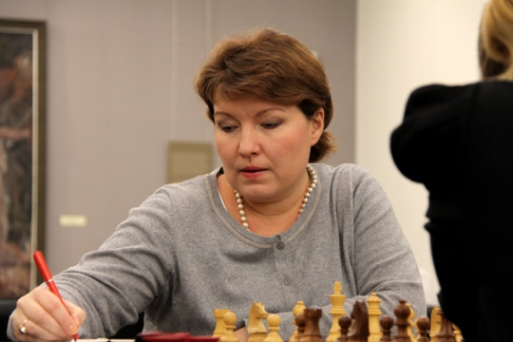
27.Qd1 Rae8 28.Qd2 Qg4(e)
29.Qd1 Qf5 30.d5(f) cxd(g)
31.Nxb5 Bxf4!?(h) 32.Nd6 Qg6
33.Nxe8 Rd3! 34.Qb1(i) Bxh2+!
35.Kh1(j) Bg3 36.Kg1 Qh6
37.Rxf6! Qe3+ 38.Kh1 gxf6
39.Nxf6(k) Qh6+ 40.Nh5+ d4
41.Qxd3 Qxh5+ 42.Kg1 Qh2+
43.Kf1 Qh1+ 44.Ke2 Qxg2+
45.Kd1 Qxb2 46.Rc1 Bf4
47.Rc4 Be3 48.Rc2 Qb1+
49.Ke2 Ne6 50.Qf5(l) Nf4+
51.Kf3 Qf1+ 52.Ke4 Qh1+ Alisa Galliamova
53.Ke5 Qd5+ 54.Kf6 Nh5+
White resigns

a) To prevent Black’s natural advance …e5.
b) Striving to win, Black avoids 12…f5 blocking the position further, instead speculatively sacrificing a pawn.
c) 13.Bc4 is also good.
d) With better bishop and control of the e file, Black has ample positional compensation for the pawn.
e) Threatening 29…Re2!
f) White avoids a possible draw by repetition by 30.Qd2 Qg4.
g) 30…Bxf4 is best (31.g3 Rd3 / 31…Be3+)
h) Black now allows a knight fork.
i) White should now play 34.Nxf6!! Rxd1 35.Raxd1 winning.
j) Not 35.Kxh2? Qg3+ 36.Kg1 Rd2 winning.
k) Better 39.Bxf6+ Kg8 40.Bg5! Qxg5 41.Qxd3 Qh6+ 42.Kg1 Qh2+ 43.Kf1 Qh1+=.
l) If 50.Qd1 Qxb3 maintains the advantage.

SOLUTION: 1.e5! (We often see pawn sacrifices to open up diagonals. This sacrifice closes the h2-b8 diagonal) 1…fxe 2.Ne8 Qb7 3.Rxd7! Qxd7 4.Nf6+ (if 1…Nh7 to protect f6, 2.Rc4 Qa7 3.Rc8+ Nf8 4.exd wins).

