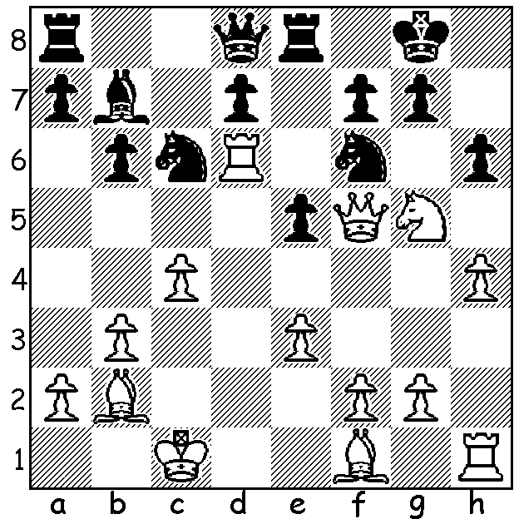
Magnus Carlsen - Nurlan Ibraev 2004:
White to play and win (6 moves):

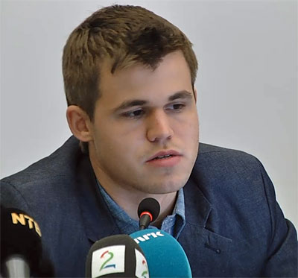

With the passing of 2014 one might look back on one’s achievements and highs. On a personal level, in a year with no tournament wins, I take some satisfaction from setting up the Ian Rogers interview on ABC Classis FM radio with Margaret Throsby (I hope you managed to listen to it).
If Stepan Osinovsky were asked to name the achievement or high of the past year it would undoubtedly be playing and defeating the world champion Magnus Carlsen. Stepan, aged 29 from Russia, ranked a modest 2241 by top world standards, was one of 10 players from chess.com members to take part in an internet simultaneous by Carlsen with a time limit of 25 mins + 25 sec increments. Carlsen played at great speed, finishing with more than 25 mins on his clock in many of the games and won the match 9-1. His most satisfying win entailed a positional queen sacrifice while his loss also entailed a winning positional queen sacrifice:

Magnus Carlsen - Penguingani 1 (rated 2384)
chess.com Simultaneous, December 2014
Queens Gambit Declined
1.Nf3 d5 2.c4 e6
3.d4 Nf6 4.Nc3 Be7
5.Bf4 0-0 6.e3 Nbd7
7.c5 Ne4 8.Rc1 f5
9.h3 c6 10.b4 Bf6
11.Bd3 a5 12.a3 axb
13.axb b5 14.0-0 Re8
15.Ne2 Bb7 16.Ra1 Qe7
17.Ne5 Rxa1 18.Qxa1 Nd2
19.Rd1 Ra8 20.Qxa8+! Bxa8
21.Rxd2 Bb7 22.Ra2 Qd8
23.Ra7 Nxe5(a) 24.dxe5 Qb8
25.Rxb7! Qxb7 26.exf6 gxf6
27.Bd6 Qa6 28.Nd4 Kf7
29.Be2 Qc8 30.Bh5+ Kg7
31.f4 Qd7 32.Kh2 Kh6
33.g4 fxg 34.hxg Kg7
35.g5 f5 36.Kg3 Kg8
37.Be5 Qc8 38.g6 hxg
39.Bxg6 Qa6 40.Kh4 Qa1
41.Kg5 Qa7 42.Nxc6 Qd7
43.Nd4 Qe7+ 44.Bf6 Qf8
45.Nxe6 Qh6+ 46.Kxh6 resigns

a) Attempting to win a pawn with 23…Bxe5 24.dxe5 Qb8 25.Ra3 Nxe5 leaves Black in a nasty pin while 23..Qb8? loses to 24.Nxc6! and if 23…Qc8 24.Nxd7 Qxd7 25.Bd6 leaves White on top.


Magnus Carlsen – Stepan Osinovsky (2241)
Chess.com Simultaneous, December 2014
Trompowsky Attack
1.d4 Nf6 2.Bg5 c5
3.d5 Ne4 4.Bc1 e6
5.c4 b5 6.cxb Qa5+
7.Nd2 exd 8.e3 a6
9.bxa Nxa6 10.Nf3 Be7
11.Be2 0-0 12.0-0 Bb7
13.Ne5 Qc7 14.Nxe4 Qxe5
15.Ng3 g6 16.Bd2 Bf6
17.Bf3 Bc6 18.Bc3 d4
19.exd cxd 20 Re1? dxc3! Stepan Osinovsky
21.Rxe5 cxb 22.Rb1 Bxe5
23.Bxc6 dxc6 24.Ne4 Nb4

25.f4 Rfd8 26.Qb3 Bd4+
27.Kf1 Rab8 28.Rxb2 Na6!
29.Qc4 Rxb2 30.Qxa6 Bg7
31.Ke1 h6 32.a4 Kh7
33.Qxc6 Rdb8 34.Nf6+ Kh8
35.Nd7 R8b3 36.Qa8+ Kh7
37.Qd5 Ra3 38.Qd1 Rxg2
39.Kf1 Rxh2 40.Kg1 Raa2
41.Qd5 Rhd2 White resigns

SOLUTION: 1.Rxf6! Qxf6 2.Qh7+ Kf8 3.Ba3+ d6
4.Ne4 Qg6 5.Bxd6+ Ne7 6.Qh8#. Osinovsky, not just a chess player

