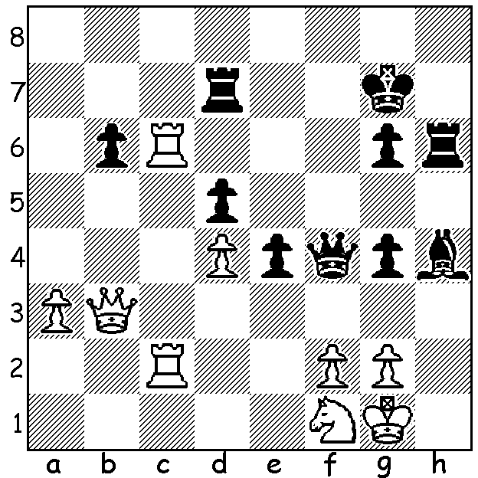

Alexei Shirov – Daniil Dubov
(Nutcracker Match of Generations 2014):
Black to play and set up a mating attack
(5 moves):

While we were enjoying the festive season eight leading chess players were engaged in a match in Moscow named the Nutcracker Match of Generations which pitted four Under 35s, ‘Princes’, against four Over 35s, ‘Kings’, in both classic chess and rapidplay (15 min + 10 sec). Each player played his four opponents once in Classic and twice in Rapidplay. The Classic finished 16 -16 (2 pts a win) while in the rapidplay Peter Leko managed to win his final game to give victory to the ‘Kings’ 16.5 -15.5. The inclusion of the exciting Latvian Alexei Shirov in the ‘Kings’ together with Peter Leko, Alexey Dreev and Alexander Morozevich, helped to create some fascinating chess. Shirov, now 42 and back in Latvia after many years in Spain, became world number 4 in 1998 and in that year defeated Vladimir Kramnik in a match to challenge Gary Kasparov for the world title. Unfortunately for Shirov the necessary financial support was not forthcoming and instead Kasparov played, and lost, to Kramnik.

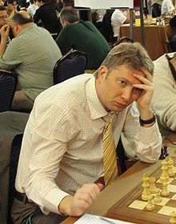
Alexei Shirov – Daniil Dubov
Nutcracker Match of Generations (Classic)
Benoni Defence
1.d4 Nf6 2.c4 c5
3.d5 g6 4.Nc3 Bg7
5.e4 0-0 6.Bd3 d6
7.h3 a6 8.a4 e6
9.Nf3 exd 10.cxd Nbd7
11.0-0 Qe7 12.Bf4 Nh5
13.Bh2 Bh6 14.Re1 Bf4
15.g3 Bh6 16.Bf1 Ne5 Alexei Shirov
17.Nxe5 Qxe5 18.f4 Qd4+
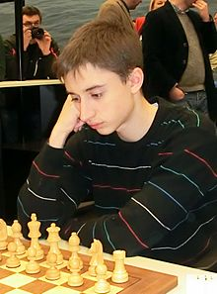
19.Kg2 Qb4 20.Qd2 f5
21.e5 dxe 22.Rxe5 Bg7
23.Re7 Nf6 24.Bg1 Bd7
25.Kh2 Rad8 26.Bg2 h5
27.d6 Bc6 28.Bxc6 bxc6
29.Rd1 Rf7 30.Qe2 Bf8
31.Re5 h4 32.Bxc5 hxg+
33.Kxg3 Qb3 34.Rd3 Qb7
35.b4 Rh7 36.Kg2 Rh4
37.Rg3 Nh5 38.Rxg6+! Kh7
39.Rxf5 Kxg6 40.Qe6+ Kh7
41.Rf7+ Kh8 42.Bd4+ Bg7 Daniil Dubov
43.Bxg7+ Nxg7 44.Qf6 resigns aged 18, GM at 14

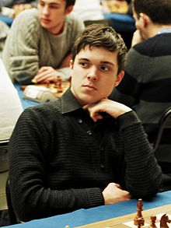
Vladimir Fedoseev - Alexei Shirov
Nutcracker Match of Generations (Rapidplay)
Queens Gambit, Semi-Slav Defence
1.d4 d5 2.c4 c5
3.Nc3 Nf6 4.e3 e6
5.Nf3 Nbd7 6.Qc2 Bd6
7.Bd3 0-0 8.0-0 dxc
9.Bxc4 b5 10.Be2 Bb7
11.Rd1 Qc7 12.Bd2 b4
13.Na4 c5 14.Rc1 Rfc8
15.Be1 Qa5 16.dxe Nxc5
17.Nxc5 Rxc5 18.Bc4 Bxf3
19.gxf3 Qc7 20.f4 a5 Vladimir Fedoseev
21.b3 Rc8 22.Qe2 g5 aged 19, GM at 16
23.f3 gxf 24.e4 Nd7
25.Qg2+ Kf8 26.Qh3 Ne5 27.Bf2 Nxc4!
28.bxc4 Rg5 29.Kh1 Kg8 30.c5 Be5
31.c6 Bc3 32.Qh4 Rg6 33.Rd7 Qxc6
34.Qe7 Kh8 35.Qxf7 Rg7 36.Qxg7+! Bxg7
37.Rxc6 Rxc6 38.Rd8+ Bf8 39.Rxf8+ Kg7
40.Ra8 resigns

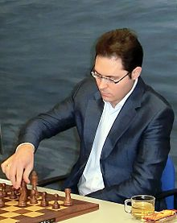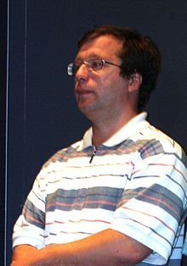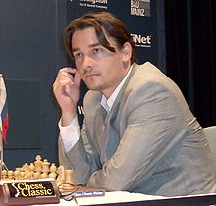

Peter Leko Alexey Dreev Alexander Morozevich

SOLUTION: 1…Bxf2+!! 2.Rxf2 Rh1+! 3.Kxh1 Qxf2 4.Rc1 Rd8 with the winning threat of 5…Rh8+. White avoided mate by 5.Rc7+ Kf6 …8.Rc6+ Kf5 9.Ne3+ Kg5 10.Rxg6+ Kxg6 11.Qxb6+ Qf6 12.Qc7 Qd6 13.Qb7 Rb8 before resigning.

