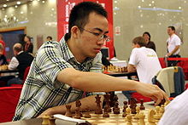
A 2011 win by Australian Open Champion
Ni Hua, White v Ahmed Adly Ni Hua
(White to play mates in 5 or wins a piece)

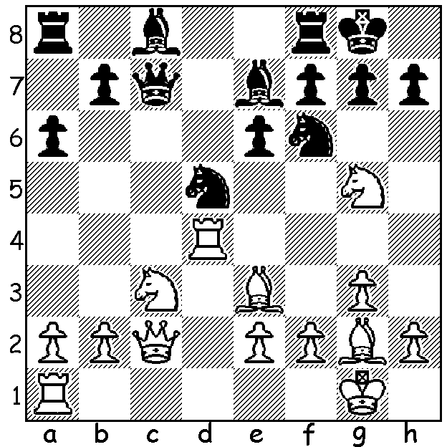

In this, the second article on the 2015 Australian Open, held in the Sydney suburb of Castle Hill, 2-11 January, won by 31 year old GM Ni Hua, a three-times Chinese champion, with 10.5/11, I have selected a couple of games by leading Australian players. I’m also able to correct a glaring omission from last week in which I failed to credit Australian champion Max Illingworth with being the leading Australian with 8/11 (2nd=). Here then is an impressive win by Illingworth featuring an opening gambit and a positional exchange sacrifice:

Gene Nakauchi - Max Illingworth
2015 Australian Open, Rd 7
Benko Gambit
1.d4 Nf6 2.c4 g6

3.g3 c5 4.d5 b5
5.cxb a6 6.bxa Bg7
7.Bg2 d6 8.Nf3 0-0
9.0-0 Bf5 10.Nc3 Nxa6
11.Nd2 Nb4 12.Nc4 Bc2
13.Qd2 Bb3 14.Na3 Bxd5
15.Nxd5 Nfxd5 16.Nc4 Nc7
17.Bxa8 Qxa8 18.a3 Ne6
19.Qd1 Nd4 20.Ne3 Nbc6
21.f3 Rb8 22.Rb1 Rb3
23.Nc2 c4 24.Na1 Rb8
25.e3 Nb5 26.Bd2 d5
27.a4 Nc7 28.Bc3 e5
29.Kg2 d4 30 exd exd
31.Bd2 Ne6 32.Nc2 Qxa4
33.Na3 Qa6 34.Qc1 Ne5
35.f4 Qa8+ 36.Kh3 Nf3
37.Nxc4 Rb5 38.Ne5 Bxe5 Max Illingworth
39.fxe5 Rxe5 40.g4 Nxd2
41.Qxd2 Re3+
White could resign now but played 42.Qxe3 to avoid mate and only resigned after move 50.

And now a sharp win by David Smerdon who came =4th, also featuring a pawn and exchange sacrifice and culminating in three successive rook offers:

Tony Davis - David Smerdon
2015 Australian Open, Rd 1

French Defence, McCutcheon Variation
1.d4 e6 2.e4 d5
3.Nc3 Nf6 4.Bg5 Bb4
5.exd Qxd5 6.Bxf6 Bxc3+
7.bxc3 gxf6 8.Nf3 b6
9.Qd2 Rg8 10.Qf4 Nd7!
11.Qxc7 Bb7 12.Qf4 Rc8
13.c4 Qa5+ 14.Qd2 Qa3
15.Qe3 Qb2 16.Rc1 Rg4
17.Bd3 Bxf3 18.gxf3 Rxd4
19.f4 Qc3+ 20.Ke2 Rcxc4!
21.Bxc4 Qxc4+ 22.Kf3 e5
23.h3 Rxf4+ 24.Kg3 Nc5
25.f3 Ne6 26.Qd3 Qc7 David Smerdon
27.Qxh7 Rxf3+! 28.Kg4 Qc4+!
29.Kh5 Rf5+! White resigns

The New Zealand Open, played in Devonport near Auckland (115 players), was also won by a player from China, Xue Zhao, with a score of 8/9, one point ahead of four runners-up including tournament favourite David Howell (UK). Four West Australians, Robert, Natalie and Fred Maris and Robin Shaw were among a number of Australians competing.

SOLUTION: 1.Nxd5!! Qxc2 (1…Nxd5 2.Qxh7#) 2.Nxe7+ Kh8 3.Nxf7+! Rxf7 4.Rd8+ Rf8 5.Rxf8#.

