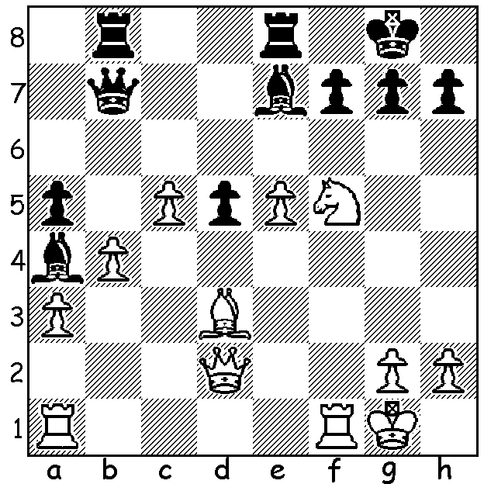

Patrick Gong – Patrick Slater-Jones
(Australian Junior Championships 2015):
White to play and win:

Play under way at Canberra Grammar The 2015 Australian Junior Championships were held
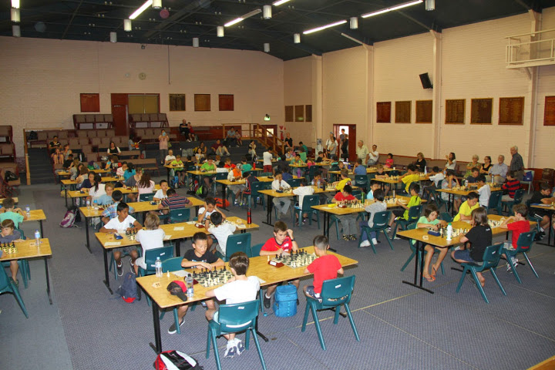
at Canberra Grammar School from 17 to 25 January with
269 entrants in age groups Under 18 to Under 8. For the
second year in succession WA provided the winner in the
Under 16 section with Patrick Gong scoring 8.5/9.
Patrick also won the Problem Solving Competition and
came 4th in the Under 18 Lightning Championship. In the
Under 10 Benjamin Hurst came 3rd with 7/9. Benjamin
faced the ultimate winner in the final round when a win
would have given him =1st and a play-off for the title but
could only draw. Other WA scores: Under 16 – Paddy Koh 4.5/9:Under 14 – Sri Krishna Dharmapuri 4.5/9: Under 12 – Kundan Dharmapuri 4/9. Here are a couple of games showing our boys’ combinative attacking flair:

Patrick Gong - Rebecca Strickland
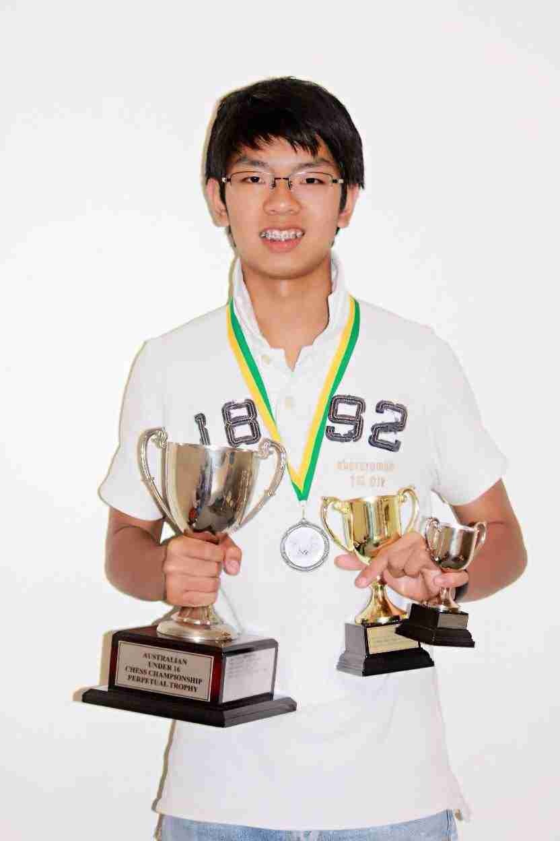
2015 Australian Under 16 Championship
Philidor Defence
1.e4 e5 2.d4 exd
3.Nf3 d6 4.Nxd4 Nf6
5.Nc3 Be7 6.Be2 0-0
7.0-0 Re8 8.f4 c6
9.Bf3 Nbd7 10.Kh1 Nc5
11.b4 Ne6 12.b5 Qa5
13.Nce2 cxb 14.Nf5 Qc7
15.Bb2 Rd8 16.g4 Ne8
17.Bg2 Qd7 18.Qe1 Bf8
19.Rd1 Qc6 20.Ne3 N6c7
21.f5 Bd7 22.Nf4 Qa6
23.a3 Bc6 24.g5 Be7
25.Qg3 f6 26.h4 b6
27.Nh5 Rd7 28.gxf Bf8 Patrick at Prize Giving
29.Ng4 Kh8 30.Ne5!! resigns

This brilliant deflection sacrifice brings a fitting end to a well-played attack - 30…dxe5 31.Rxd7 Bxd7 32.Bxe5 wins.

Benjamin Hurst - Xander Liebert
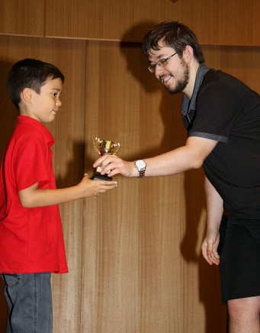
2015 Australian Under 10 Championship
French Defence, Advance Variation
1.e4 e6 2.d4 d5
3.e5 c5 4.Be3 cxd
5.Bxd4 Nc6 6.Nf3 Qc7
7.Nc3 Nxd4 8.Qxd4 Bc5
9.Qd2 Ne7 10.Bb5+ Bd7
11.Bxd7+ Qxd7 12.0-0 Nc6
13.Qg5 0-0 14.Rad1 Qe7
15.Qh5 f6 16.Rfe1 Rae8(a)
17.exf gxf6(b) 18.Nxd5! Qg7.
19.Nxf6+! Qxf6 20.Qxc5 Qxb2
21.Rd7 Rf5 22.Qxf5! & wins(c)

a) 16…fxe is winning for Black. Ben receiving his trophy from 2014 b) If 17…Qxf6 18.Nxd5! Qxb2 19.Ng5 keeps White on top. Australian champion Max Illingworth
c) 22…exf5 23.Rxe8#

WA clubs have reopened for the new year with Metro starting its championships on Feb 5 and Perth commencing one of its principal tournaments on Feb 4. The new Southern Suburbs club based at Leeming Primary, Meharry Rd, opens on Tues 3 Feb and will hold an Open Championship starting on 17 Feb. If you are living south of the river you would be assured of a welcome and even if you are a member of another club please consider entering the Open to help the club get off the ground.

SOLUTION: 1.Nh6+! gxh6 2.Qxh6 Bxc5+! 3.bxc5 f6 4.exf Qf7 5.Bxh7+! Qxh7 6.f7+ Qxf7 7.Rxf7 Kxf7 8.Rf1+ Ke7 9.Qd6#.

